ARTICLE XIV. MIXED USE INNOVATION DISTRICT

14.1. PURPOSE AND APPLICABILITY

Purpose. The Mixed Use Innovation District (MIX) incorporates the area north of the Route 128 Corridor as delineated on the MIX Zoning District. MIX is a major gateway into Burlington with access to Interstate 95/Route 128, the Middlesex Turnpike (Route 3), and Cambridge Street (Route 3A). The MIX District is identified in the Burlington 128 District Concept Plan and Report (2022) and the MIX District Concept Plan and Character Districts (2023) as an area targeted for new development and reinvestment. The standards set forth herein for MIX District are intended to:
- Promote development that is consistent with Burlington’s land use plans and initiatives to facilitate new investment and create a vibrant, diverse, connected, and resilient district.
- Guide the physical character of development by providing context-based building and site development standards that reflect scale, design characteristics, and development patterns envisioned for the district.
3. Create a public realm with high quality streetscapes, enhanced outdoor recreation areas, and active public and publicly-oriented gathering spaces that enhance development and reinforce pedestrian orientation and multi-modal transportation in the district.
4. Encourage a range of business development opportunities using the advantages of access to Interstate 95/Route 128, Middlesex Turnpike (Route 3), Route 3A, and other major town roads.
5. Encourage high quality housing production for a variety of age groups, household types, and income ranges in strategic locations within the MIX District.

Designated Districts and Subdistricts. The MIX District is a base zoning district and contains one subdistrict which is identified below and on the MIX Regulating Plan, which is integrated into the Town of Burlington Zoning Map.

MIX Subdistrict (MIXSD): The design and development standards for the MIX Subdistrict are included in Section 14.5.

14.2. REGULATING PLAN
The MIX District is shown on the Regulating Plan which is an enhanced zoning map that illustrates additional development and design standards specific to MIX District and the MIX Subdistrict. The Regulating Plan includes the following elements:

Civic and Park Nodes. The Regulating Plan identifies Civic and Park Nodes which are areas within the district that are intended to be used as a public or publicly accessible Outdoor Amenity Space under Section 14.8.

Streets, Greenways, and Trails. The Regulating Plan identifies existing and potential new streets, multi-use pathways, and walking trails within the MIX District in their approximate locations. See Section 14.8 for additional standards.

Transitional Buffer Zones.

- Purpose: The Transitional Buffer Zones are applied on certain MIX District boundaries where buildings and uses must be buffered to create a compatible transition with the surrounding neighborhoods and other sensitive land uses. Transitional Buffer Zones are identified on the MIX District Regulating Plan.
- Buffer Requirements: Where required, buffers may include a combination of natural or landscaped screening and fencing that provides an opaque visual barrier to a minimum height of eight feet above the ground. All buildings, structures and associated uses shall be setback a minimum of 75 feet from the property line along all Transitional Buffer Zone boundaries.

FIGURE 1. TRANSITIONAL BUFFERS
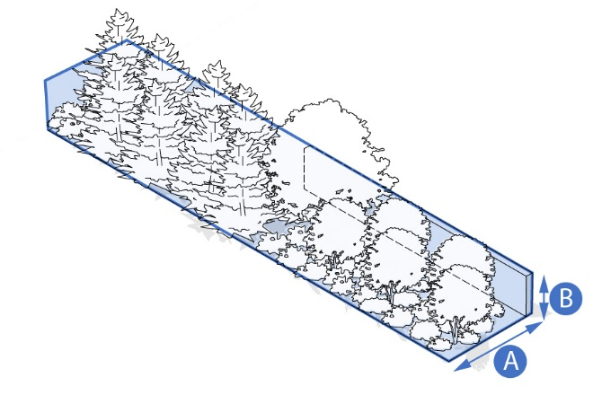 | 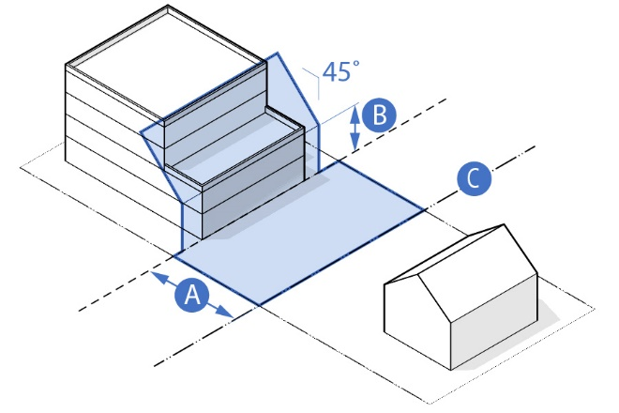
Transitional Landscape Buffer  A = Minimum depth of 20 feet with landscaping. B = Minimum height of 8 feet with opaque fence. | Transitional Building Buffer  A = Minimum building setback of 75 feet.  B = Maximum building height of 25 feet at setback.  C = TC Boundary Line

Pedestrian Frontage Zones.

- Purpose: The Pedestrian Frontage Zones (PFZ) are properties along existing or future Primary or Secondary Streets as defined in Section 14.10. The PZF prioritizes pedestrian-oriented and active ground floor uses. Pedestrian Frontage Zones are identified on the MIX District Regulating Plan.
FIGURE 2. PEDESTRIAN FRONTAGE ZONES
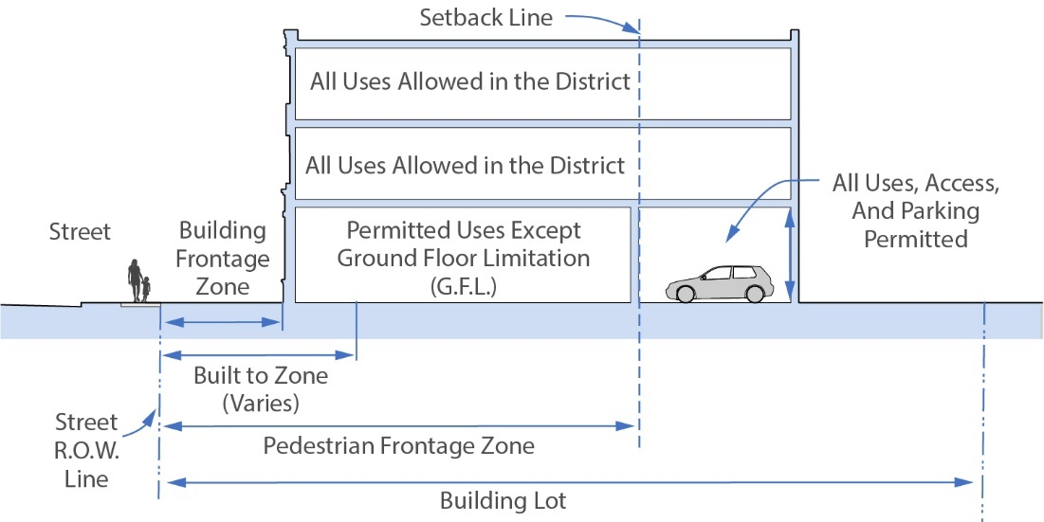

- Requirements: Buildings fronting on the designated street segments for Pedestrian Frontage Zones shall be subject to the following Ground Floor Limitations:
- Ground floor uses shall be reserved for retail, restaurant, and other publicly-oriented and accessible uses such as personal service, real estate office, financial institutions office, repair, and similar uses.
- Residential uses and non-residential uses not oriented to public access shall be allowed to have access from the building frontage zone by an entrance that leads to the upper floors of the building or the rear of the building.
- Residential uses and non-residential uses not oriented to public access shall be allowed on ground floors where:
- The use is within a building with frontage on the street and the use is set back a minimum of 60 feet from the street right of way (R.O.W.) line; or
- The Planning Board may waive this requirement if it determines that street-front residential and/or other non-publicly oriented uses will not have an adverse impact on the continuity and vitality of the publicly-oriented street-front uses.
- Application: Buildings fronting on Primary Streets in the MIX Subdistrict shall be subject to the Ground Floor Limitations in Section 14.2.D above.

14.3. GENERAL STANDARDS FOR ALL BUILDINGS AND LOTS

Building Placement and Orientation.

- Building Lot: Dimensional standards are defined in Figure 11 for each of the permitted Building Types.
- Number of Buildings: More than one principal building is allowed on a building lot where the development as a whole meets all dimensional standards, setbacks, required open space, and required parking except where otherwise restricted in this section.
- Building Placement: No principal buildings and/or accessory structures shall be located in any required front, side, or rear setbacks except as otherwise permitted in this section. Building placement standards are set forth for each Building Type in Figure 11.

FIGURE 3. BUILDING PLACEMENT ON THE LOT EXAMPLE
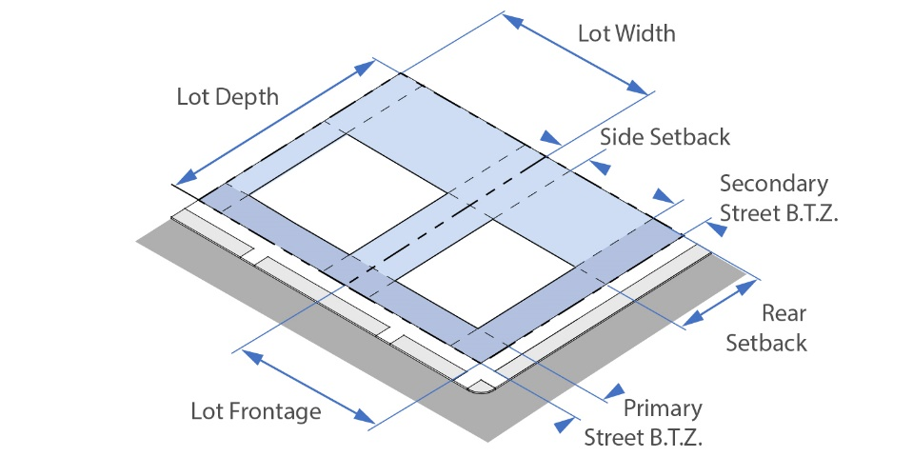

- Build-To-Zones (BTZ): The area between the minimum front setback and maximum front setback is the Primary Street Build-To-Zone (BTZ) in which the front façade of the primary building facing the primary street shall be placed. If the lot is on a street corner, the side façade facing the secondary street shall be placed in the required Secondary Street Build-To-Zone. The BTZ is defined for each Building Type in Figure 11.

FIGURE 4. PRIMARY AND SECONDARY BUILD-TO-ZONE (BTZ)
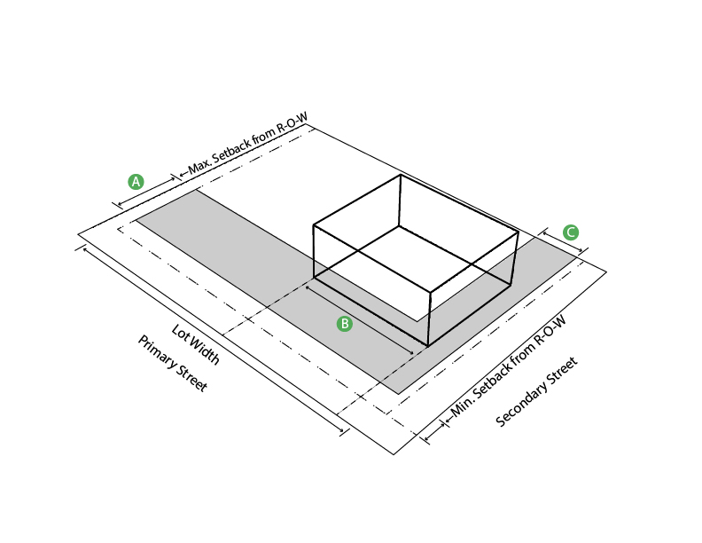
A: Primary Street Build-To-Zone
B: Primary Building Build-To-Zone Occupancy
C: Secondary Street Build-To-Zone

- Build-To-Zone Occupancy (BTZO): The width of the primary building façade facing the Primary Street measured as a percentage of the street frontage shall determine the percentage occupancy of the Build-To-Zone. Primary BTZ Occupancy shall be equal to at least 50% of the frontage width at the street R.O.W. line unless otherwise specified in the Building Type standards in Figure 11.
- Façade Orientation: The front façade and entrance of the principal building must be built parallel to a street R.O.W. line. On a corner lot, the building façade may be retracted up to 30 feet between the curb radius to allow for Outdoor Amenity Space.

FIGURE 5. FAÇADE ORIENTATION AND CORNER LOT SITE CLEARANCE
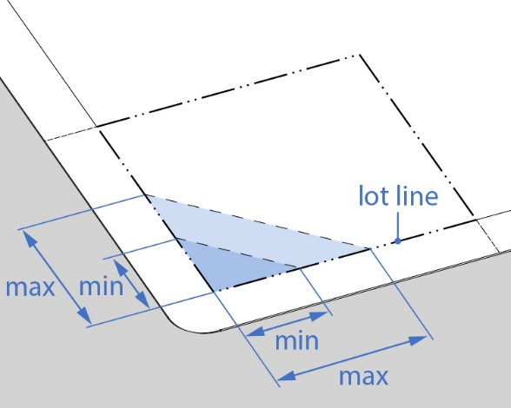 | 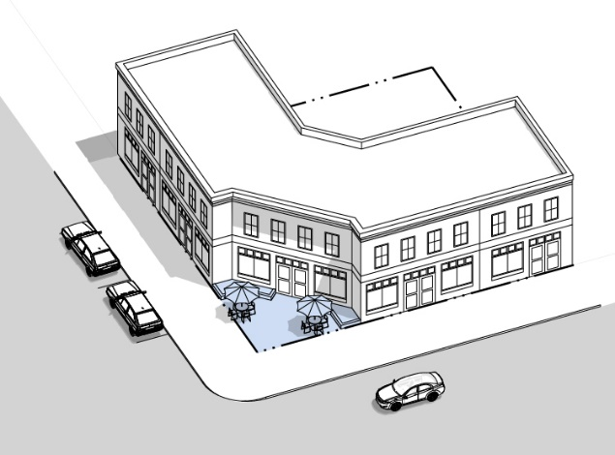

Building Height.

- Minimum and Maximum Height: The minimum and maximum height and number of stories is defined by Building Type in Figure 11.
- Building Height Exceptions: Height limits do not apply to Outdoor Amenity Spaces such as a roof deck, terrace, garden, trellises, and related structures conforming to Section 14.8. Height limits do not apply to mechanical and stairwell housing; roof mounted cellular, radio, and internet transmission equipment; vents or exhausts; solar panels or small wind turbines; skylights; flagpoles; and belfries, chimneys, cupolas, monuments, parapets, spires, steeples, and other non-habitable architectural features.
- Building Stepback and Street Enclosure: Buildings shall be set back or stepped back from the street right-of-way line in accordance with Figure 6 below. Therefore, a building may have to be setback or step back further from the street right-of-way line in order to achieve the maximum height allowed for a given building type. The purpose of this requirement is to enhance the pedestrian environment and prevent excessive street enclosure and shadowing on narrower streets. Notwithstanding the provisions of Figure 6, in no event shall any building exceed the maximum height requirements for individual Building Types in Figure 11. Within the spaces created by building setbacks or stepbacks, Outdoor Amenities Space is encouraged and may be required under Section 14.8.

FIGURE 6. BUILDING SETBACK AND STEPBACK
Distance from Street Right-Of-Way Line | Maximum Building Height by Street Type (See Section 14.4)
Distance from Street Right-Of-Way Line | Primary Street | Secondary Street | Private Street | Access Way
At Street Line (0 Feet) | 40 | 40 | 40 | A 5-Foot Setback from the Street Line and based on the Maximum Height for Building Type in Section 14.4.
10 Feet | 45 | 45 | 45
20 Feet | 50 | 50 | 50
30 Feet | 55 | 55 | 55
40 Feet | 60 | 60 | 60
50 – 150 Feet | 65 | 65 | 75
151–200 Feet | 75 | 75 | 90
201 Feet and Over | 90 | 90 | 90
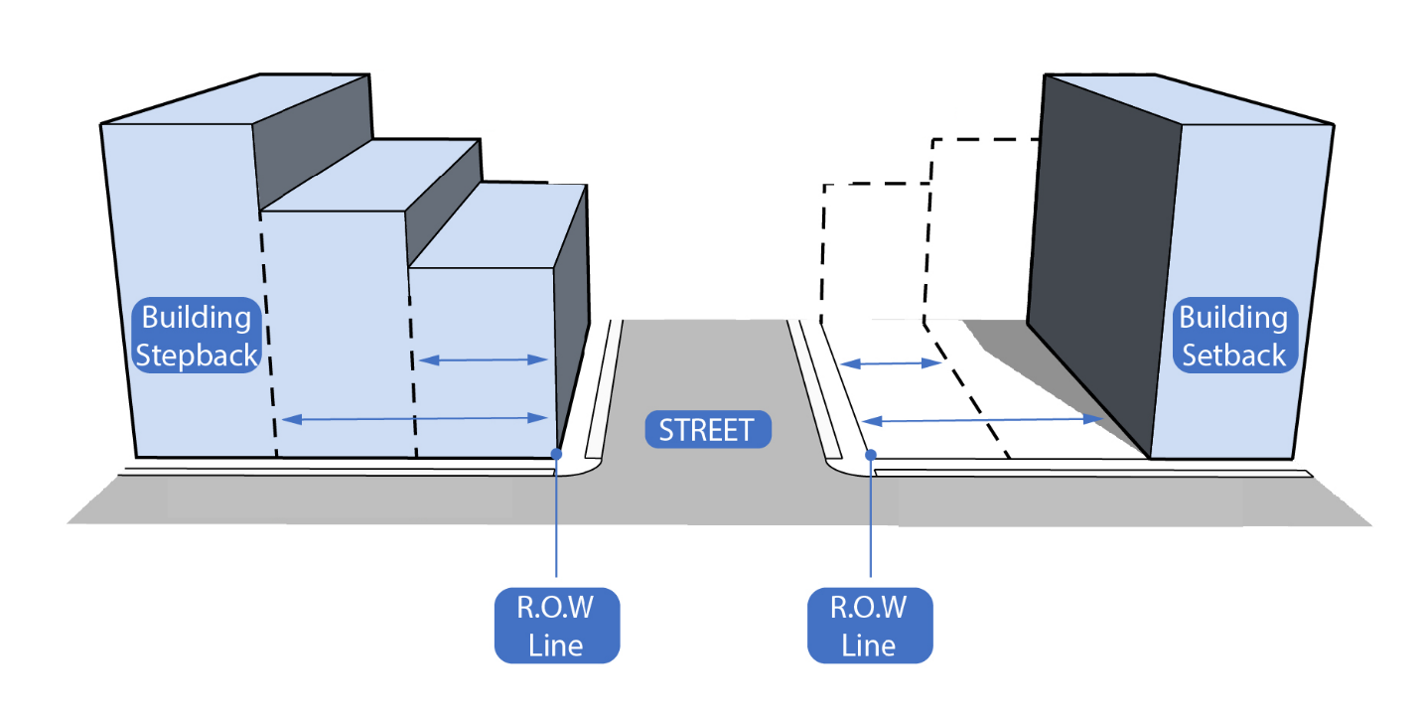

Building Proportions and Façade Composition.

- Vertical Modulation and Articulation.
- The minimum and maximum building width shall be determined for each building type under Figure 11. Street-facing building facades shall be vertically articulated with architectural bays to create an equal, central, or end articulated façade composition.
- Buildings greater than one hundred and fifty (150) feet in width shall be designed to read as a series of smaller buildings with varied articulation, architectural detailing, and fenestration patterns. Articulation must result in a change in vertical plane of the façade of at least four (4) feet (in depth or projection) for at least one modulated bay in width for every seventy-five (75) feet of total street-facing façade width.
- The façade on buildings that are wider than tall shall be articulated and defined by piers built into the façade at least 12 inches wide and 4 inches deep or of equivalent separation on the street-facing façade.

- Horizontal Modulation and Articulation. Street-facing building façades should be horizontally articulated with a clearly defined base, middle, and top as illustrated below. For buildings three (3) stories and taller, the following standards apply:
- The top story of each street-facing façade should have a cornice, parapet, roof element, or change in massing as an expression of the building’s top.
- Materials appearing heavier in weight should be used for the building’s base, with materials appearing similar or lighter in weight used above.

FIGURE 7. VERTICAL & HORIZONTAL FACADE MODULATION
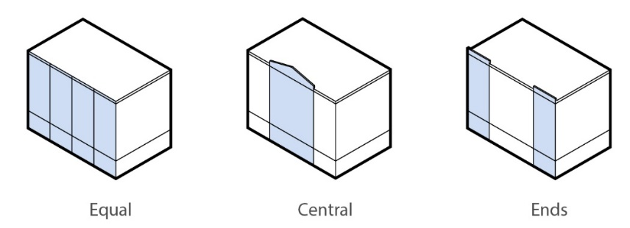 | 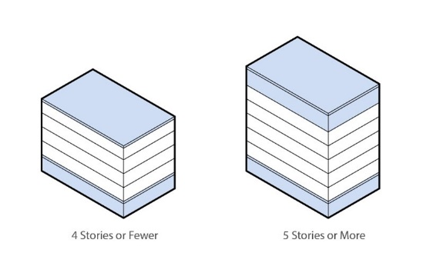
Vertical Modulation | Horizontal Modulation

- Surface Relief with Architectural Features. Street-facing building façades should provide surface relief through the use of bay windows, cladding, columns, corner boards, cornices, door surrounds, moldings, piers, pilasters, sills, sign bands, windows, and other equivalent architectural features that either recess or project from the average plane of the façade by at least four inches. See Figure 7.
- Parapet Wall. Buildings with flat roofs shall be capped by an articulated parapet that is visible from all sides of the building and screens the rooftop mechanical infrastructure from view at ground level.

FIGURE 8. FAÇADE COMPONENTS AND ARCHITECTURAL FEATURES
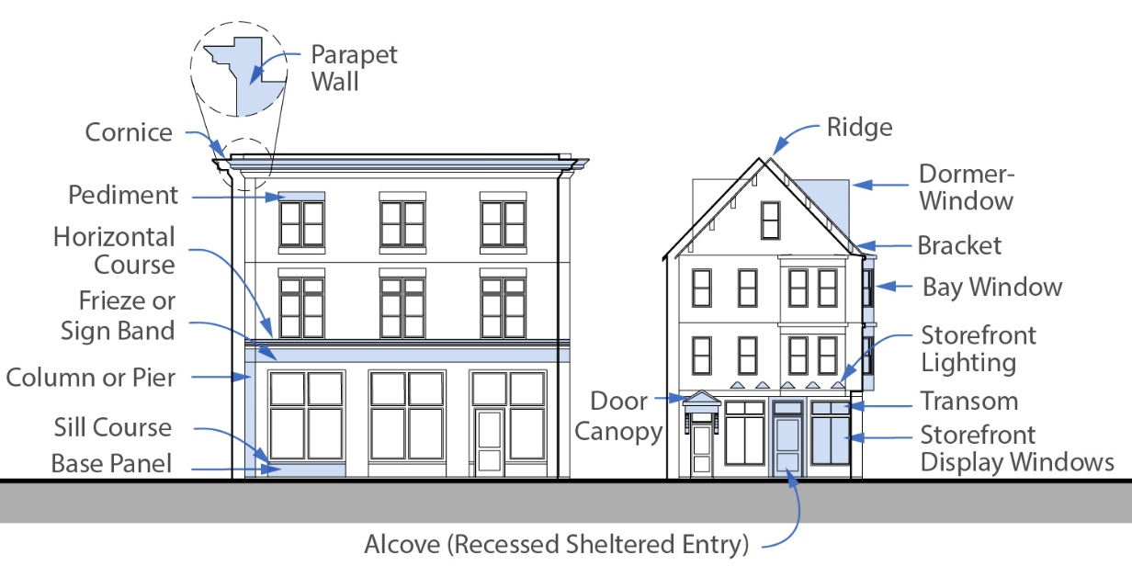
EXAMPLE GRAPHIC/REPLACE
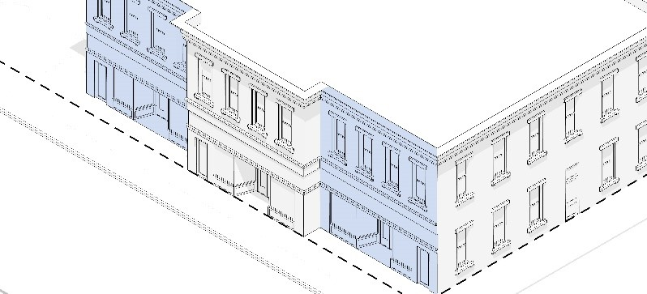

- Building Transparency. The following standards apply to all commercial and mixed-use buildings in MIX District with ground floor office, retail, and restaurant uses:
- Façades shall have windows and doors with highly transparent, low reflectivity glass for a percentage of the total area of a façade, measured for each story independently.
- Façade transparency of a ground story façade is measured between two feet (A) and twelve feet (B) above the adjacent street as shown in Figure 8.
- Façade transparency requirements are only applicable to façades facing primary and secondary street right-of-way line.

FIGURE 9. GROUND AND UPPER FLOOR TRANSPARENCY
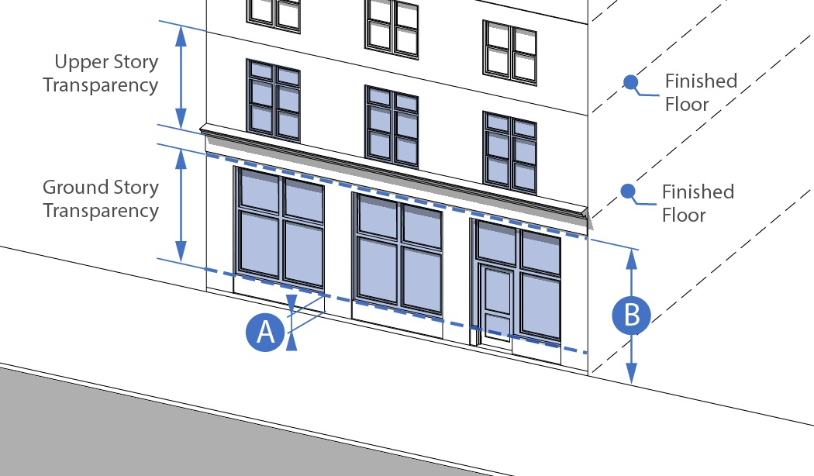

- Blank Walls. The following standards apply to all building facades facing a Primary Street:
- Blank wall area is any portion of a facade that does not include fenestration (doors and windows) and surface relief through the use of columns, cornices, moldings, piers, pilasters, sills, sign bands, murals, or other equivalent architectural features that either recess or project from the average plane of the facade.
- Blank wall area limitations apply both vertically and horizontally for all stories of a building for street-facing facades.
- Blank wall limitations are provided by building type in Figure 11.

FIGURE 10. BLANK WALL LIMITATION
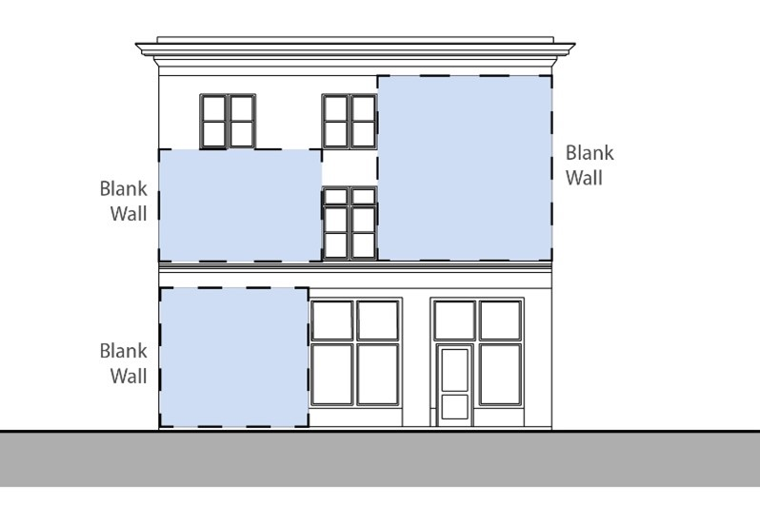

Exterior Treatments.

- The main elements of the architectural treatment of the building’s street-facing façade, including the materials used, should be continued around all sides of the building that are visible from existing and planned streets, pedestrian passages, parking lots, or Outdoor Amenity Spaces.
- Construction materials such as brick, stone, and block are suggested construction materials for smaller buildings. Other contemporary construction materials such as glass, metal, and other siding materials are appropriate in the MIX District for larger buildings and should be compatible with adjacent buildings which have more traditional materials.

14.4 BUILDING TYPES, USE AND DESIGN STANDARDS

- Allowable Uses
Uses allowed by right and by special permit are identified in Schedule of Uses in Section 4.2.0, 4.3.0, and 4.4.0 of the Zoning Bylaw. The Planning Board shall be the special permit granting authority (SPGA) for all special permits required in the MIX Zoning District and will be applying design criteria as part of the Site Plan Review approval process.

- Determination of Building Type
- The Building Commissioner shall classify new principal structures as a specific building type based on the definition of each type and upon finding that the structure is substantially similar in placement, height, massing, use, and features to one of the permitted building types for the zoning district where the structure is located. The Building Commissioner shall also classify pre-existing structures that are being expanded or converted to new uses under this section. If the Building Commissioner is unable to classify an existing principal structure as one of the building types of this section, the applicant is subject to special permit review by the Planning Board under Section 9.2.0.
- If a new building is proposed that cannot be classified as one of the allowed building types of this section by the Building Commissioner, the building type is subject to special permit review by the Planning Board under Section 9.2.0. The Planning Board may not allow additional uses that are not listed in the Schedule of Uses in Article IV of the Zoning Bylaw.
- Allowed Building Types and Development Standards. See Figure 11 below.

FIGURE 11. RESIDENTIAL BUILDING TYPES AND DESIGN STANDARDS
1. BUILDING TYPES
 |  | TOWNHOUSE (TH) | MULTI-FAMILY BUILDING (MF)
ILLUSTRATIVE DIAGRAM |  | 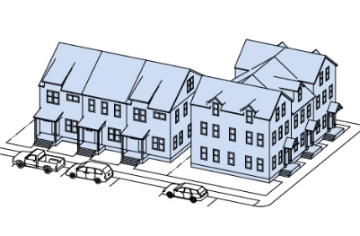 | 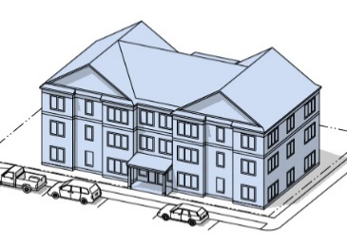
2. LOT STANDARDS
2.1 | Lot Size (S.F.) (Min.) | 1,200 S.F. Per Unit | 10,000 S.F.
2.2 | Frontage (Min./Max.) | 18 Ft. Minimum | 100 Ft. Minimum
2.3 | Front Yard Build-To-Zone (Min./Max.) | 5 Ft. / 25 Ft. | 10 Ft. / 50 Ft.
2.4 | Side Yard Setback (Min.) | 0 Ft. (15 Feet if Detached) | 15 Ft. Minimum
2.5 | Rear Yard Setback (Min.) | 15 Ft. Minimum | 20 Ft. Minimum
2.6 | Outdoor Amenity Space Lot Coverage (Min.) | 20% Minimum | 20% Minimum
2.7 | Impervious Surface Lot Coverage (Max) | 50% Maximum | 50% Maximum
3. DESIGN STANDARDS
3.1 | Building Height (Max.) | 2.5 Stories/35 Ft. | 6 Stories / 70 Ft.
3.2 | Street Facing Wall Width (Min.) | 18 Ft. Min. / 24 Ft. Max. | 18 Ft. / 100 Ft.
3.3 | Street Facing Entrance | Required | Required
3.4 | Street Facing Ground Floor Fenestration (Min.) | 20% Min. | 20% Min.
3.5 | Maximum Building Footprint (SF) | Not Required | Not Required
4. ADDITIONAL STANDARDS
4.1 |  | Off-street parking is not allowed in front of the buildings. On-street parking is permitted. | Off-street parking is not allowed in front of the buildings. On-street parking is permitted.
4.2 |  | Attached, detached, and integral parking garages must be accessed from the rear.
4.3 |  | A maximum of 12 units can be attached by a common wall before access way of 20 feet is provided for pedestrians, vehicles or outdoor amenity space.

FIGURE 11. MIXED-USE BUILDING TYPES AND DESIGN STANDARDS
1. BUILDING TYPES
 |  | LIVE-WORK BUILDING (LW) | MIXED USE BUILDING (MUB)
ILLUSTRATIVE DIAGRAM |  | 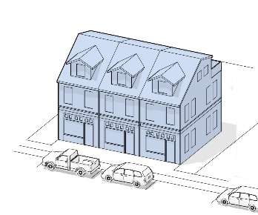 | 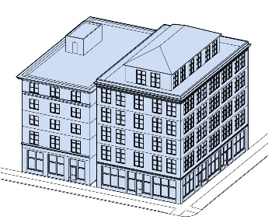
2. LOT STANDARDS
2.1 | Lot Size (S.F.) (Min.) | Not Required | Not Required
2.2 | Frontage (Min./Max.) | 50 Ft. Minimum | 100 Ft. Minimum
2.3 | Front Yard Build-To-Zone (Min./Max.) | 0 Ft. Min./ 20 Ft. Max | 0 Ft. Min./ 50 Ft. Max.
2.4 | Side Yard Setback (Min.) | 0 Ft. (15 Feet if Detached) | 30 Ft. (0 Ft if Common Wall)
2.5 | Rear Yard Setback (Min.) | 30 Ft. Minimum | 50 Ft. Minimum
2.6 | Outdoor Amenity Space Lot Coverage (Min.) | 20% Minimum | 20% Minimum
2.7 | Impervious Surface Lot Coverage (Max) | 40% Maximum | 50% Maximum
3. DESIGN STANDARDS
3.1 | Building Height (Max.) | 2.5 Stories/35 Ft. | 6 Stories /70 Ft.
3.2 | Street Facing Wall Width (Min.) | 20 Ft. Minimum | 50 Ft. Minimum
3.4 | Street Facing Entrance | Required | Required
3.5 | Street Facing Ground Floor Fenestration (Min.) | 20% Min. | 40% Min.
3.6 | Maximum Building Footprint (SF) | Not Required | 50% of the Lot
4. ADDITIONAL STANDARDS
4.1 |  | Off-street parking is not allowed in front of the buildings. On-street parking is permitted. | Off-street parking is not allowed in front of the buildings. On-street parking is permitted.
4.2 |  | Attached, detached, and integral parking garages must be accessed from the rear. | Where there is a side setback, a minimum of 10 feet is required to accommodate pedestrian access or 30 feet to accommodate vehicle access to the side and rear of the property.
4.3 |  | A maximum of 12 units can be attached by a common wall before access way of 20 feet is provided for pedestrians, vehicles or outdoor amenity space. | One-Story buildings must have a minimum street facing façade height of 18 feet.

FIGURE 11. COMMERCIAL BUILDING TYPES AND DESIGN STANDARDS
1. BUILDING TYPES AND DEFINITIONS
 |  | GENERAL COMMERCIAL BUILDING (GCB) | FUELING STATION/CONVENIENCE STORE (GB)
ILLUSTRATIVE DIAGRAM |  | 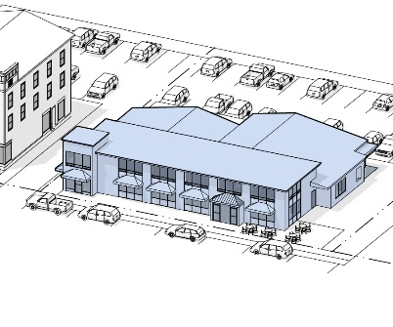 | 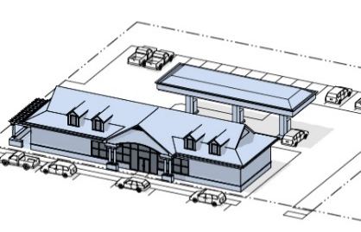
2. LOT STANDARDS |  | UPDATE IMAGE | REMOVE?
2.1 | Lot Size (S.F.) (Min.) | Not Required | Not Required
2.2 | Frontage (Min./Max.) | 50 Ft. Min. | 100 Min. / 150 Ft. Max. (Per Street)
2.3 | Front Yard Build-To-Zone (Min./Max.) | 0 Ft. Min./ 75 Ft. Max. | 5 Ft. Min./15 Ft. Max. (Per Street)
2.4 | Side Yard Setback (Min.) | 30 Ft. Min. (0 Ft if Common Wall) | 20 Ft Min.
2.5 | Rear Yard Setback (Min.) | 50 Ft | 30 Ft. Min.
2.6 | Outdoor Amenity Space Lot Coverage (Min.) | 20% Minimum | 10% Minimum
2.7 | Impervious Surface Lot Coverage (Max) | 50% Maximum | 50% Maximum
3. DESIGN STANDARDS
3.1 | Building Height (Max.) | 6 Stories/70 Ft. (90?) | 1.5 Stories / 24 Ft.
3.2 | Street Facing Wall Width (Min.) | 50 Ft. Minimum | 30 Ft. / 60 Ft.
3.4 | Street Facing Entrance | Required | Required
3.5 | Street Facing Ground Floor Fenestration (Min.) | 30% Min. | 30% Min.
3.6 | Maximum Building Footprint (SF) | Not Required | 4,000 S.F.
4. ADDITIONAL STANDARDS
4.1 |  | One-Story buildings must have a minimum street facing façade height of 18 feet. | The convenience store shall be placed along the street line and the gas pumps and canopy shall be located to the rear of the store.
4.2 |  | Where there is a side setback, a minimum of 10 feet is required to accommodate pedestrian access or 30 feet to accommodate vehicle access to the side and rear of the property. | A maximum of 12 gas pumps are allowed and must be located behind the convenience store and have to means of access and egress.
4.2 |  | Off-street parking is not allowed in front of the buildings. On-street parking is permitted. | Gas station canopies should be designed as an integral part of the store architecture whenever possible.

FIGURE 11. INDUSTRIAL BUILDING AND DESIGN STANDARDS
1. BUILDING TYPES AND DEFINITIONS
 |  | FABRICATION/FLEX BUILDING (FFB) | LABORATORY BUILDING (LAB)
ILLUSTRATIVE DIAGRAM |  | 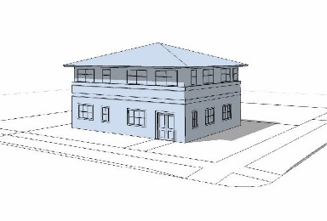 | 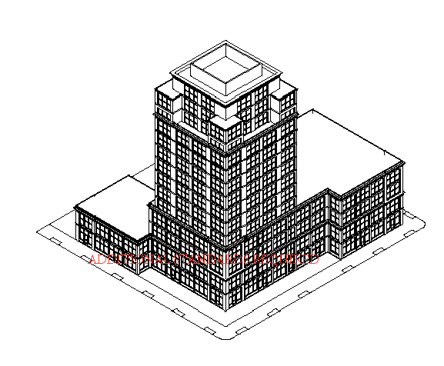
2. LOT STANDARDS |  |  | UPDATE IMAGE
2.1 | Lot Size (S.F.) (Min.) | Not Required | Not Required
2.2 | Frontage (Min./Max.) | 50 Min. | 100 Minimum
2.3 | Front Yard Build-To-Zone (Min./Max.) | 10 Ft. Minimum | 50 Ft. Minimum
2.4 | Side Yard Setback (Min.) | 50 Ft Min. (0 Ft if Common Wall) | 75 Ft Min. (0 Ft if Common Wall)
2.5 | Rear Yard Setback (Min.) | 50 Ft. Minimum | 75 Ft
2.6 | Outdoor Amenity Space Lot Coverage (Min.) | 20% Minimum | 20% Minimum
3. DESIGN STANDARDS
3.1 | Building Height (Max.) | 6 Stories / 70 Ft | 7 Stories / 90 Ft
3.2 | Street Facing Wall Width (Min./Max.) | 50 Ft. Minimum | 50 Ft. Minimum
3.4 | Street Facing Entrance | Required | Required
3.5 | Street Facing Ground Floor Fenestration (Min.) | 20% Min. | 30% Min.
3.6 | Maximum Building Footprint (SF) | Not Required | Not Required
4. ADDITIONAL STANDARDS
4.1 |  | Where there is a side setback, a minimum of 10 feet is required to accommodate pedestrian access or 30 feet to accommodate vehicle access to the side and rear of the property. | Where there is a side setback, a minimum of 10 feet is required to accommodate pedestrian access or 30 feet to accommodate vehicle access to the side and rear of the property.
4.2 |  | Off-street parking is not allowed in front of the buildings. On-street parking is permitted. | Off-street parking is not allowed in front of the buildings. On-street parking is permitted.
4.2 |  |  | Lab buildings shall be setback a minimum of 150 feet from any residential buildings.

- Infill Development of Non-Historic Pre-Existing Buildings.
- The Building Commissioner shall determine the building type of the existing building and proposed addition under Section 14.4.B and the addition shall be subject to the Building and Lot Standards of that building type.
- Where the expansion of an existing building in the MIX District is unable to meet the Building and Lot Standards in Section 14.4.B, the existing building shall comply with the following non-conforming provisions:
FIGURE 12. BUILDING ADDITION IN THE MIX DISTRICT
Type of Addition | Standards
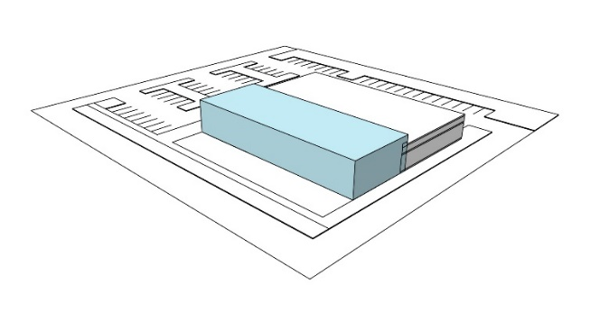 | - Front Addition. Any addition in front of the existing building shall meet the minimum setback of the Front Build-To Zone (BTZ). The addition does not have to meet the minimum Front Build-To-Zone Occupancy (BTZO).
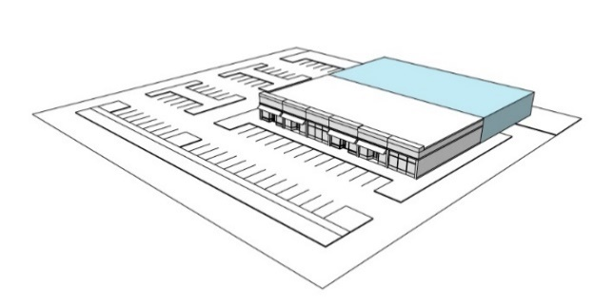 | - Rear Addition. Rear additions must meet the minim Rear Yard Setback for the building type and be setback a minimum of 75 feet when abutting residential districts.
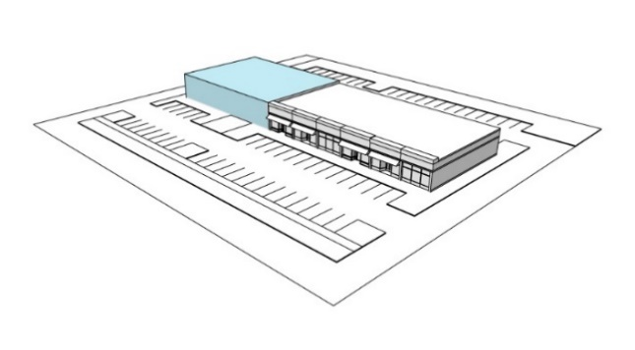 | - Side Addition. Side additions are allowed to a minimum side yard setback line and to a length not exceeding the maximum façade width for the designated Building Type.
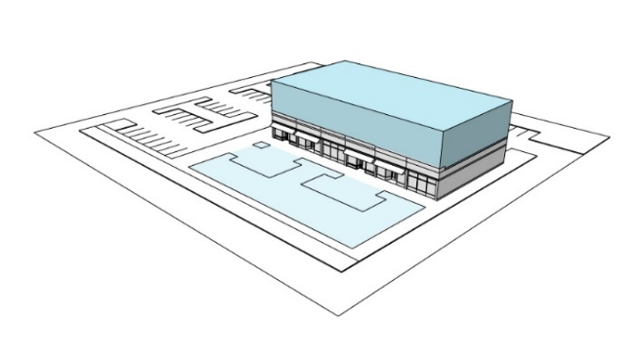 | - Story Addition. Story additions are allowed up to the maximum story and building height for the designated building type.
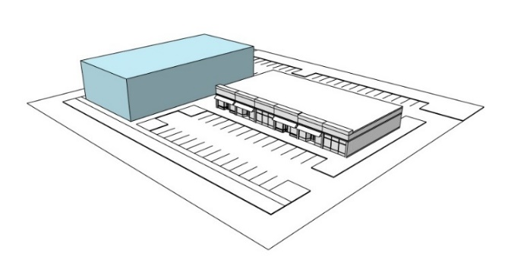 | - Additional Principal Building. Where a new building is being constructed on a lot or site with an existing building the following provisions apply: Any new building must be placed in the Front Build-To-Zone (BTZ) until the minimum occupation percentage for the lot has been met; New side or rear buildings are not permitted until the minimum Front Build-To-Zone Occupancy (BTZO) percentage for the lot has been met.

14.5 SITE DEVELOPMENT STANDARDS

- Development Tracts.

- Definition. A Development Tract is any lot or group of contiguous lots owned or controlled by the same person or entity, assembled for the purpose of a single development including one or more principal buildings.

FIGURE 13. DEVELOPMENT SITE
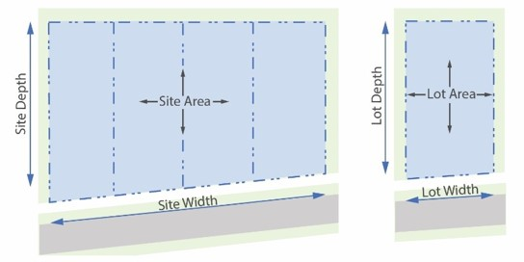
- Development Tract Area. The Development Tract area is the cumulative area of all contiguous lots that the site is composed of. The development tract area does not include existing or proposed right-of-way, whether dedicated or not dedicated to public use.
- Permitted Building Types. A Development Tract may include a combination of Building Types as permitted in the MIX District in Section 14.4 that are assembled on an individual lot or group of contiguous lots for the purpose of a single development.
- Access. All Development Tracts must be accessed from a public or publicly accessible street with a minimum frontage of 50 feet.
- Street Frontage. Internal streets and pathways within a Development Tract must meet the type and design requirements for the MIX District on the Regulating Plan and in Section 14.2. Street frontage requirements are determined by each Building Type and streets within the Development Tract may be public or private.
- Outdoor Amenity Space. The amount of Outdoor Amenity Space provided within the Development Tract is the cumulative land area of Outdoor Amenity Space required for the total number and types of building that the site is composed of. The type of Outdoor Amenity Space may be any combination of those permitted under Section 14.8.

- Development Types. The types of development permitted in the MIX District are identified below:

- General Industrial Development. A development containing multiple fabrication, flex, laboratory, or general industrial uses permitted in the MIX District and building types in accordance with design standards in Section 14.4.
- General Commercial Development A development containing multiple commercial uses permitted in the MIX District and building types in accordance with design standards in Section 14.4.
- Mixed Use Development. A development containing multiple residential, nonresidential, and mixed-use building types is permitted in the MIX Mixed Use Sub-District in accordance with design standards in Section 14.4.
- General Residential Development. A development containing multiple residential building types and community, or civic buildings permitted in the MIX Mixed Use Sub-District and in accordance with design standards in Section 14.4.

- Special Permit Mixed Use Development Types. The Planning Board may approve a special permit for a mixed use development in the MIX District under the following criteria:
  - Residential Density. The maximum residential density is 15 dwelling units per acre.
  - Building Types. All buildings shall meet the design standards for Building Types under Section 14.4.
  - Ratio of Building Space. The gross floor area (GFA) of residential building space including the square footage of dwelling units and associated residential amenity buildings and space shall not exceed 40% of all gross floor area in the mixed use development.

- Development Block Standards.
These standards establish maximum block length along public or private streets within a Development Tract as a method to ensure that access and walkability are integrated into the placement of buildings, outdoor amenity spaces, and site utility areas. Generally, blocks are laid out to orient buildings to the street and sidewalk while concentrating utility elements and parking out of public view. However, Outdoor Amenity Space can be oriented to the side or rear of the building and rear public access should be provided where parking is located internally.

- Size and Dimension. The maximum length of a block face and length of a block perimeter shall be determined as set forth in Figure 14. The Planning Board may grant a special permit for a longer block face or block perimeter where the applicant can demonstrate that the block will be highly walkable with Pedestrian Passages, curb extensions, streetscape enhancements, mid-block crossings, and/or other enhancements.

FIGURE 14. BLOCK DESIGN STANDARDS
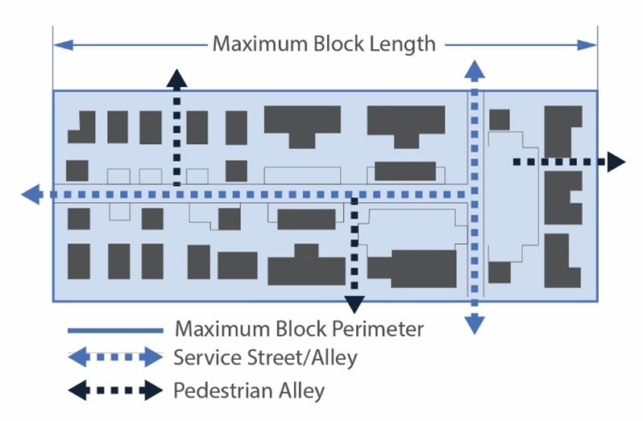
Development Type | Max. Block Face Length | Max. Block Perimeter Length
Mixed Use Development | 400 Feet | 1,200 Feet
Residential Development | 300 Feet | 1,200 Feet
Other Development Types | Not Applicable | Not Applicable

- Access and Utilities. Access to the interior utility area of a block shall be made by a paved Private Street or Access Way consistent with the Complete Street Design Standards in Section 14.10. A Private Street or Access Way shall be located no less than 50 feet from any intersecting street at the corner of a block. A Pedestrian Passage is required along a block face that exceeds 300 linear feet between intersecting streets and where shared parking areas or Outdoor Amenity Space is located within the interior of the block.

14.6 PARKING STANDARDS
Parking and loading standards are provided in Section 7.2.0 and 7.3.0 of the Zoning Bylaw.

14.7 SITE LANDSCAPING AND SUSTAINABILITY STANDARDS
- Streetscape Treatments.
- In the MIX District, streetscape treatments are required along the entire primary and secondary street frontage within twenty (20) feet of the of the street right-of-way as follows:
- Curbing. Where granite curbing is not in place within the existing street right-of-way, six (6) inch raised granite curbing is required along the entire street property line and the curve radiuses for points of ingress and egress where driveways are located.
- Street Belt and Street Trees. Deciduous street trees shall be installed along the entire primary and secondary street frontage in a continuous street belt with a minimum width of eight (8) feet and located at the street right-of-way line. Street trees shall be spaced fifty (50) feet on center. Street trees shall be a minimum size at planting of 3 ½" caliper at 4.5 feet diameter at breast height (DBH) and of native species common to the area. All trees shall be drought and salt tolerant. Street trees shall be regularly trimmed to provide clear visibility into the site from the street and provide shade over the walkway.
- Ground Cover. Low lying and low maintenance grasses, shrubs, bushes, flowers, and similar vegetative materials shall be planted evenly in the Tree Belt throughout the street frontage. All ground cover must be maintained at no more than 30 inches to avoid blocking visibility for drivers entering or exiting the site.
- Sidewalks. A 5-foot concrete sidewalk is required along the entire length of the primary and secondary street frontage where a sidewalk does not exist within the street right-of-way. Sidewalks must connect to sidewalks on adjacent properties and to buildings on the development site.
- Pathways. A paved pathway may be provided along the street frontage between the Trees Belt and the buildings on site. A pathway must be a minimum of eight (8) feet in width and should run the entire length of the primary and secondary street frontage and connect to pathways on adjacent properties where they exist. Pathways should connect to buildings on the development site.
- Monument Signs. Monument signs should be integrated into the streetscape plan. See Section Article XIII for sign regulations.

- Sustainable Site Design Standards.
The goal of sustainable design applications in the MIX is to effectively balance environmental, economic, and aesthetic objectives through a range of best practices.
- Low Impact Development / LEED Certification. All new developments are encouraged to meet certification standards under well-established sustainability rating system such as Leadership in Energy and Environmental Design (LEED) for neighborhoods, development sites, and buildings. Other sustainable development and design rating systems are encouraged as well.
- High-Performance Building Skin. As applicable, new buildings should use low emissivity windows, high R-value spray insulation, reduced thermal bridging, adequate depth exterior walls, solar shading, and sustainable cladding which all contribute to a high-performance building envelope.
- Plant Trees. Trees reduce solar gain, provide shade for pedestrians, filter the air, convert CO2 to oxygen, provide habitat for birds, and absorb stormwater on site. MIX developments should provide ample canopy trees that are located to allow grow to their mature size and specify measures to ensure sufficient space for water penetration and root growth.
- Green Roofs and Walls. Green roofs and walls reduce storm water runoff by absorbing and then slowly releasing rainwater. They protect the underlying roof, reduce solar gain during the summer months, and provide habitat for wildlife. If located on lower roofs or walls of the building, they can also be a visual amenity. These sustainable applications are highly recommended in the MIX.
- Rain Gardens and Permeable Pavers. Stormwater, flooding, and ground water recharging are important site planning issues in the MIX. New developments should incorporate natural elements to create resilience such as rain gardens that temporarily retain storm water until the ground can adequately absorb it. Permeable paving is also recommended to allow rainwater to naturally leach into the ground and recharge the water table. These sustainable applications reduce flooding and stress on public infrastructure, replenish aquifers, filter out pollutants, and help keep trees healthy.
- Sustainable Outdoor Amenity Spaces. As applicable, outdoor amenity spaces such as pocket parks, plazas, terraces, and other civic gathering spaces should incorporate light imprint techniques that address the quantity and quality of stormwater on site.
- Latent and Renewable Energy Sources. In a climate with large seasonal temperature swings, efficient methods for heating and cooling buildings are critical to reducing a building’s carbon footprint. As applicable, developers should utilize the latent energy of their sites to meet energy needs such as through the following applications:
  - Roof-installed solar panels and solar shades over surface parking lots which produce energy and reduce solar gain.
  - Geothermal energy can be captured to offset the large temperature variations between seasons and reduce the thermal loading of the building.
  - Small roof mounted or pole mounted wind turbines that harness latent energy on site.
  - Installing energy efficient mechanical systems, appliances, and other devices as a priority.

- Utilities.
- Public Utilities. All new public utilities (except structures and other facilities that require above-grade access) shall be installed underground.
- Trash and Service Areas.
- All service, loading, trash, and recycling storage areas viewable from a public or private street right-of-way or from an adjacent residential area shall be screened by one or a combination of masonry, a wood screen, or evergreen plantings to reduce their visual impact.
- Loading and service areas shall not face any residential area unless no other location is feasible.
- Garage doors and loading spaces are prohibited on the street facing façade of any building unless no other location is feasible.

- Site Improvement Guidelines.
In addition to the Site Landscaping and Sustainability Standards of this section, applicants for new buildings and developments in the MIX District should refer to the appropriate Town of Burlington Planning Board Rules & Regulations Design Review Guidelines.

14.8 OUTDOOR AMENITY SPACE STANDARDS

- General Standards.
- Outdoor Amenity Space Types. Outdoor Amenity Spaces include the following types:
- Civic Space (CS): Open space that includes publicly-owned or controlled parks, active and passive recreation areas, civic buildings, and other gathering spaces that are fully accessible to the general public.
- Publicly Oriented Private Spaces (POPS): Open and gathering spaces on private land primarily serving the residents, businesses and patrons of the principal building or Development Tract, and generally available to the public.
- Private Open Space (PS): Open space associated with individual dwelling units and multi-family buildings and developments and is not intended for public access.
- Required Outdoor Amenity Space. The required percentage of a building lot dedicated to Outdoor Amenity Space is identified for each building type in Section 14.4. Where multiple lots or buildings are assembled to form a Development Tract under Section 14.5, the required amount of Outdoor Amenity Space is the cumulative land area of Outdoor Amenity Space required for the total number and types of building of which the site is composed.
- Permitted Outdoor Amenity Spaces.
Permitted Outdoor Amenity Spaces and associated design standards are identified in Figure 15 below: [Relocate to Burlington Planning Board Rules & Regulations Design Review Guidelines?]

FIGURE 15. OUTDOOR AMENITY SPACE TYPES AND DESIGN STANDARDS
Type | Description and General Design Standards
- Private Yard (PS) | Description: A private open space associated with private residence or non-residential buildings not intended for public access.  Design Standards: Where applicable, a walkway should be provided between the public sidewalk and the front door.
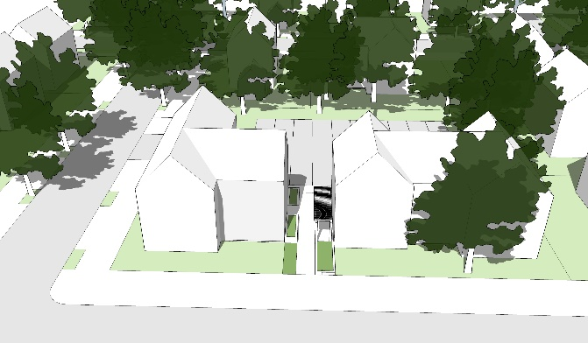
- Dooryard (PS) | Description: A private open space where the building façade is aligned close to the Street R.O.W. Line and defined by a low wall, decorative fence or hedge providing a strong spatial definition from the public sidewalk. The result is a small semi-private dooryard containing the principal entrance in the front yard. This type is commonly associated with ground-floor residential use.  Design Standards: The dooryard may be slightly raised, sunken, or at-grade, and may be planted or landscaped. A paved walkway from the sidewalk to the front door is required.
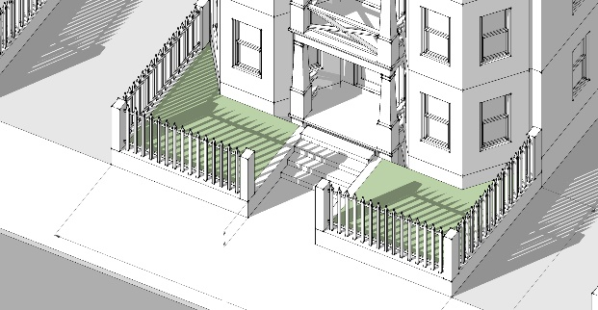
- Forecourt (POPS, PS) | Description: A private open space where a portion of the façade is aligned close to or at the Street R.O.W. Line, and the central portion of the façade is set back to create a courtyard with a principal entrance at-grade and space for gathering and circulation, or for outdoor shopping or restaurant seating. The forecourt may be planted or paved to join with the public sidewalk.  Design Standards: Forecourts shall be a minimum width and depth of 15 feet.
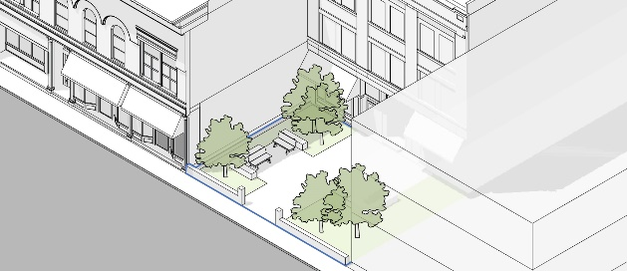
- Community Garden (CS, POPS, PS) | Description: An open space designed as individual garden plots available to residents for horticultural purposes, including storage facilities for necessary equipment. Community gardens may be freestanding or incorporated as a subordinate feature of a community park, neighborhood or pocket park, or Development Tract.  Design Standards: Community gardens shall be a minimum of 5,000 S.F.; 90% permeable surfaces; and 1 tree/500 SF on average.
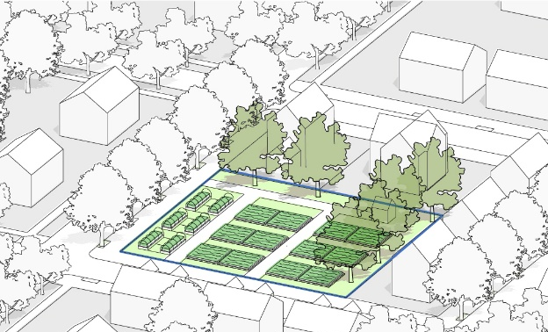
- Courtyard (POPS, PS) | Description: A courtyard (or court) is an enclosed open space, often surrounded by a building or buildings, that is open to the sky. Courtyards may include a variety of passive recreational activities, community gardens, and other amenities for community gatherings.  Design Standards: Courtyards shall be a minimum of 3,000 S.F. in area and 40 feet in width; The maximum ratio of building height to forecourt width shall be 1:2; Forecourt shall be enclosed by building facades on at least 3 sides.
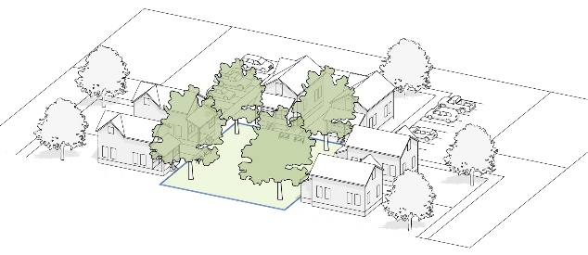
- Common or Green (CS, POPS) | Description: A common or green is a free-standing site with streets on all sides and landscape consisting of lawns, paths, and trees. This open space type is for active and passive recreation and gathering purposes.  Design Standards: Commons shall be a minimum of 20,000 S.F.; 85% permeable surfaces; and 1 tree/2,000 SF on average.
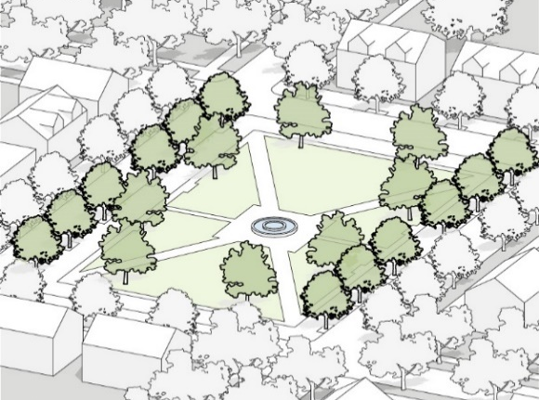
- Plaza or Square (CS, POPS) | Description: An open space type designed for passive recreation, civic purposes, and commercial activities, with landscape consisting primarily of hardscape. Plazas are generally located in activity centers or the nexus of major circulation routes.  Design Standards: Squares shall be a minimum of 8,000 S.F.; 50% permeable surfaces; 1 tree/2,000 SF on average; and include public seating.
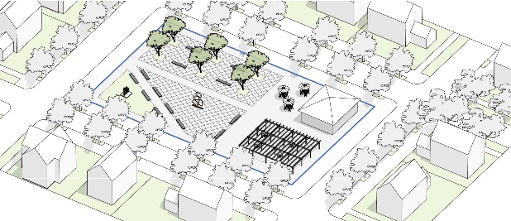
- Pocket Park or Playground (CS, POPS, PS) | Description: An open space type designed for passive recreation consisting of vegetation, a place to sit outdoors, and playground equipment.  Design Standards: Pocket Parks shall be a minimum of 5,000 S.F.; 75% permeable surfaces; and 1 tree/200 SF on average; and include seating and recreational equipment.
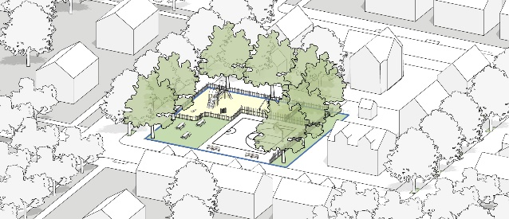
- Athletic Field or Ball Court (CS, POPS) | Description: A publicly accessible open space designed and equipped for active recreation and organized sports. Playing fields and courts may include grass, artificial turf, clay, dirt, stone dust, concrete, asphalt, ice or other pervious or impervious materials to support various sporting organizations and events.  Design Standards:  Size of Space: 10,000 S.F. Min.  Furnishing: Seating: 1 Seat/275 S.F. Min.  Landscape: Landscaped Area: 20%
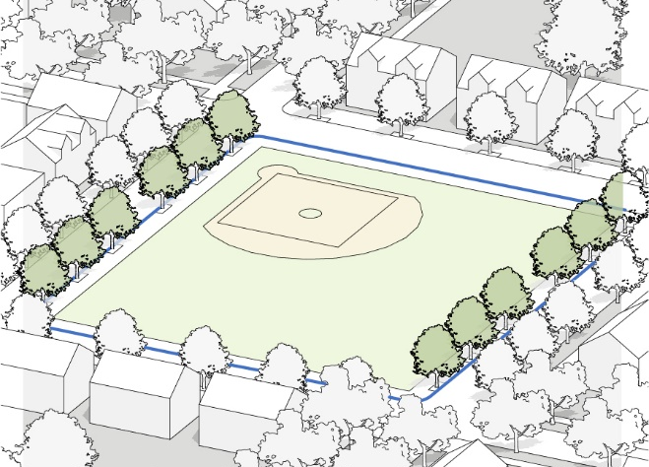
- Neighborhood Park or Preserve (CS, POPS) | Description: An open space designed for active and passive recreation with features and facilities that support the community or immediate neighborhood. Parks can include other Outdoor Amenity Spaces such as community gardens, recreation fields and courts, trails and pathway, swimming pools and water features, and other facilities intended for public events, gatherings, and organized activities.  Design Standards: Neighborhood Parks shall be a minimum of 20,000 S.F.; 80% permeable surfaces; and 1 tree/350 SF on average.
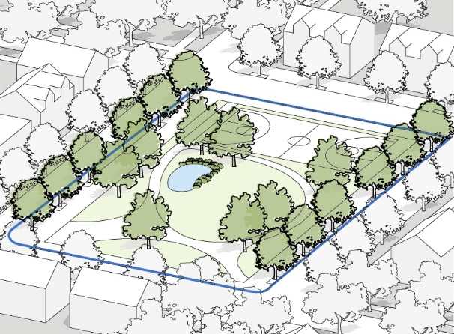
- Pathway (CS) | Description: A linear open space that may follow natural corridors providing unstructured and limited amounts of structured recreation. A pathway may be spatially defined by segment and include access to pedestrians, bicyclists, and other designated modes of transportation. Pathways may provide access and connections between natural areas, neighborhoods, villages, public facilities, and other points of interest.  Design Standards: The minimum width shall be 8 feet; Pathways shall be surfaced with stone dust, concrete, or asphalt.
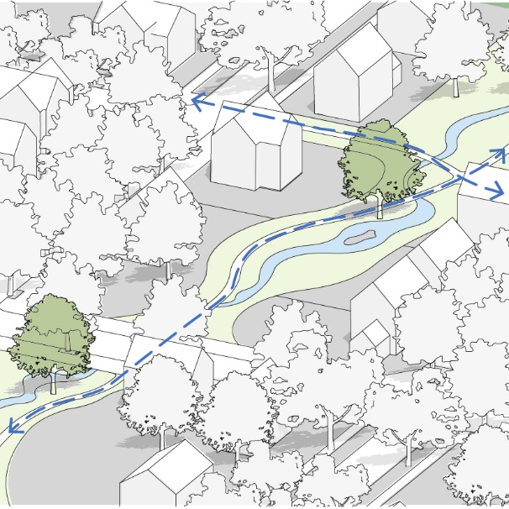
- Pedestrian Passage (CS, POPS) | Description: A paved or brick pedestrian connector between buildings. Pedestrian Passages provide direct connections between parking areas, buildings, streets, and sidewalks. Pedestrian Passages may be covered by a roof, trellis, and may be lined by shopfronts.  Design Standards: The minimum width shall be 10 feet (A) with 5 feet of throughway for pedestrians (B); hard surface such as asphalt, concrete, or paver stones is required; lighting is required; landscaping is recommended.
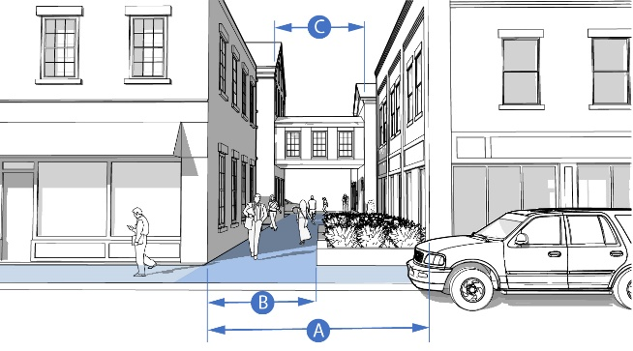
- Outdoor Dining (POPS) | Description: An open space where the building façade is setback from the Street R.O. W. Line and the space between is occupied by a hardscape intended for use as an extension of the public sidewalk and outdoor amenity space such as for outdoor seating or displays. The space may also allow for public circulation along the façade and can be used to provide at-grade access or a grade change along a Street R.O.W. Line.
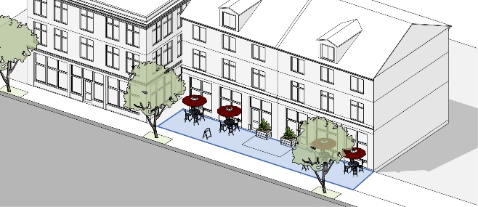
- Rooftop Terrace (POPS, PS) | Description: A roofless, raised platform on the roof of a building that provides community gathering space such as a terrace, community garden, food and entertainment, or other outdoor amenities.  Design Standards: Terrace must be setback a minimum of 5 feet from any building wall and secured by a perimeter fence at least 4 feet tall.
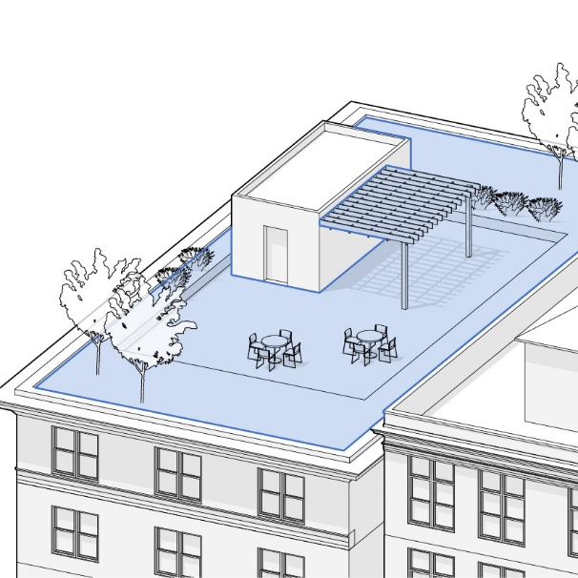
- Other OAS Types | Permitted by special permit by the Planning Board

PUBLIC REALM STANDARDS
[Relocate to Burlington Planning Board Rules & Regulations Design Review Guidelines?]

- Purpose. To facilitate a vibrant “Outdoor Room” that promotes economic vitality, social activity, and health benefits within the public right-of-way and on properties within the pedestrian frontage zone.
- Application
- Public Realm Activation Components. The allowed type and location of public realm activation components are listed in Figure 16 below.
- Activation Permits. Activation permits may be approved by the Board of Selectboard for activation of a public street right of way under the allowed applications in this section. Applicants may include business owners with storefronts along the public right-of-way (with permission from the property owners), or operators of food trucks, pop-up stores, or similar types of activation.
FIGURE 16. PUBLIC REALM ACTIVIATION COMPONENTS
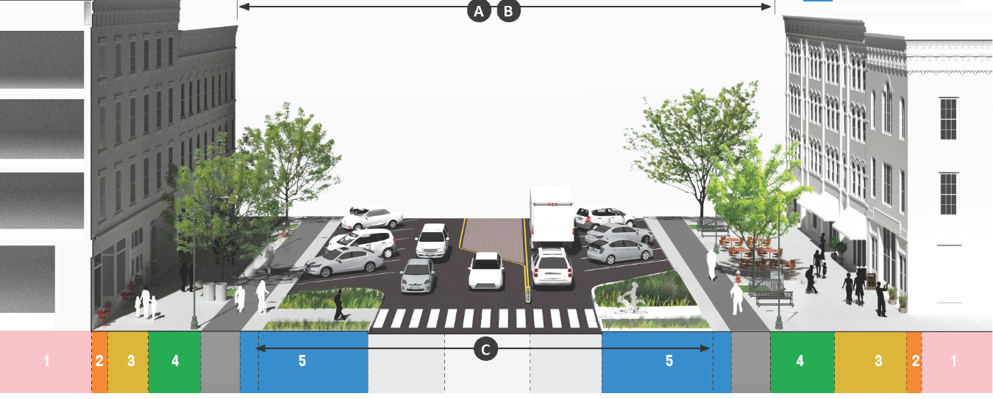
ACTIVATION COMPONENT | C. Vehicle Throughway Zone | 5. Street Enhancement Zone | 4. Furnishing and Utility Zone | 3. Pedestrian Throughway Zone | 2. Public Frontage Zone | 1. Building Lot Frontage Zone (See Public Realm Stds)
Parklets
Tactical Urbanism
Landmarks and Public Art
Café Seating
Storefront Displays and Chef Stations
Building Frontage Treatments
Building Facade Treatments
Building Encroachments

- Public Realm Interface
- Building Frontage Zones. A Building Frontage Zone is the setback space between the street facing façades of the building and the street R.O.W. line. Building Frontage Zone uses provide a compatible transition and interface between the Private Realm (private buildings and land uses) and the public realm (public sidewalks, streets, and civic spaces). Outdoor Amenity Spaces are required in the Building Frontage Zone along Primary and Secondary Streets.

FIGURE 17. BUILDING FRONTAGE ZONES
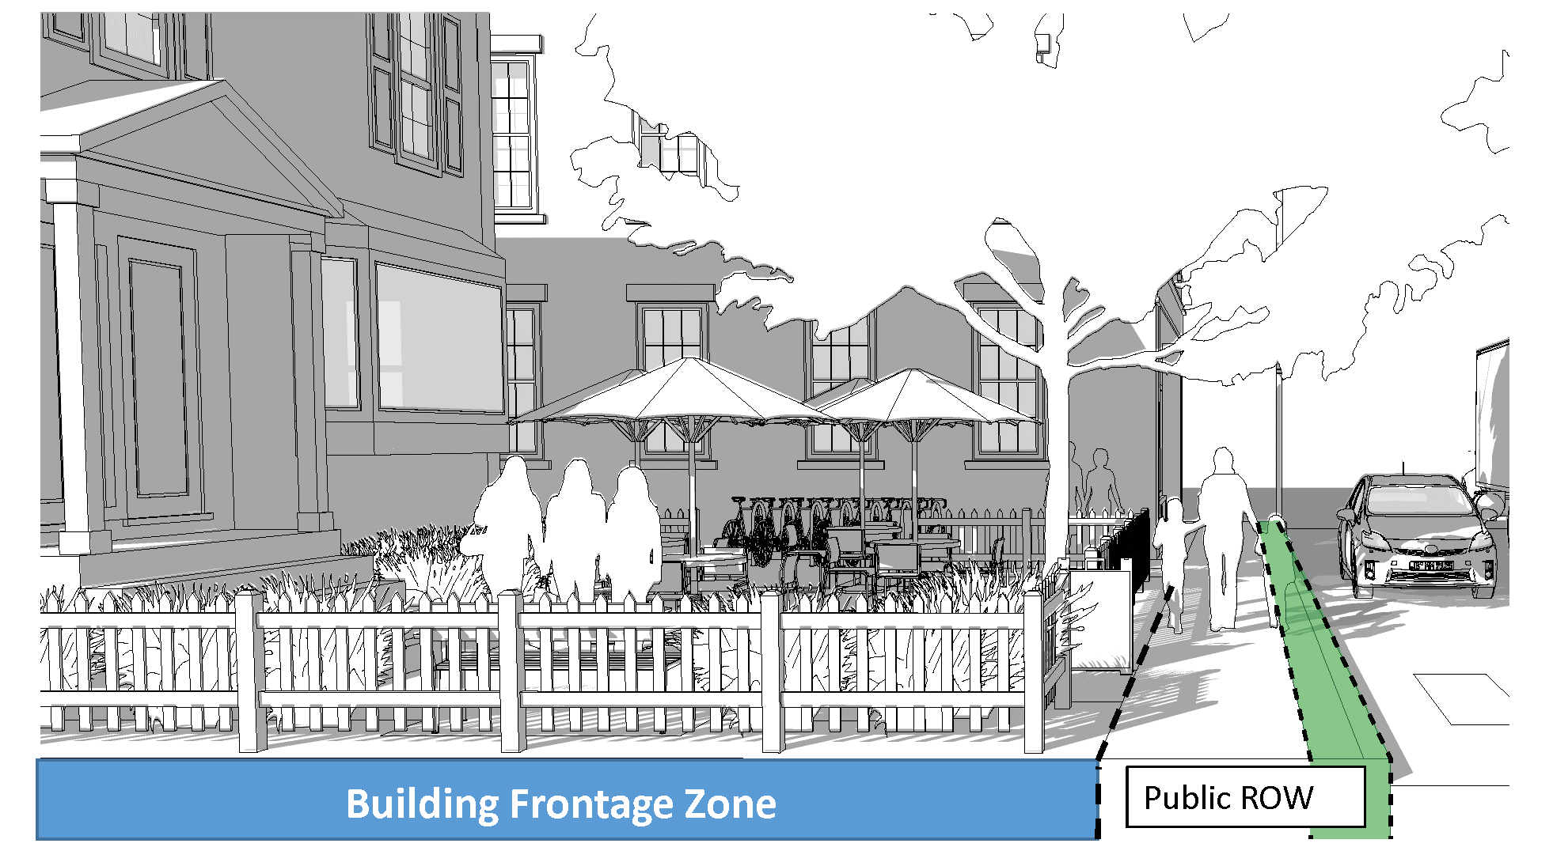

- Building Interface within the Public ROW. Building interfaces such as building components, Outdoor Amenity Spaces, signs, displays, and related interactive components may be permitted by special permit from the Planning Board on the Public Frontage Zone when they contribute to vibrant spaces for the enjoyment of the public and do not interfere with the 5-foot minimum Walkway Zone. All building interfaces on the public ROW shall comply with all relevant Town Bylaws. Permissible building interfaces are set forth in Figure 18 below.

FIGURE 18. BUILDING FRONTAGE ZONE AND PUBLIC REALM INTERFACE APPLICATIONS
Type | Description and Design Standards
- Sidewalk Dining | Sidewalk dining is permitted as an ancillary activity of any restaurant, pub, or other food and drink establishment. Permission is required from the Board of Selectboard for sidewalk dining in the Public Frontage Zone.
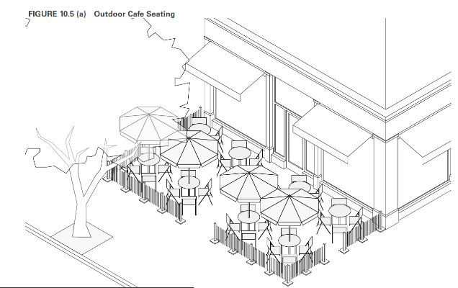
- Storefront Display | Storefront displays on a public sidewalk shall be within three (3) feet of the building; are prohibited from interfering with pedestrian travel in the Walkway Zone; and shall be removed when the business is not open; and requires a permit from the Selectboard.
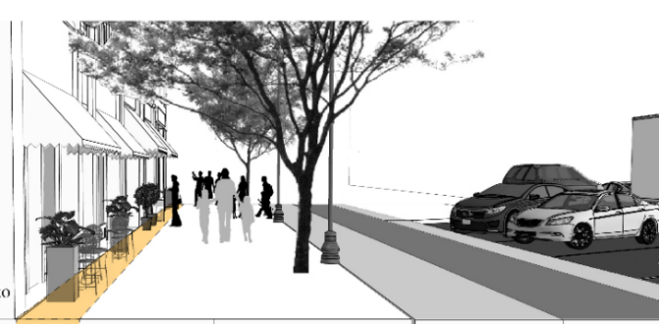
- Sidewalk Sign | A freestanding portable sign, not secured or attached to the ground or any building or structure, composed of a sign panel and supporting structure or one or more panels which form both the structure and sign face, and which is intended to be placed in a sidewalk or pedestrian way. See Sign Regulations in Article XIII.
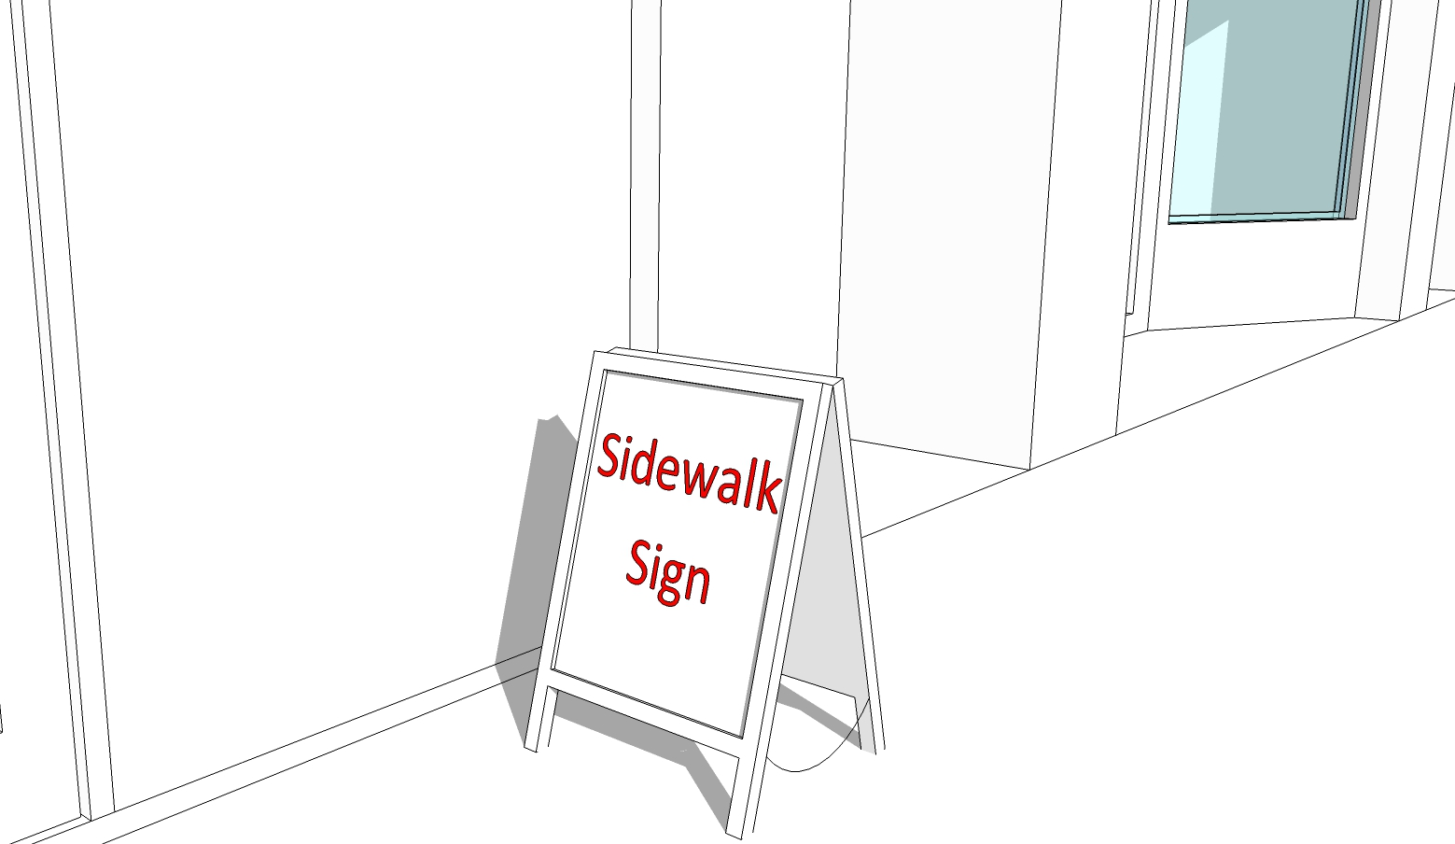
- Awning | An awning projecting over the sidewalk of a public street shall have eight (8) feet of clearance in height to the sidewalk grade, eight (8) feet in clearance from the curbline requires a permit from the Selectboard.
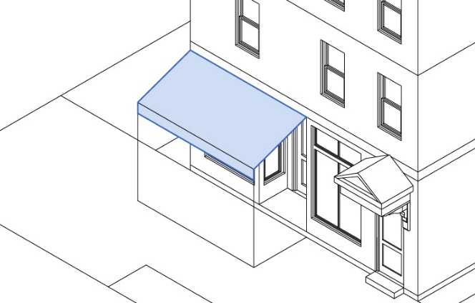
- Balcony | A balcony projecting over the sidewalk of a public street shall have twelve (12) feet of height clearance to the sidewalk grade, eight (8) feet in clearance from the curbline and requires a permit from the Selectboard.
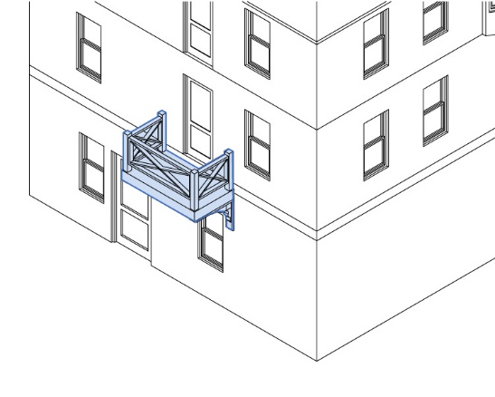
- Bay Window | Bay windows projecting over the sidewalk of a public street shall have twelve (12) feet of height clearance, 8 feet in clearance from the curbline, and requires a permit from the Selectboard.
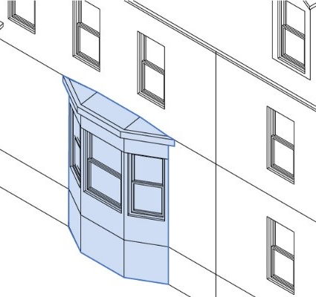
- Gallery | A gallery is an attached cantilevered shed or lightweight colonnade within the Building Frontage Zone or overlapping the sidewalk of a public street and providing shelter for pedestrians.
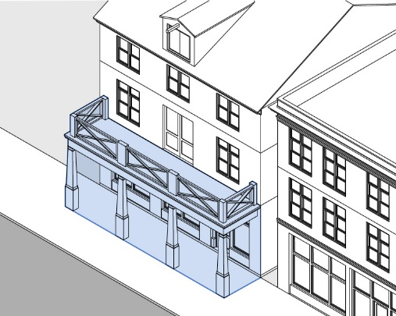
- Parklet | A parklet is a temporary treatment that typically extends out from the sidewalk at the level of the curb to the width of the adjacent on-street parking land. They are intended to enhance the pedestrian environment and provide outdoor amenity space where desirable.
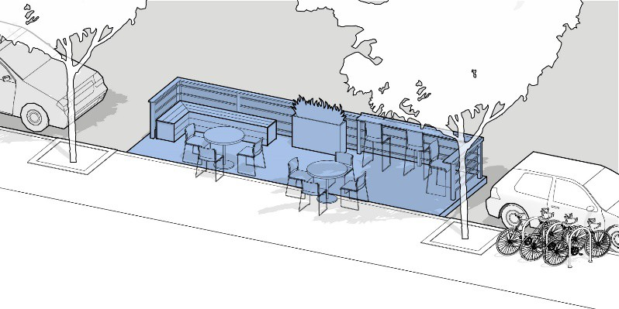
- Permitting and Design Guidelines

Public Realm Activation applications require approval from the Selectboard. Public Realm Activation design guidelines and standards are provided in the Planning Board Rules & Regulations.

COMPLETE STREETS STANDARDS
[Relocate to Burlington Planning Board Rules & Regulations Design Review Guidelines?]

- Purpose.
- To encourage the development of a well-connected travel network, composed of direct and convenient routes that reinforce a walkable and bikeable mixed use environment.
- To encourage “Complete Streets” that accommodate multiple modes of transportation, consistent with the character of commercial, industrial, and mixed use districts, and attractive to pedestrian and bicyclists.
- To promote pedestrian and motor vehicle safety, promote economic vitality, preserve, and enhance the character of the public realm along primary streets, and promote the social, environmental, and health benefits provided by walkable development patterns.
- Application.
- Public Infrastructure Projects. These standards shall be considered in the design and utilization of new or redesigned public streets.
- Private Participation. Applicants for site plan approval for a development project, subdivision approval, building permit, or change of use may participation in partnership with the Town of Burlington on the construction of streetscapes improvements planned for public streets including the areas within the right-of way between the vehicle lane and street line along the applicant’s property frontage. All improvements must be approved by the Board of Selectboard in consultation with the Planning Board and Department of Public Works.
- Standards For All Thoroughfares
- Complete Street Zones and Components. Figure 19 below identifies complete street components are allowed in each segment of public realm zone which includes the public right-of-way and the building frontage area.
- Complete Street Design and Construction Standards. Public streets must be engineered and constructed in accordance with the Town of Burlington Subdivision Regulations. In the absence of official standards, Thoroughfares must be designed and constructed according to the standards deemed to be appropriate by the Town Engineer and Planning Board. Figure 19 below provides design guidelines for new public streets in Burlington.
FIGURE 19. COMPLETE STREET ZONES AND COMPONENTS
STREET COMPONENT | C. Vehicle Throughway Zone | 5. Street Enhancement Zone | 4. Furnishing and Utility Zone | 3. Pedestrian Throughway Zone | 2. Public Frontage Zone | 1. Building Lot Frontage Zone (See Public Realm Stds)
Motor Vehicle Travel Lanes
Bicycle Facilities
Crosswalks
On-Street Parking Lanes
Curb-Extensions
Bus Facilities
Utilities/Green Infrastructure
Street Trees and Tree Pits
Public Seating
Bicycle Parking
Driveway and Alley Crossings
Sidewalks

- Street Types and Design Alternatives.
- Applicability. Figure 20 below identifies the types of streets and options for design consistent with the Town of Burlington Subdivision Rules and Regulations. Design and construction standards shall apply as follows:
- All new streets, whether public dedicated or privately held;
- The reconstruction of elements of the public realm when the public realm has been disturbed by development; or
- Substantial street reconstruction of a street.
- Waiver. The Planning Board may waive requirements of a particular street type or apply another type when it finds that applying the requirements of Figure 20 in a particular instance is either practically infeasible or detrimental to the safety of people who walk, or bike and these detrimental effects cannot be mitigated.

FIGURE 20. COMPLETE STREET TYPES AND DESIGN OPTIONS
Street Component | Primary Street | Secondary Street | Private Street | Access Way
Right-Of-Way (B) | 100 Ft. Min. | 50 Ft. Min. | 40 Ft. Min. | 24 Ft. Min.
Vehicle Lanes (C)
Travel Lane (C-5) | 12 Ft. Min. | 11 Ft. Min. | 10 Ft. Min. | 10 Ft. Min.
Parking Lane (5) | Optional/  8 Ft. Min. | 8 Ft Minimum | 1 Side or Informal | N/A
Bike Lanes | Optional/  5 Ft. Min. | Optional/  5 Ft. Min. | Sharrows/Informal | N/A
Multi-Purpose Path | Required | N/A | N/A | N/A
Sidewalk
Public Frontage Zone (2) | Optional/  3 Ft. Min. | Optional/  3 Ft. Min. | N/A | N/A
Throughway Zone (3) | 5 Ft. Min. | 5 Ft. Min. | 4 Ft. Min. | 1 Side/  4 Ft. Min.
Furnishing/Utility Zone (4) | 5 Ft. Min. | 5 Ft. Min | 4 Ft. Min. | N/A
Street Enhancement Zone (5) | Optional | Optional | N/A | N/A

- Vehicle Throughway Zone
- Design and Construction. A Vehicle Throughway must be designed and constructed in accordance with the Town of Burlington’s Street and Sidewalk Design Standards and/or the Subdivision Regulations. In the absence of official standards, Thoroughfares must be designed and constructed according to standards deemed to be appropriate by the Town Engineer and Planning Board in accordance with the following standards.
- Travel Lanes.
- Motor vehicle travel lanes may have a width between ten (10) feet and twelve (12) feet.
- When two opposing motor vehicle lanes share space as part of a “yield street configuration,” the combined width of the travel lanes may be reduced to a minimum of 16 feet.
- No more than two (2) motor vehicle travel lanes may be combined for any single direction of traffic flow.
- Materials must be as follows unless otherwise specified by the Department of Public Works.
  - Pavement must be hot mix asphalt.
  - The surface course must be 1.5” deep.
  - The binder course of the pavement must be Geotextile plus 2.5” asphalt.
  - The subbase must be 24” for poor to fair soils and 12” for good to excellent soils.
- Pervious pavement may be acceptable if planned and implemented in consultation with the Department of Public Works and an engineer who has experience with pervious pavement, and established specifications such as those provided by the University of New Hampshire Stormwater Center Design Specifications for Porous Asphalt Pavements and Infiltration Beds.
- Bicycle Travel Facilities.
- Bicycle Travel Facilities may be located within the Vehicle Throughway Zone, or the Street Enhancement Zone. (For example, a separated bike lane may be located between on-street parking and the Furnishing and Utility Zone).
- Separated Bicycle Lanes must be designed in accordance with the 2015 MassDOT Separated Bike Lane Planning and Design Guide or the latest version.
- Bicycle throughways (bicycle lanes) may be constructed of hot mix asphalt or porous asphalt. Porous asphalt must be planned and implemented in consultation with the Department of Public Works and an engineer who has experience with pervious pavement, and established specifications such as those provided by the University of New Hampshire Stormwater Center Design Specifications for Porous Asphalt Pavements and Infiltration Beds.

- Crosswalks.
- The Continental Crosswalk pattern is preferred by the Town of Burlington.
- Crosswalks must be aligned with the pedestrian throughways to which they are connected, unless granted a waiver by the Planning Board under Site Plan Approval.
- Where an adjacent pedestrian throughway is wider than the prescribed width of the crosswalk, the crosswalk markings should be widened to match the adjacent pedestrian throughway.

FIGURE 21. PEDESTRIAN CROSSWALK DESIGN STANDARDS
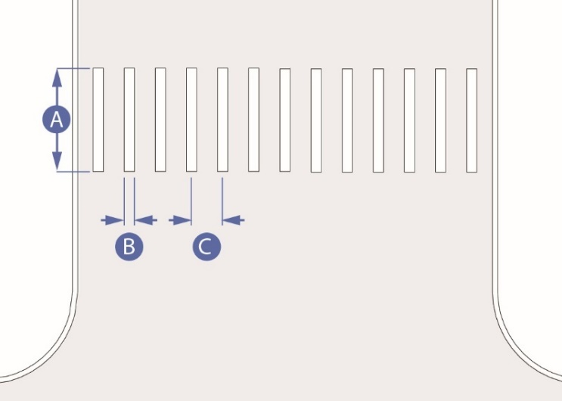
 | Stripe Width (Min.) | 10 feet
 | Stripe Thickness | 1 feet
 | Stripe Length | 10 feet
 | Stripe Offset (baseline, to be customized based on expected tire positions) | 3 feet on center

- Crosswalks must be thermoplastic unless epoxy is approved by the Department of Public Works. The Planning Board may allow flush granite and a mix of materials such as stamped concrete with flush granite to create visual cues and reinforce a specific design character.

14.9 STREETS ENHANCEMENT ZONE
[Relocate to Burlington Planning Board Rules & Regulations Design Review Guidelines?]

- Overview. The street enhancement zone includes the area between the Furnishing & Utility Zone and the edge of motor vehicle and bicycle travel lanes. Components in this area include temporary activation uses like parklets and food trucks (where allowed – See Section B – Public Realm Activation), and permanent components like on street parking spaces, stormwater infiltration areas, curb extensions, and crosswalks. The Street Enhancement Zone can include some of the same elements as the Furnishing & Utility Zone, such as public seating, bike racks, and planting.

FIGURE 22. STREET ENHANCEMENT ZONE
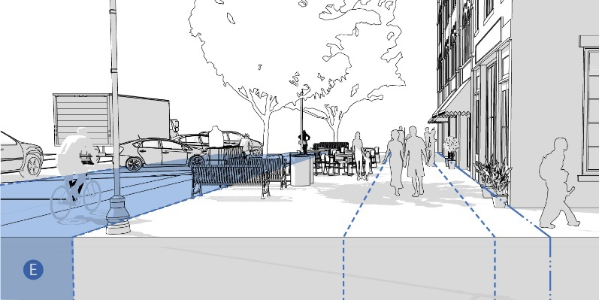

- On-Street Parking Lanes.
- Where motor vehicle parking lanes are desired, they must be eight (8) feet wide minimum and twenty-two (22) feet long maximum for parallel parking spaces; and nine (9) feet wide and eighteen (18) feet long for angled parking spaces.
- Angled on-street parking may be 60⁰ or 90⁰ angle parking. Sixty degree (60⁰) angle parking may be head-in or reverse-angle parking per the recommendation of the DPW.
- Gutter seams, drainage inlets, and utility covers must be flush with the pavement surface and oriented to prevent conflicts with bicycle tires.

- Curb Extensions.
- A curb extension is required at mid-block crossings and may be required at intersections as deemed necessary by the DPW based on traffic volumes, visibility, accident history, and required vehicle turning radii. A curb extension should only be installed where motor vehicle traffic deflection is provided through on-street parking, a parklet, another curbside use, or pavement markings.

FIGURE 23. CURB EXTENSION DESIGN STANDARDS
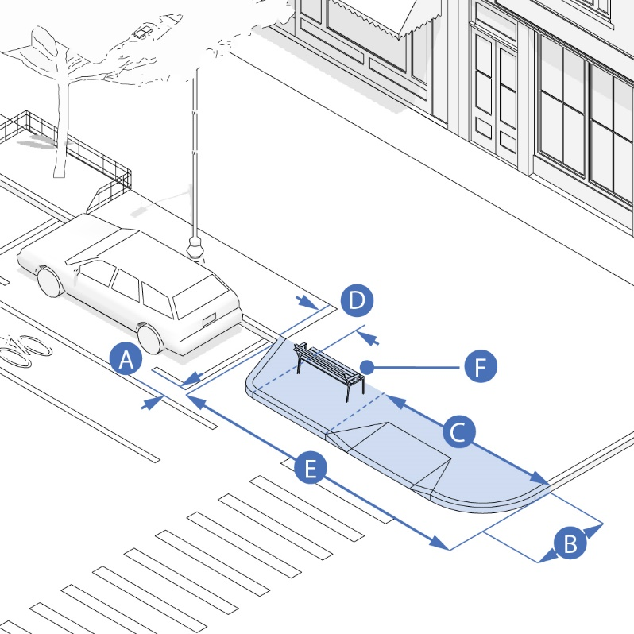
 | Buffer between curb extension and travel lane (Min.) | 1 foot
 | Width (Recommended Min.) | 6 feet
 | Minimum length of curb extension | Site specific. From intersecting street to far edge of crosswalk. Curb return should located outside of width of crosswalk
 | Recommended width of curb extension (Min.) | 20 feet
 | Placement of street furniture, trees, green infrastructure in curb extension is encouraged, but must not interfere with sight lines or travel pathways

- A curb extension should occupy as much of the width of the parking lane as is practicable, while providing a minimum of 1 foot between the edge of the curb extension and adjacent motor vehicle or bicycle lanes. The recommended minimum width of a curb extension is 6 feet. When a curb extension includes a streetside gutter adjacent to a bicycle lane, the curb extension must be set back so that the gutter does not extend into the bike lane.
- A curb extension should be, at a minimum, as long as the width of the adjoining crosswalk with the curb returns from the curb extension located outside of the width of the crosswalk. Where possible, a curb extension should be 20 feet long to restrict parking within 20 feet of an intersection.
- Where a sidewalk extension includes a bus stop, the design of the sidewalk extension must follow the guidelines for Boarding Bulb Stops found in the latest edition of the NATCO Transit Street Design Guide.
- Incorporation of street furniture, trees, and/or green infrastructure into curb extensions is encouraged. However, these elements must not interfere with pedestrian flow, emergency access, or visibility between pedestrians and other roadway users.

- Bus Facilities.
- Where bus stops exist, site design and ancillary improvements to the public realm should ensure:
          - Adequate sight lines for bus stop signage,
          - Minimization of circulation conflicts between bus stops users and vehicles or pedestrians using the adjacent public realm or site,
          - Attractive surroundings and amenities for bus riders, including where appropriate covered bus shelters with illumination and adequate seating for anticipated riders, bicycle racks, and information kiosks.
- Bus Pullout design should be consistent with the guidelines found in the latest edition of the NATCO Transit Street Design Guide. The “Curbside Pull-Out Stop” is the preferred bus stop type in the Town, except when the DPW and Planning Board find another bus stop type is preferable.

- Utilities.
- The design and construction of all water and sewer utilities, stormwater management infrastructure, public lighting, and public furniture is subject to review and approval by relevant Town departments and/or adopted standards by the Planning Board and/or Department of Public Works.
- All new electrical, communications, and cable utilities must be located underground.
- Green Infrastructure.
- Green Infrastructure is encouraged wherever possible, subject to the standards found in Town of Burlington Subdivision Regulations and Planning Board Rules & Regulations.

  - FURNISHING & UTILITY ZONE
[Relocate to Burlington Planning Board Rules & Regulations Design Review Guidelines?]
- Overview. The Furnishing & Utility Zone is the area of the sidewalk where pedestrians might pause or rest on benches or cafe seating and where many of the utilities, like lighting and hydrants, are located. This is the area typically planted with street trees. The Furnishing & Utility Zone varies in width.
FIGURE 24. FURNISHING & UTILITY ZONE
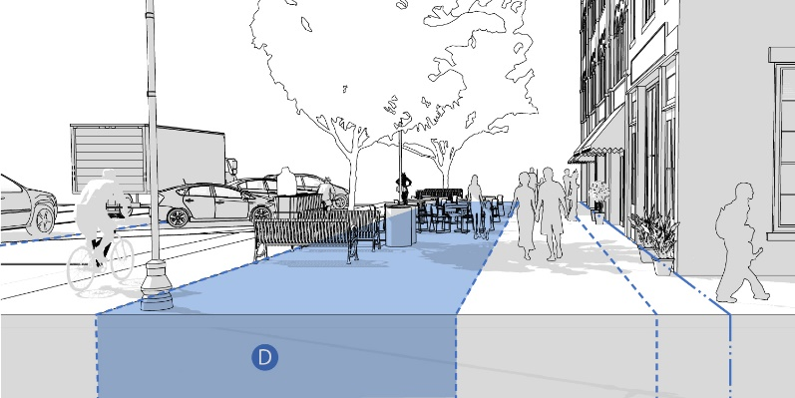

- Width. The required width of the Furnishing & Utility Zone is determined by street type. See Figure 20.
- Surfacing. Unless otherwise specified in these regulations or in specifications adopted by DPW, the Furnishing & Utility Zone must be surfaced with concrete and edged with a granite curb on the streetside. Pervious concrete unit paving, per the specifications of the DPW, may be used over areas contributing to street tree minimum recommended soil volumes (see Street Tree and Tree Pit Standards).
- Street Trees and Tree Pits.
- Installation Requirements.
          - New street trees should be planted within the Furnishing & Utility Zone to fill any gaps greater than 50 feet long between existing street trees. The Planning Board may grant a waiver from this requirement based on numbers 4, 5, 6, or 7 below.
          - Street trees should be planted in a regularly spaced pattern with trees aligned parallel to the curb. Trees should generally be spaced twenty to thirty (20 - 30) feet on center depending on species, and no greater than forty (40) feet on center.
          - When trees are planted both in the Furnishing & Utility Zone and in Public Frontage Zone or the Building Frontage Zone, the trees on either side of the Pedestrian Throughway should be aligned in an allee pattern, when possible.
          - Spacing of trees planted in the Furnishing & Utility Zone or Building Frontage Zone may be adjusted to avoid obscuring windows, doors, and signage.
          - A tree must not be planted in a location where it will block passage to a doorway or stairs, or where it will narrow a Throughway to less than the minimum dimensions required by this ordinance.
          - The Planning Board may, at its discretion, grant a waiver from street tree requirements when the tree would obstruct a terminated vista or when a tree would obstruct views to or into a civic space.
          - Street Trees must be planted at least five (5) feet from fire hydrants, six (6) feet from street signs, seven (7) feet from curb cuts, and thirty (30) feet from stop signs. The edges of tree planting beds must be at least two (2) feet from gas, electric, water, and sewer lines, and at least four (4) feet from oil fill pipes.
          - A tree pit must be a minimum of five (5) feet wide (dimension perpendicular to curb) and ten (10) feet long (dimension along curb). The Planning Board may grant a waiver from these specific dimensions, if this configuration is not possible due to site constraints, and an alternate configuration that amounts to a minimum of 50 square feet of surface is provided.
          - A tree should be planted generally in the center of its surrounding soil area.
          - The soil area around a street tree must be protected from compaction due to foot traffic. When the adjacent throughway is five (5) feet or wider, a tree guard (a metal fence at least 18 inches tall), must be installed around three sides of the tree (the curbside remains unfenced). When the adjacent throughway is less than five (5) feet wide, the soil area around a street tree must be protected by porous rubber tree pit surfacing. To prevent tripping hazards, the finished grade of the porous rubber tree pit surfacing must be level with the grade of the surrounding pavement.
          - A gap of approximately eight (8) inches must be left between any mulch or porous rubber tree pit surfacing and the trunk of the tree to avoid mounding above the trunk flare.
          - When planted, street trees must be a minimum height of ten (10) feet and/or two and one half (2.5) inches in caliper.

FIGURE 25. STREET TREE PLANTER DESIGN STANDARDS
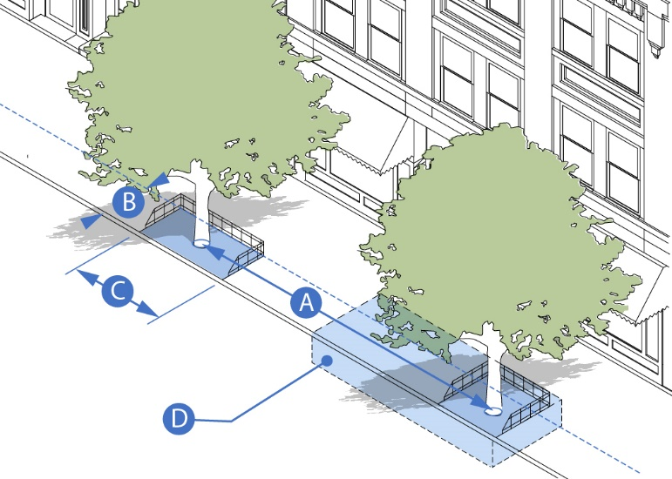
 | Tree Spacing (Recommended Min./Max.) | 20 to 30 feet/40 feet
 | Tree Pit Width (Recommended Min.) | 5 feet
 | Tree Pit Length (Recommended Min.) | 10 feet
 | Recommended Soil Volume | 600 cubic feet (min.) for small tree or 1,000 cubic feet (min.) for large tree
 | Minimum soil surface area for alternate tree pit dimensions | ≥50 square feet

- Recommended Techniques for Achieving Adequate Soil Volume. Urban soils beneath sidewalks are often compacted and deprived of water and nutrients, significantly compromising tree health, stability, and lifespan. When those conditions exist, the following techniques are strongly encouraged:
          - The use of a modular suspended paving system, like Silva Cells, beneath the surrounding concrete sidewalk. The structural units in these systems are designed to bear the load of the concrete surface above, while providing void space which is filled with planting soil. Besides offering an environment for a tree’s roots to grow, the more loosely compacted soil in these systems also offers bioretention of stormwater, which enters the system through permeable paving or through the tree pit.
          - Adjacent tree pits’ soil volumes should be connected as a continuous trench, paved with permeable pavers or porous rubber surfacing.
          - Structural soil is not a substitute for modular suspended paving systems. The space for planting soil within structural soil is limited to the void spaces among the aggregate (only about 20% total). This is significantly less than the soil volume in a modular suspended paving system. Therefore, structural soil, while less expensive per cubic foot, ultimately restricts tree growth and health compared to a modular suspended paving system and so it should only be used as a supplement (around the backs and edges).

FIGURE 26. RECOMMENDED ELEMENTS OF A
MODULAR SUSPENDED PAVEMENT SYSTEM
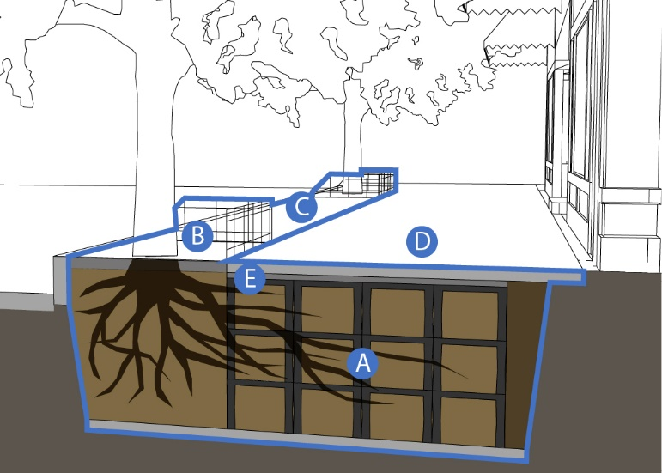
Modular suspended pavement system filled with planting soil that supports concrete sidewalk and aggregate base while allowing tree root growth and stormwater infiltration. The diagram above shows a system that provides 1,000 cubic feet of soil volume (5 feet deep, 10 feet wide, and 20 feet long).
Soil pit protected by tree guard fencing or permeable rubber mulch walking surface.
Permeable paving strip, over modular suspended pavement system
Concrete sidewalk and aggregate base
Edge restraint between aggregate base and tree pit opening

- Public Seating. (Also applies to Street Enhancement Zone, Furnishing & Utility Zone, Public Frontage Zone, and Building Frontage Zone).
- Public seating is an essential component of Burlington’s public realm. It should be provided whenever possible. Public seating can take a variety of shapes including chairs, benches, seating walls, or low tables.

FIGURE 27. ILLUSTRATIVE EXAMPLES OF PUBLIC SEATING
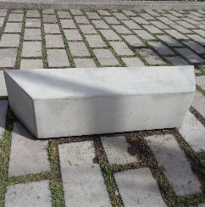 | 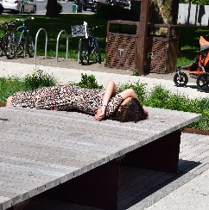 | 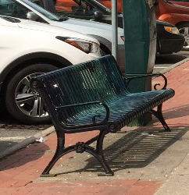

- Any seating within the Street Enhancement Zone (e.g. in a curb extension), the Furnishing & Utility Zone, or the Public Frontage Zone will be considered public seating. Public seating must be available for public use and must comply with the standards in this section.
- Providing public access to seating in the Building Frontage Zone is encouraged. Seating in the Building Frontage Zone must comply with the standards in this section.
- Public seating must be sited according to the following design standards:
          - Public seating must not be placed where it would narrow the Pedestrian Throughway below the required minimum width.
          - Public seating must not be placed where it would obstruct access to a building entrance or exit.
          - Public seating must not be placed where it would obstruct access to bicycle parking, informational kiosks, fire hydrants, trash receptacles, or other street furniture.
          - Public seating must be permanently affixed to the ground. Moveable furniture may be acceptable within the public realm if a responsible party agrees to maintain the moveable furniture in good working order, remove it at night and during snow emergencies, and replace it as necessary.
          - The following ADA clear widths must be maintained when installing public seating:
            - Three (3) feet minimum on either side of the seating.
            - Five (5) feet minimum from fire hydrant.
            - One (1) foot minimum from any other amenity, utility, or fixture.
- Public seating should be sited according to the following design guidelines:
          - Site benches to provide views, preferably of people walking by.
          - Provide seating in a variety of micro-climates. Locate some seating where there is summer shade, preferably from street trees. Locate other seating where it will be warmed by winter sun, especially adjacent to surfaces that will hold that heat, like stone or brick walls.
          - Maintain adequately spaced pathways from parked cars and loading zones.
          - Where possible, provide one (1) foot between the front of the bench and any Throughway so that the legs of people sitting on the bench do not obstruct the Throughway.
          - Where the back of the seat abuts a building, wall, or other obstruction, a 1 foot minimum clear width should be provided for maintenance and trash removal.
FIGURE 28. PUBLIC SEATING ORIENTATION
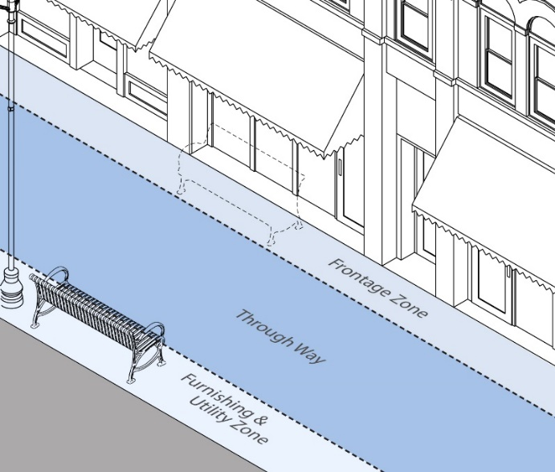 | 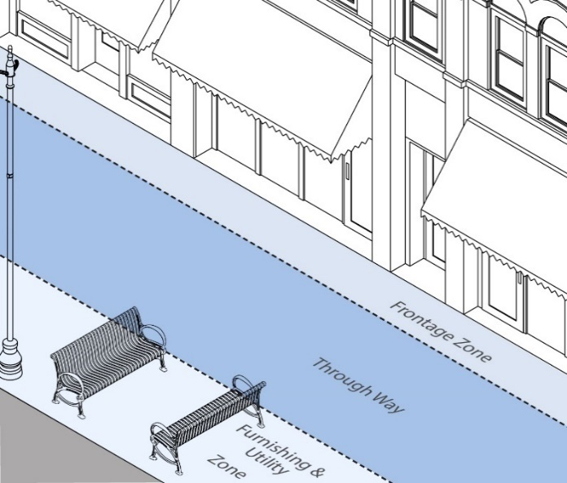

- Public seating should generally be oriented so that it faces the nearest Throughway zone. When two or more seats are arranged facing each other, the benches may be oriented perpendicular to the Throughway Zone. When public seating is adjacent to a bus stop, it should face the bus stop, and be located to the right of the front door loading zone.
- Seating should be provided both with and without armrests if possible. Armrests provide stability for those who require assistance sitting and standing. Seating without armrests allows a person in a wheelchair to maneuver adjacent to seating or to slide onto it easily. Seating areas longer than 4 feet should provide armrests or other dividers to discourage reclining.

- Bicycle Parking. (Also applies to Street Enhancement Zone, Furnishing & Utility Zone, Public Frontage Zone, and Building Frontage Zone).

FIGURE 29. BICYCLE PARKING DESIGN STANDARDS
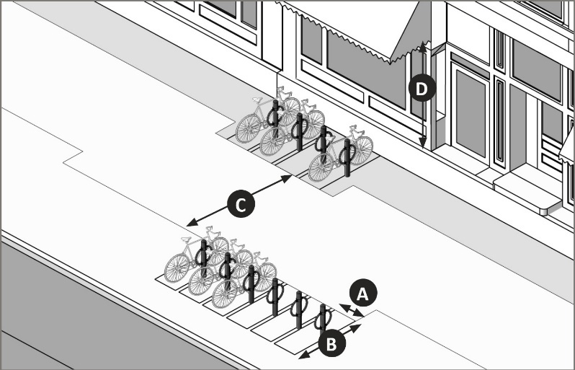
 | Minimum space between bicycle racks | 2.5 feet on center if arranged side-by-side; 8 feet if arranged end-to-end
 | Minimum length of space | 6 feet
 | Minimum Pedestrian Throughway adjacent to bicycle parking | 5 feet
 | Minimum clear height above bicycle parking space | 7 feet

- The following list sets out the Town’s preferred locations for bicycle parking from most preferred location to least preferred location: the Furnishing & Utility Zone, the Street Enhancement Zone, the Public Frontage Zone, the Building Frontage Zone, beside a building, behind a building.
- Installation of a bicycle rack within the public realm requires Town approval from the Board of Selectboard.
- Driveway and Alley Crossings.
- A driveway or alley that crosses a paved Furnishing & Utility Zone must be designed to maintain the grade and clear width of the adjacent Pedestrian Throughway and must include sloped flares on both sides of the driveway apron.
- A driveway or alley that crosses a continuously planted Furnishing & Utility Zone must be designed to maintain the grade and clear width of the adjacent Pedestrian Throughway and must include returned curbs.

FIGURE 30. DRIVEWAY AND ALLEY CROSSING DESIGN STANDARDS
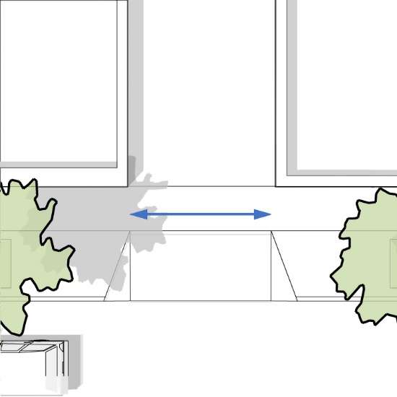 | 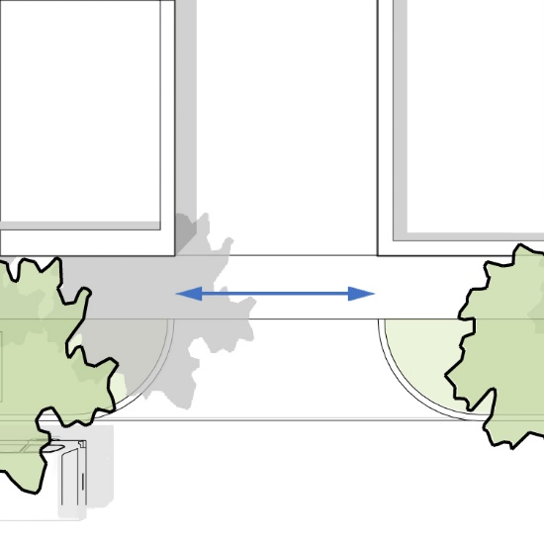
Driveway Apron with Sloped Flares | Driveway Apron with Returned Curbs

- The appearance of any walkway (i.e. scoring pattern or special paving) must be maintained across any driveway or alley to indicate that, although a vehicle may cross, the area traversed by a vehicle remains part of the sidewalk.
- A curb cut may be no wider than the driveway or vehicular entrance it serves, excluding flares or returned curbs. Additional curb cut standards may be established for individual zoning districts.
- Shared driveways are permitted and encouraged.

14.11 PEDESTRIAN THROUGHWAY ZONE
FIGURE 31. PEDESTRIAN THROUGHWAY ZONE
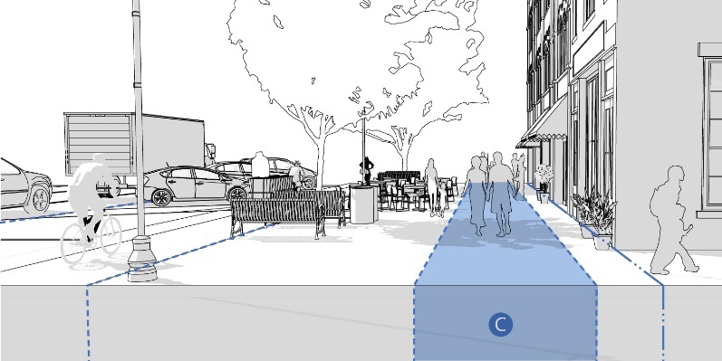

- Description. The Pedestrian Throughway Zone is also known as the sidewalk. It is the primary portion of the sidewalk used for active movement and travel by pedestrians. The Pedestrian Throughway Zone must be of an adequate width for comfortable two-way pedestrian movement, must remain clear of obstacles, and its paving surface must be relatively level.
- Width. The required width of the Pedestrian Throughway Zone must be in accordance with the appropriate Street Type found in Section 14.10.
- Accessibility. All new and reconstructed sidewalks must be accessible to and usable by persons with disabilities in accordance with the Americans with Disabilities Act and the Rules and Regulations of the Massachusetts Access Board (521 CMR), as amended.
- Construction. Pedestrian Throughways (sidewalks) must be constructed of cement concrete that is 4 inches deep. Where a driveway crosses a sidewalk, the sidewalk’s cement concrete must be 6 inches deep.
- Pavement. The pavement design of Pedestrian Throughways must be continuous for the full length of each block face.

FIGURE 32. PEDESTRIAN THROUGHWAY DESIGN STANDARDS
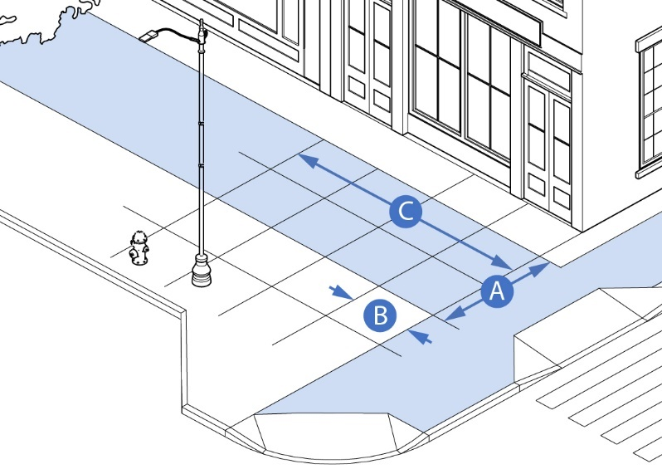
 | Minimum Width | Per Street Type
 | Control Joint Maximum Spacing | One (1) Control Joint per 5 feet
 | Expansion Joint Maximum Spacing | One (1) Expansion Joint per 25 feet. Wherever possible, align control and expansion joints with boundaries between sidewalk zones and facade segments.

SIGN REGULATIONS
Building and site signs shall comply with the rules and regulations in Section Article XIII. The specific type of permitted signs and related design standards in Section 7.2.5, Tables 1-10 shall be applicable as identified in each of the MIX District.

RESIDENTIAL DENSITY STANDARDS

- Base Residential Density.
Residential buildings and developments within MIX District shall be subject to the following density standards in Figure 33 below. Density bonuses for qualified public benefit improvements may be achieved under the criteria in Section 14.12.C. below.

FIGURE 33. RESIDENTIAL DENSITY BY ZONING DISTRICT
BUILDING TYPES | BY RIGHT/SPECIAL PERMIT UNITS PER ACRE
BUILDING TYPES | MIX | MIXSD
Single Family and Duplex | Not Allowed | 15 D.U./Acre by Right
Rowhouse/Townhouse | 15 D.U./Acre by Special Permit | 15 D.U./Acre by Right
Multi-Family Building | 15 D.U./Acre by Special Permit | 15 D.U./Acre by Right
Mixed-Use Buildings | 15 D.U./Acre by Special Permit | 15 D.U./Acre by Right

- Affordability Requirements.
- Number of Affordable Units. The base requirement for affordable dwelling units in any residential development in the MIX District and MIX MU Subdistrict is 20% of all dwelling units constructed. Where the total units result in a fractional dwelling unit less than 0.5, the applicant may either provide an eligible dwelling unit or make a contribution to the Town of Burlington for affordable housing purposes in an amount sufficient to construct that fraction of an eligible dwelling unit, net of the dwelling unit’s restricted resale price, as determined by the Planning Department. Where this calculation results in a fractional dwelling unit greater than .05 the applicant must provide an affordable dwelling unit to site.
- Qualified Affordable Units. Affordable units constructed under this provision shall be sold or rented to households with incomes at or below 80 percent for for-sale housing and 60 percent for rental housing of the Median Regional Household Income (as determined by the U.S. Department of Housing and Urban Development (HUD) as amended and adjusted for family size and shall be restricted to sales prices or monthly rents that are affordable to such households. The sales price or monthly rent shall, in all instances, be such that the dwelling unit qualifies as a local initiative unit under the Commonwealth's Local Initiative Program (LIP) and meets the requirements of a subsidized housing unit for the purposes of listing in the Town's subsidized housing inventory under G.L. c. 40B Sec. 20-23.
- Density Bonus Requirements.

- General Requirement. The Planning Board may, by special permit, may allow higher density up to the maximum established on Figure 34 below if certain Public Benefit Improvements are made by the applicant that provide benefits to residents and businesses in the Development Tract, the MIX District, and surrounding area. If sufficient Public Benefit Improvements are made, the Planning Board shall make a written finding that the applicant will provide significant improvements providing a public benefit, in addition to those improvements necessary to meet the base density requirements of this bylaw. A development agreement shall be required between the Town and the applicant, and the Town may establish a Community Benefit Fund for the purpose of implementing improvements within the MIX District.
FIGURE 34. PUBLIC BENEFIT TYPE AND BONUS SCHEDULE
PUBLIC BONUS TYPE | LEVEL OF BONUS
Public/Publicly Accessible Open Space Improvements or Facilities | 30 D.U./Acre
LEED Certification or Similar Sustainable Rating System | 20 D.U./Acre
Affordable Housing (Above Required Amount) | 30 D.U./Acre
TMOD/Transportation Improvement Plan (REMOVE?) | 30 D.U./Acre

- Approval of Density Bonus Improvements. The Planning Board shall be under no obligation to grant a density bonus and may determine, in its sole discretion, whether the offered improvements are sufficient in nature, scope, cost or otherwise, to justify such a bonus. The offer and commitment by an applicant to provide all or any number of Public Benefit Improvements does not, in and of itself, require the Planning Board to grant such a density bonus. In order to make this determination, the following are required:
- The applicant shall provide the Planning Board with a written description of the intended improvements, the public benefit provided, significance to the Town, provision for maintenance if required, applicant’s cost estimates, and a sketch plan showing the location and type, size and extent of improvements.
- The Planning Board may require a bond to cover the cost of any Public Benefit Improvements that will be constructed, or a binding agreement approved by Town Counsel, to remain in place until the improvements are completed to the satisfaction of the Town.
- A specific time frame for the completion of all required off-site Public Benefit Improvements shall be incorporated as a condition of approval of the Planning Board.
- The applicant shall provide a list of all permits and approvals required relating to any proposed Public Benefit Improvements with the application. These approvals shall be obtained prior to approval of the development, unless an exception for good cause is explicitly authorized by the Planning Board.

DESIGN WAIVERS AND SPECIAL PERMIT CRITERIA
- Purpose. A design waiver allows a specifically authorized type of exception from the provisions governing development in the MIX District and MIX MU Subdistrict pertaining to General Standards in Section 14.3, Building Types in Section 14.4, Site Development Standards in Section 14.5, Outdoor Amenity Space in Section 14.8, Public Realm Standards in Section 14.8, Complete Streets Standards in Section 14.10.

- Review Criteria. In addition to the criteria in Section 9.2.0, and by special permit, the Planning Board may authorize a design waiver where authorized in a particular section of this bylaw upon making positive findings under the following criteria:
- Consistency with the general purpose and goals of the 128 Master Plan and Town Comprehensive Plan;
- Consistency with any waiver eligibility requirements, as indicated in Section 14.13.A above;
- Such relief shall not result in substantial detriment to the MIX district or surrounding neighborhoods;
- Adequacy and safety of traffic flow, access, parking, and loading;
- Adequacy of utilities and other public services;
- Positive impacts on pedestrian comfort and safety including streetscape enhancements and outdoor amenity spaces;
- Positive fiscal impact, including impact on municipal services, tax base, and employment; and
- Social, economic, or community needs are served by the waiver.

- Other Special Permits. All special permits authorized under this Article IV: Use Regulations shall be subject to the criteria of Section 14.13.B
- Conditions. The Planning Board may attach supplemental conditions and/or limitations that it deems necessary in order to ensure compliance with the findings and/or standards for the specific special permit requested.

