MIXED USE INNOVATION DISTRICT
FORM-BASED ZONING AMENDMENTS

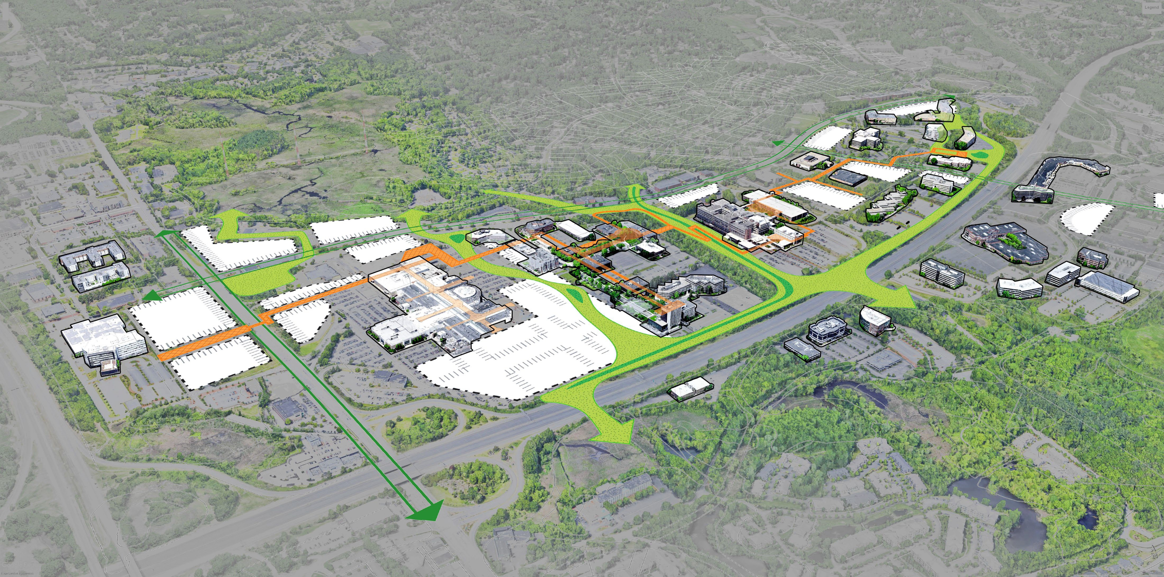

Town of Burlington, MA
Mall Road Advisory Committee
Burlington Redevelopment Authority
Brovitz Community Planning & Design
Dodson & Flinker Associates

August 23, 2023

MIXED USE INNOVATION DISTRICT (MIX)
PROPOSED ZONING AMENDMENTS

ARTICLE II. DEFINITIONS

See New Definitions in Article II

ARTICLE III. DISTRICTS

SECTION 3.1.0. DISTRICTS

Add Amendment to Section 3.1.0.
Other Districts
Mixed Use Innovation District (MIX)
Mixed Use Innovation Sub-District (MIXSD)
ZONING MAP

Add New Regulating Plan/MUID Zoning District:
Mixed Use Innovation District (MIX)
Mixed Use Innovation Sub-District (MIXSD)

ARTICLE IV. USE REGULATIONS

USE REGULATION SCHEDULES

Amend Use Regulation Tables as follows:
Section 4.2.0 Principal Use Regulation Schedule
ADD COLUMNS for the “Mixed Use Innovation District (MIX)” and permitted uses by right and special permit, and prohibited uses in each district; and add column for “Special Regulations” as set forth in the Amended Table of Uses attached hereto.
Section 4.3.0 Accessory Use Regulation Schedule
ADD COLUMNS for the “Mixed Use Innovation District (MIX)” and permitted uses by right and special permit, and prohibited uses in each district; and add column for “Special Regulations”, as set forth in the Amended Table of Uses attached hereto.
Section 4.4.0 Permitted Uses in the Wetlands District
ADD COLUMNS for the “Mixed Use Innovation District (MIX)” and permitted uses by right and special permit, and prohibited uses in each district; and add column for “Special Regulations”, as set forth in the Amended Table of Uses attached hereto.

ARTICLE V. DIMENSIONAL REQUIREMENTS
AMEND Section 5.2.0. DENSITY REGULATION SCHEDULE by adding the Mixed Use Innovation District to the table.

ARTICLE XIII. SIGN REGULATIONS
AMENDED SIGN BYLAW IN PROGRESS

ARTICLE XIV. MIXED USE INNOVATION DISTRICT (MIX)
SEE NEW BYLAW

PLANNING BOARD RULES & REGULATIONS - DESIGN GUIDELINES
NEW MIX DESIGN GUIDELINES IN PROGRESS

