Planning Board
Procedural Rules & Regulations

Mixed Use Innovation District (MIX)
Design Standards & Guidelines

DRAFT 1.0 - OCTOBER 2023

Effective ___________
Pursuant to Mass. General Laws, Ch. 40A, Sec. 9

By the Planning Board of the Town of Burlington, Massachusetts

Filed with the Town Clerk _________.

TABLE OF CONTENTS

  - PURPOSE AND APPLICABILITY
    - PURPOSE AND INTENT……………………………………………………………………………………………………………………1
    - PRINCIPLES IN PRACTICE. ………………………………………………………………………………………………………………1
    - SUMMARY OF SUSTAINABLE DEVELOPMENT ELEMENTS.………………………………………………………………1

  - ADMINISTRATION
    - PRE-APPLICATION REVIEW. ……………………………………………………………………………………………………………1
    - APPLICATION FOR DEVELOPMENT. ………………………………………………………..………………………………………1
    - COMPLIANCE ALTERNATIVES. ……………………………………………….….……………………………………………………1

  - SITE DEVELOPMENT
    - APPLICABILITY. …………………….…………………………….………………….……………………………………………………1
    - PRINCIPLES IN PRACTICE….………………………………………………………….………..……………………………………1
    - DEVELOPMENT FORMS, PURPOSE, AND INTENT. …………………………………………………….…………………1
    - GENERAL SITE IMPROVEMENTS AND DESIGN STANDARDS. ………………………………….……………………1
    - SITE ACCESS AND CONNECTIVITY. ………………………………………………………………………………………………1
    - INTERNAL SITE CIRCULATION.………………………………………………………………………………………………………1
    - PARKING………………………………………………………………………………………………………………………………………1
    - OPEN SPACE…………………………………………………………………………………………………………………………………1
    - OUTDOOR AMENITY SPACE TYPES AND STANDARDS.…….……………………………………………………………1
    - SITE FURNISHINGS. ………………………………………………………….…………………………………………………………1
    - LANDSCAPE AND STREETSCAPE. …………………………………………………………………………………………………1
    - TRANSITIONAL BUFFERS. ……………………………………………………………………………………………………………1
    - SITE LIGHTING. ………………………………………………………………………..…………………………………………………1
    - SUSTAINABLE DESIGN…………………………………………………………………………………………………………………1

  - BUILDING TYPES AND DEVELOPMENT STANDARDS
    - BUILDING TYPES…………………………………………………………….……………………………………………………………1
    - ARCHITECTURAL STANDARDS AND GUIDELINES…………….……………………………………………………………1
    - RESTORING AND REPURPOSING HISTORIC STRUCTURES. ……………………………………………………………1
    - SUSTAINABLE BUILDING MATERIAL AND APPLICATIONS.…….………………………………………………………1
    - BUILDING LIGHTING……………………………………………………………………………………………………………………1

  - SITE AND BUILDING SIGN STANDARDS
    - SIGN STANDARDS AND GUIDELINES……………………………….……………………………………………………………1

  - COMPLETE STREETS STANDARDS
    - PURPOSE………………………………………………………………………..……………………………………………………………1
    - APPLICATION………………………………………………………………….……………………………………………………………1
    - STANDARDS FOR ALL THOROUGHFARES………………………………………………………………………………………1
    - STREET TYPES AND DESIGN ALTERNATIVES…………………….……………………………………………………………1
    - VEHICLE THROUGHWAY ZONE.………………………………………….…………………………………………………………1
    - BICYCLE TRAVEL FACILITIES…………………………………………….……………………………………………………………1
    - CROSSWALKS.…………………………………………………………….…………………………………………………………………1
    - STREET ENHANCEMENT ZONE………………………………………………………………………………………………………1
    - FURNISHING & UTILITY ZONE…………………………………………………………….…………………………………………1
    - PEDESTRIAN THROUGHWAY ZONE…………………………………..……………………………………………………………1
    - BUILDING FRONTAGE ZONE……………………………………………..……………………………………………………………1

  - PUBLIC REALM ACTIVATION STANDARDS
    - PURPOSE………………………………………………………………………….……………………………………………………………1
    - APPLICATION…………………………………………………………………..……………………………………………………………1
    - PUBLIC REALM INTERFACE……………………………………………….……………………………………………………………1
    - INFORMAL ACTIVATION APPLICATIONS.…………………………………………………………………………..……………1

FIGURES
FIGURE 1. MIX GENERAL CONCEPT PLAN (2021)
FIGURE 2. DEVELOPMENT REVIEW PROCESS
FIGURE 3. SITE DEVELOPMENT BEST PRACTICES
FIGURE 4. EXAMPLES OF PEDESTRIAN ACCESS
FIGURE 5. ILLUSTRATIVE EXAMPLES OF SITE CIRCULATION
FIGURE 6. PARKING PLACEMENT, ACCESS, AND LANDSCAPING
FIGURE 7. STRUCTURED PARKING ACTIVATION
FIGURE 8. STRUCTURED PARKING ACTIVATION
FIGURE 9: SPECIAL PARKING TYPES
FIGURE 10. ILLUSTRATIVE EXAMPLES OF PARKING PLACEMENT AND DESIGN
FIGURE 11: OUTDOOR AMENITY SPACE TYPES AND DESIGN STANDARDS
FIGURE 12. ILLUSTRATIVE EXAMPLES OF LANDSCAPE AND STREETSCAPE DESIGN
FIGURE 13. TRANSITIONAL BUFFERS
FIGURE 14. SUSTAINABLE BEST PRACTICES
FIGURE 15. MIX DISTRICT BUILDING TYPES
FIGURE 16. FRONTAGE ZONE BUILDING COMPONENTS
FIGURE 17. ILLUSTRATIVE EXAMPLES OF ARCHITECTURAL APPLICATION
FIGURE 18. ILLUSTRATIVE EXAMPLES OF SUSTAINABLE BUILDING APPLICATIONS
FIGURE 19. ILLUSTRATIVE EXAMPLES OF SIGN DESIGN
FIGURE 20A. COMPLETE STREET TYPES AND DESIGN OPTIONS
FIGURE 20B. COMPLETE STREET TYPES AND DESIGN OPTIONS
FIGURE 21. COMPLETE STREET ZONES AND COMPONENTS
FIGURE 22. PEDESTRIAN CROSSWALK DESIGN STANDARDS
FIGURE 23. STREET ENHANCEMENT ZONE
FIGURE 24. CURB EXTENSION DESIGN STANDARDS
FIGURE 25. FURNISHING & UTILITY ZONE
FIGURE 26. STREET TREE PLANTER DESIGN STANDARDS
FIGURE 27. RECOMMENDED ELEMENTS OF A MODULAR SUSPENDED PAVEMENT SYSTEM
FIGURE 28. PUBLIC SEATING PLACEMENT AND ORIENTATION
FIGURE 29. ILLUSTRATIVE EXAMPLES OF PUBLIC SEATING
FIGURE 30. BICYCLE PARKING DESIGN STANDARDS
FIGURE 31. DRIVEWAY AND ALLEY CROSSING DESIGN STANDARDS
FIGURE 32. PEDESTRIAN THROUGHWAY ZONE
FIGURE 33. PEDESTRIAN THROUGHWAY DESIGN STANDARDS
FIGURE 34. BUILDING FRONTAGE ZONES
FIGURE 35. PUBLIC REALM ACTIVIATION COMPONENTS
FIGURE 36. BUILDING FRONTAGE ZONE AND PUBLIC REALM INTERFACE APPLICATIONS

ADDENDUMS
- Request for Waivers Form
- Alternative Compliance Request Form

  - PURPOSE AND APPLICABILITY

    - PURPOSE AND INTENT.

The Burlington Planning Board adopted these Design Standards & Guidelines on (_______________) in accordance with MGL Chapter 40A to supplement the site plan and special permit development review process as part of the Planning Board Rules and Regulations. These Design Standards and Guidelines are intended to be used by the Planning Board for all eligible development projects in the Mixed Use Innovation District (MIX) under the Burlington Zoning Bylaw, Article IX – Administration and Procedures.

The Planning Board’s intention in adopting the MIX Design Standards & Guidelines is to maintain and/or improve the quality of life for Burlington residents, the value of property, and the viability of commerce districts using context-based design and sustainable development practices. The Design Standards & Guidelines and review process encompasses a range of topics and elements of site planning and design. This requires the collaboration of multiple disciplines and perspectives such as community planning, urban design, architecture, landscape architecture, civil engineering, and resource management to achieve meaningful, economically viable, environmentally sustainable, and aesthetically pleasing development.

The purpose of the Design Standards & Guidelines is to establish the minimum requirements and expectations for the quality of design for development in the MIX District. Applicants are encouraged, but not required, to achieve beyond the scope of these Design Standards & Guidelines in each category.

Any development that requires Site Plan or Special Permit approval administered by the Planning Board is required to follow the Design Standards & Guidelines. Adherence to the Design Standards & Guidelines helps applicants to achieve approval and may accelerate the review process. The standards also establish a framework for site plan review by the Planning Board.

    - PRINCIPLES IN PRACTICE.

These guiding principles reflect Burlington’s goals and aspirations for a sustainable community today and for future generations. They are consistent with the Burlington 128 District Concept Plan and Report (2022), Burlington Comprehensive Plan (2022), Burlington Housing Needs Assessment (2022), Burlington Complete Streets Policy and Streetscape Design Guidelines (2020), Burlington Open Space & Recreation Plan (2019), and Burlington Hazard Mitigation Plan (2016).

    - Sustainable Growth and Development. Development projects should strive to address the highest ecological principles by protecting and enhancing the overall health, natural environment, and quality of life in Burlington. Conservation and sustainable use of natural resources shall be prioritized. Protection of natural and working lands from air, water, light, and land pollution should be prioritized. Both site design and construction of buildings should result in efficient use, reuse, and recycling of resources, including energy, water, and construction materials. The Planning Board highly favors projects that intend to seek certification under the Leadership in Energy and Environmental Design (LEED) Green Building Rating System, the LEED-Neighborhood Development Rating System™, and other sustainable design rating systems. Low Impact Development (LID) techniques should be used to reduce the concentration of stormwater runoff and maintain existing stormwater flows. Where feasible, bioswales, rain gardens and other bioretention techniques should be employed. Green roofs and rain storage systems are encouraged in order to reduce and reuse roof drainage.

    - Compact Development and Human Scale Design. The Planning Board encourages compact development to promote a more efficient use of land, reduce dependency on personal vehicles for travel, and reduce the costs of providing public infrastructure and services. Development should be designed for the human scale, considering the relationship between the dimensions of the human body and the proportion of traveled ways, public spaces, and buildings. Site design should consider how various site features enhance pedestrian mobility, safety, comfort, enjoyment, and walking distance to other off-site amenities. The design of buildings, streetscapes, signs, open spaces, and other site attributes should be determined based on creating a pleasant environment for the pedestrian.

    - Mixed Uses and Flexible Building Space. Designated areas of the MIX District where mixed-use development is allowed should include a mixture of residential, commercial, and civic uses at a scale appropriate for the community. Mixed use development can be an important sustainability tool in the MIX district by including a variety of housing types and sizes to accommodate households of a broad range of ages, family composition, incomes, and physical abilities. Mixed use can also reduce personal vehicle use, promote health, and expand economic opportunities. To promote vibrant commercial districts and dynamic neighborhoods, housing may be appropriate adjacent to or above commercial uses such as shops, restaurants, and offices forming a “Live, Work, Play” district.

    - Architectural Context and Adaptive Reuse of Historic Structures. In the MIX District, new buildings should be designed to reflect a compatible mix of traditional and contemporary architecture that reflects the modern technology, innovation, and market trends of a thriving business district while being compatible in within a traditional New England community. Existing historic buildings should be renovated and rehabilitated for adaptive reuse as a first resort if structurally and economically viable.

    - Neighborhood Preservation and Expanded Housing Choices. A broad range of housing choices at moderate density in the MIX District should be provided. Housing provides residents an opportunity to live in close proximity of work and amenities while supporting local business in terms of customers and employment base. Increased housing choices can be incorporated in a variety of development forms such as traditional neighborhood developments, townhouses and rowhouses (attached single family units), multi-family buildings, and mixed-use development. These mixed use developments should also provide a positive transition between commercial/industrial development and surrounding neighborhoods. Convenient pedestrian and vehicular connections should be provided between districts by a network of streets, sidewalks, bikeways, crosswalks, and trails. At the same time residential areas should be protected from unwanted traffic, visual intrusion, and negative impacts to the pace and scale of their environments.

    - Active Open and Civic Space. New developments should contribute to the successive increase in private and publicly accessible open spaces in Burlington. Shared outdoor spaces should be a major element of any development plan. Such spaces should emphasize the retention, restoration, or development of natural areas, planted with native vegetation. Natural spaces reduce heat islands, provide wildlife habitat, and create opportunities for the public to engage in passive recreation. Site planning should emphasize connectivity between natural open spaces, which provide corridors for both humans and wildlife to move from place to place. The type and distribution of Outdoor Amenity Spaces should be coordinated with public facilities such as the Vine Brook Corridor, TRW Field, Marvin Field, Mary Cummings Park, and other existing and future open and civic spaces in and around the MIX District.

    - Quality Landscape and Streetscape Character. Landscaping and streetscaping should be arranged in such a way as to act as a unifying element between buildings, sidewalks, streets, pathways, and public spaces. Special attention should be given to street trees which in general should be located in a green belt between the curb and sidewalk and should be continuous along all primary and secondary streets. Landscaping should complement the scale of a development project and its surroundings. In general, larger, well-placed contiguous planting areas are preferred to smaller, disconnected areas. Open spaces should be integrated throughout a development project with an emphasis on functionality – such as providing a comfortable, shaded place to sit and not simply for aesthetic appeal.

    - Multi-Mobility Transportation Network. An interconnected network of circulation systems that facilitate walking, bicycling, and driving is a sustainability goal in Burlington. Streets should be designed to establish a satisfactory level of service for vehicular travel and promote the safe and efficient use of different transportation modes. A connected street network disburses traffic patterns and creates multiple routes for pedestrians, bicyclists, and motorists. Streets should incorporate “traffic calming” techniques, such as differentiated paving, smaller turning radii, and/or street trees, to slow traffic speed and promote pedestrian safety. New development projects should implement traffic mitigation best practices to enhance walking, bicycling, ride-sharing, car sharing, and public transit as a viable alternative to personal vehicles.

    - Economic Opportunity. New commercial and industrial development should expand and diversify the Burlington economy through new business development and job creation. Sustainable economic development requires flexibility in order to fulfill market opportunity and business diversity while requiring high quality design and development.

FIGURE 1. MIX GENERAL CONCEPT PLAN (2021)
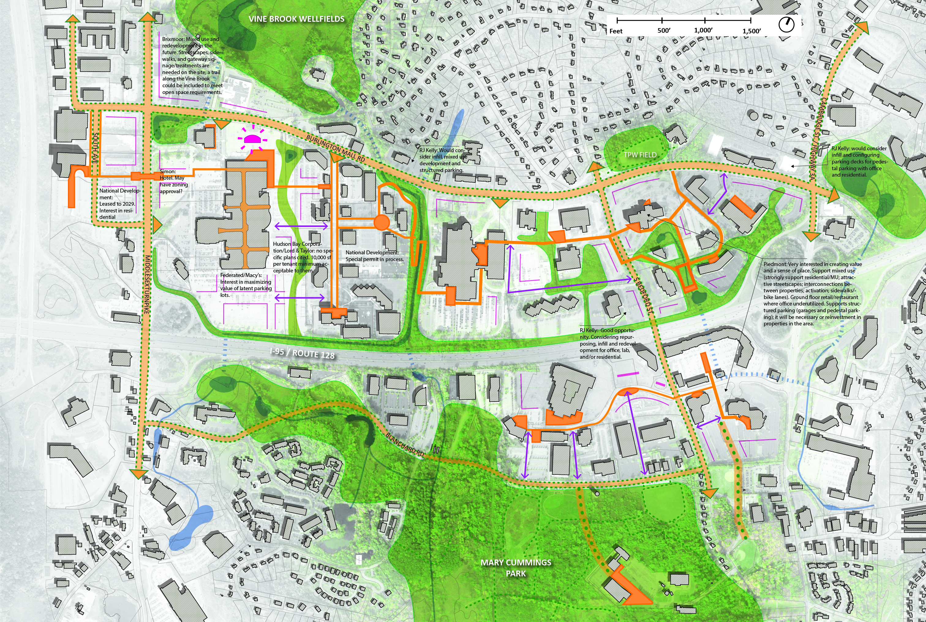

    - SUMMARY OF SUSTAINABLE DEVELOPMENT ELEMENTS.

The Design Standards and Guidelines contain Private Realm and Public Realm components. For example, Private Realm design standards address site access, parking placement, landscaping and screening, stormwater management, building placement, frontages and façade treatments, outdoor amenity spaces, and other site design components. Public Realm design standards address street design, streetscape treatments, on-street parking, pathways, utilities, and related elements.

In any vibrant mixed use district, there is a strong, supportive relationship between private development and public spaces such as streets and open spaces. In particular, the transitional areas in pedestrian-oriented districts are critical such as the placement, orientation, and access to buildings in relationship to streets and sidewalks. The Design Standards & Guidelines are intended to reinforce the strong relationship between the Private Realm and Public Realm with the understanding that there’s an investment to be made and benefit to be realized by the developer as well as the Town.

  - ADMINISTRATION

Burlington property owners are strongly encouraged to use the Design Standards & Guidelines when planning and designing potential renovations, redevelopment, or new buildings on their properties. Any significant change to an existing building or property will likely require site plan review with the Planning Board. Town staff will review preliminary plans and applications for compliance with the Burlington Zoning Bylaws and consistency with these Design Standards & Guidelines prior to submitting a formal application. Once a formal application is submitted, Town staff will review the plans and prepare a report with recommendations for Planning Board consideration.

    - PRE-APPLICATION REVIEW. Applicants are required to meet with town staff within 30 days prior to submitting a formal development application to the Planning Board and its formal review. During the pre-application phase, both site and building designs can be discussed as they relate to the Design Standards & Guidelines. The objective is to provide an open discussion and a mutual understanding of both the development opportunities and challenges posed by a particular site and development program. This type of dialogue can enhance the efficiency of the approval process and outline design directions that are mutually beneficial to the Town and applicant. At any point in the process, the Burlington Planning Department is available for permitting guidance and assistance.

    - APPLICATION FOR DEVELOPMENT. Development review is initiated by the Planning Department upon receipt of a Site Plan or Special Permit Application. The Planning Department will provide an initial review, according to a Design Standards & Guidelines Checklist. This review determines the areas of focus for discussion between the applicant and the Planning Board. The planning staff will present final written recommendations to the Planning Board.

FIGURE 2. DEVELOPMENT REVIEW PROCESS
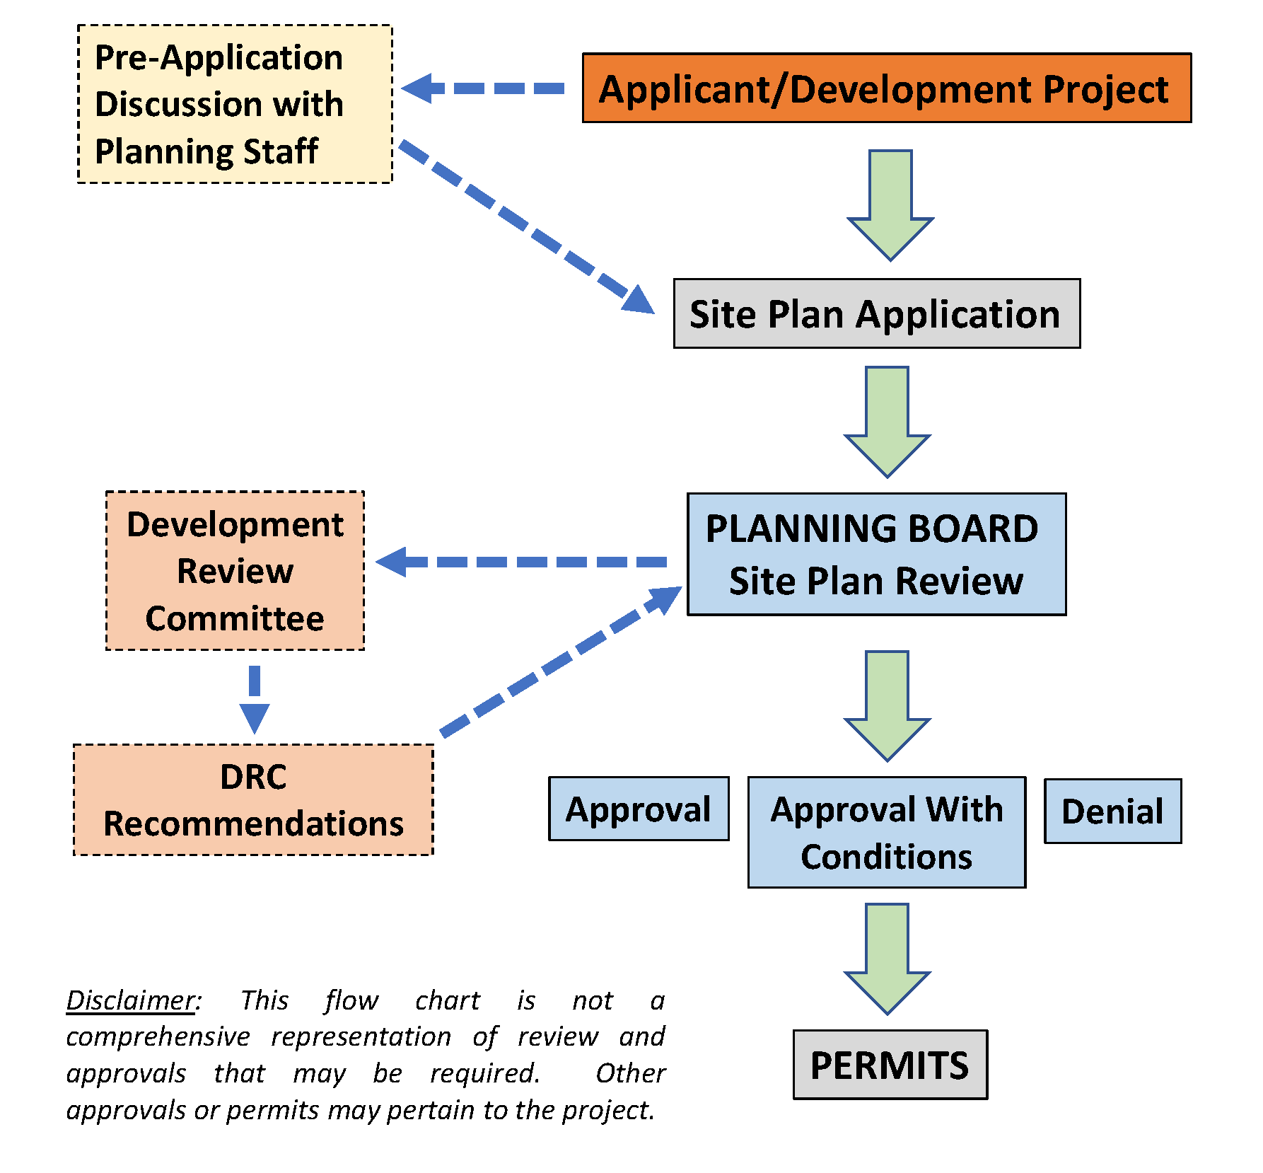
    - COMPLIANCE ALTERNATIVES. It can be difficult for Design Standards & Guidelines to predict all possible site planning and design scenarios, or anticipate new trends, technologies, or best practices. If specific standards and/or guidelines will not be followed by an applicant because they feel a better approach to achieving the Town’s sustainable community principles exist for their development; a compliance alternative may be reached as an agreed upon method to comply with the intention of the Design Standards & Guidelines. This option provides a process to arrive at innovative design solutions that all parties agree will follow the intent of the Design Standards & Guidelines. The applicant must specifically identify the areas in which they seek a compliance alternative with an Alternative Compliance Request Form, and the Planning staff and Design Review Team provides an opinion and recommendation regarding the alternative approach in writing to the Planning Board. Please contact the Burlington Planning Department for further information.
Commentary: Should there be a formal Development Review Committee (DRC) for the purpose of reviewing conceptual or preliminary site plan applications? Maybe representatives of Planning, Economic Development, DPW, Fire, Police, and Selected Boards/committees?

  - SITE DEVELOPMENT

    - APPLICABILITY. These Design Standards & Guidelines are applicable to private developments in the MIX District under the Burlington Zoning Bylaw, Article 14. The Design Standards & Guidelines may also be used to guide municipally sponsored residential development, Chapter 40B Comprehensive Permits, development under MBTA Communities Program, and other residential developments sponsored by non-profit housing and community development organizations.

    - PRINCIPLES IN PRACTICE. The Town of Burlington goal is to ensure that the design and development of new industrial, commercial, residential, and mixed use site plans are of high quality. The combination of a sustainable site layout, quality building design, passive and active outdoor amenity spaces create a vibrant district that benefits residents and the laborforce, provide economic development and tax revenue, and creates a competitive advantage in the regional market. These site development and design standards provide specific requirements and recommendations for residential, commercial, mixed use, industrial development, and publicly open space and amenities.

    - DEVELOPMENT FORMS, PURPOSE, AND INTENT. The purpose of these Design Standards & Guidelines is to promote sustainable, functional, and aesthetically pleasing development within the MIX District. This section provides guidance to landowners, developers, and businesses who currently own or are proposing development in the district and are expected to fulfill the purpose and intent:

- Residential Development.
      - To promote greater diversity and affordability of housing to meet the needs of a diverse population with respect to income, disability and accessibility needs, size of household, and stage of life.
      - To provide incentives for the creation of modestly sized market rate housing units and affordable housing units in accordance with the goals of the Burlington Master Plan and Housing Needs Assessment, recognizing the Town's moral and practical obligation to contribute to a balanced housing stock for all its residents.
      - To promote better access between housing, shops, services, and employment.
      - To encourage less sprawling and more efficient forms of development as an alternative to conventional subdivisions, so as to consume less land, preserve open space, and conform to existing topography and natural features.
      - To encourage the use of sustainable building and landscaping techniques and universal design.
      - To sustain Burlington’s cultural and historical values and to facilitate contextual development that preserves historically or architecturally significant buildings and landscapes, as well as traditional patterns of land use and neighborhood development.
      - To sustain and enhance Burlington’s natural landscapes, including forests, rivers, streams, and ponds.
      - Recognizing that not all of the stated purposes can be achieved in a single development, to nonetheless consider each carefully in approving new developments and to be mindful of the need to further these goals across the MIX District over time.

- Mixed Use, Commercial and Industrial.
- Enhance the relationship and design of buildings, parking, access, landscape, open spaces, site circulation, and the interface with other buildings and properties.
- Create a strong relationship with the “public realm” which are the spaces between buildings and within the public right-of-way including sidewalks, open spaces, landscaping, and streetscapes.
- Ensure opportunity for small to large-scale commercial, industrial, and mixed-use development through a broad range of building types and mixture of uses.
- Encourage a broad range of architecture with compatible diversity and flexibility while fostering high-quality design.
- Incorporate the highest sustainable and ecological best practices through the use of advanced green and healthy building technologies and materials.
- Promote an attractive and pleasant place to work, do business, recreate, eat, shop, learn, be entertained, and visit.

    - GENERAL SITE IMPROVEMENTS AND DESIGN STANDARDS.
The following standards and guidelines outline the site design and layout practices that shall be viewed as baseline components of a well-designed development in the MIX District.
- Create a Sustainable Site Composition. Site planning and design shall provide a responsive approach to the natural conditions of the land and adapt site elements to the attributes and constraints of the property.
- Cluster Site Development Components. The site components such as buildings, parking areas/structures, and outdoor amenity spaces shall be clustered to maintain the maximum amount of natural and undisturbed area on the property, and landscape buffers at property boundaries where necessary.
- Integrate Natural Site Features. The site design should take advantage of the natural site features by maintaining, incorporating, or adapting the inherent characteristics of the property (topography, landscape features and native vegetation, rock formations, stone walls, etc.) to guide and benefit the layout and design of the site.
- Frame Views and Spaces. Site and building layouts should frame purposeful clearings, enhance desirable vistas, and reinforce privacy between buildings.
- Share Open Space. Common open spaces should be used as a design feature in the layout of building clusters.
- Building Placement. For larger-scale development, buildings shall be used to organize the site, reinforce a sense of place, frame open space, and conceal parking and service areas.
- Orient Building to Street and Open Space. Primary building facades should be oriented to street frontages and/or common open spaces that in turn are bordered by interior streets. An alternative pattern is to provide access streets to the rear allowing for building frontage directly onto a common pathway and open space.
- Relate Buildings to Each Other. A development that includes multiple buildings shall orient the buildings to address each other and to frame street frontages and common open spaces. Variation between buildings and the manner in which they frame open spaces should occur to create distinct relationships between buildings and common open spaces.
- Minimize Parking Impacts. Site layout should be designed to minimize the visibility and impact of parking and utility-oriented functions of the property. Buildings should be oriented so that surface parking and garages are concealed in secondary locations and are not the primary visual focus of the development. Parking should be dispersed among buildings by means of smaller surface parking lots, on-street parking, and integrated parking structures where appropriate.
    - Provide Appropriate Streetscaping. Streetscaping within the front setback should visually enhance the public realm, be calibrated to the scale of the space, and complement the aesthetics of the building. High-quality surfaces, furniture, and landscape material should be combined to create beautiful open spaces that engage the pedestrian.
    - Create a Landscape Hierarchy. Development sites should include a hierarchy of landscaping that contributes to the overall site design and integrates with adjacent properties and the public realm of streets, sidewalks, and civic spaces. The hierarchy should include an entry and gateway landscape, buildings landscape, streetscape, and landscape buffers where appropriate.

FIGURE 3. SITE DEVELOPMENT BEST PRACTICES
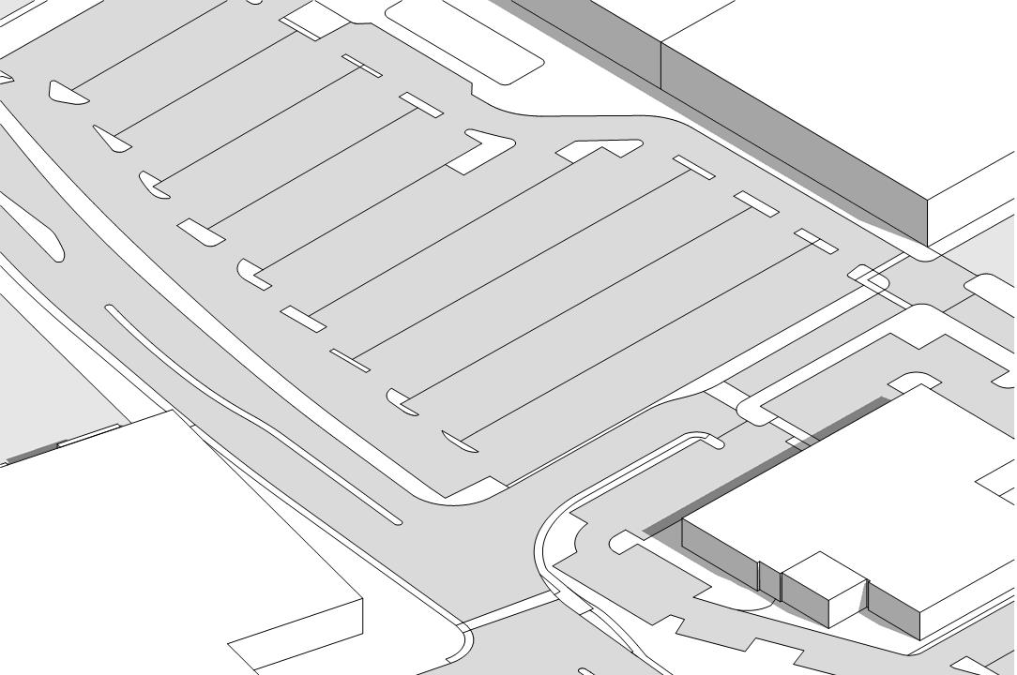 | 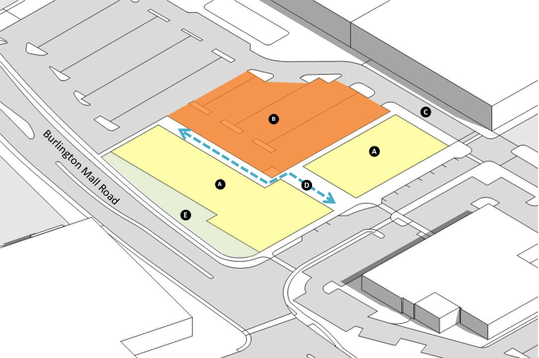
Existing Conditions | A. Building Placement, B. Parking Placement, C. Vehicular Access, D. Pedestrian Connections, E. Public Realm Interface
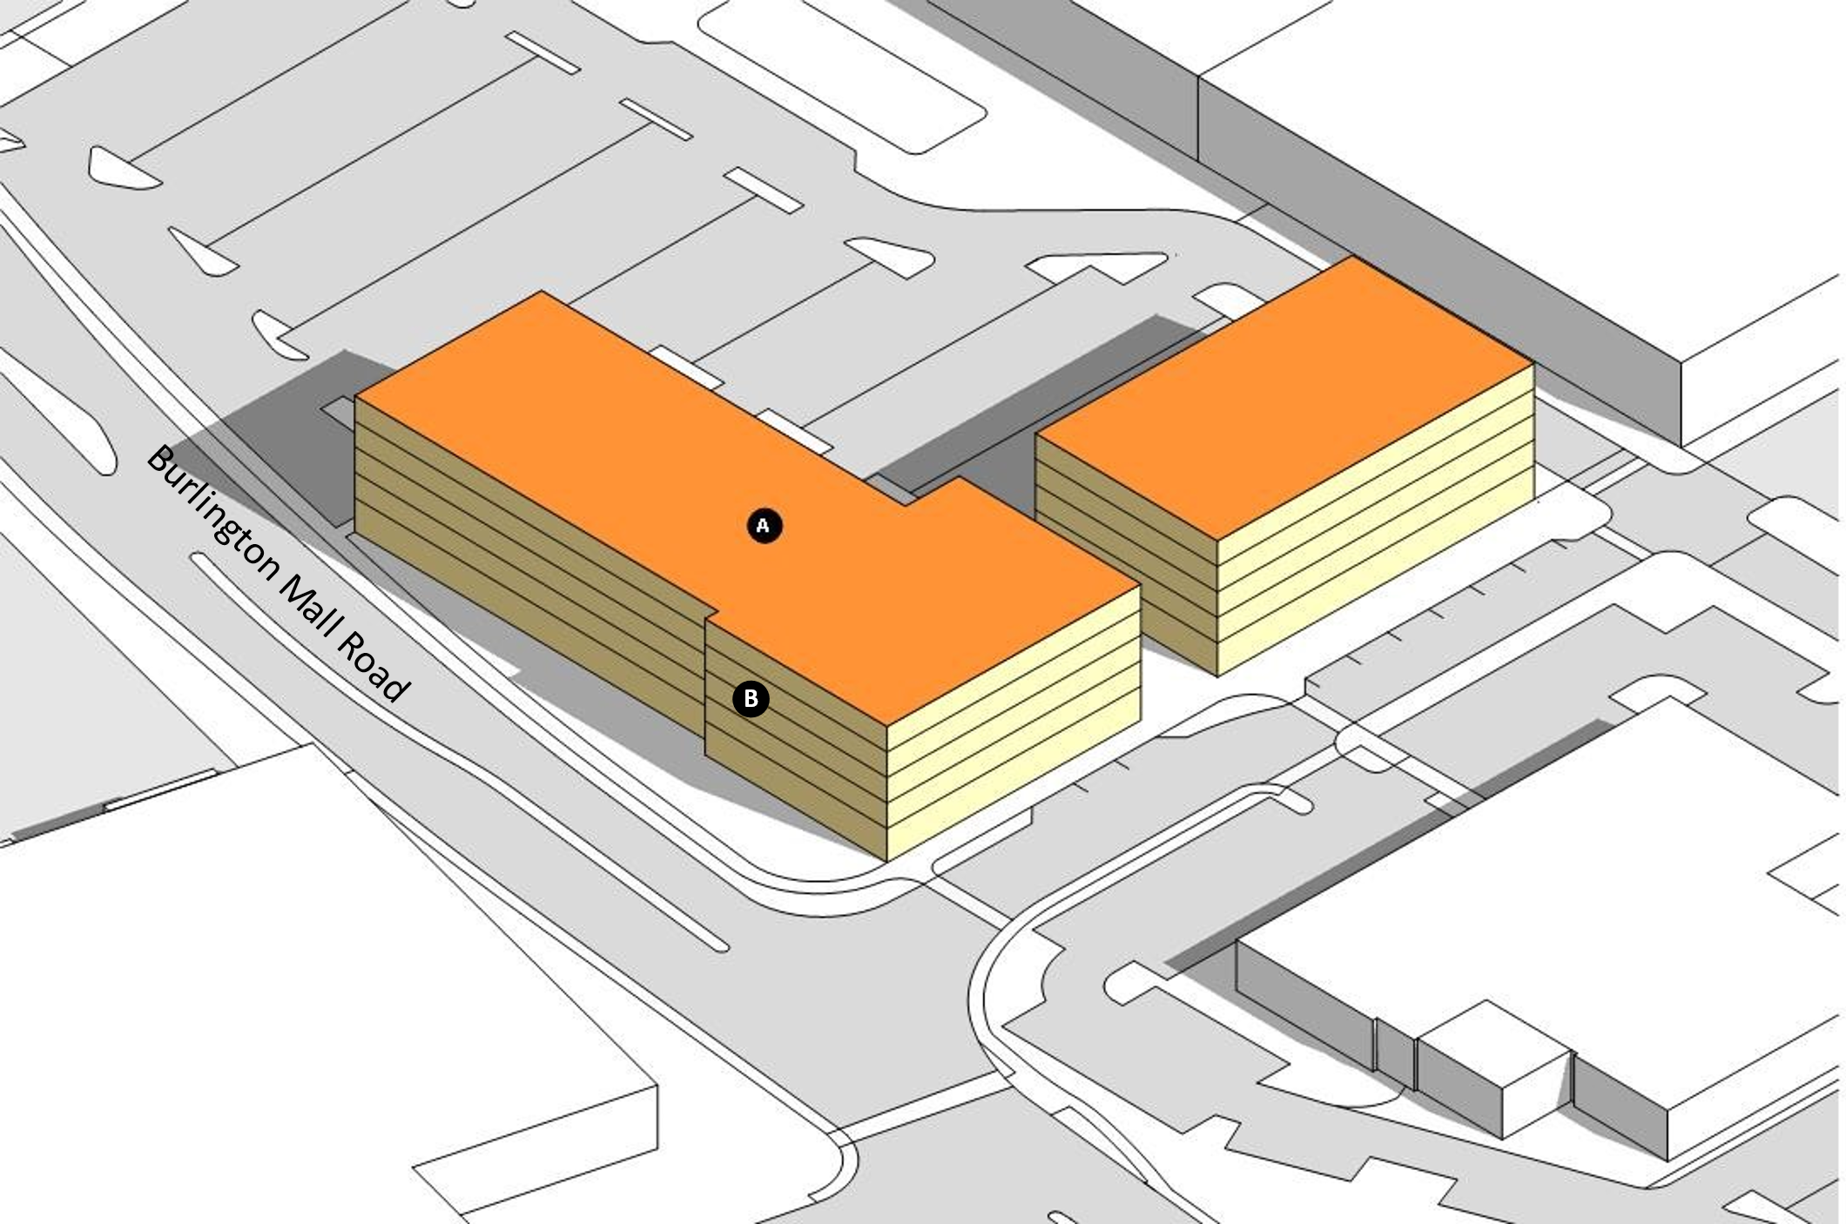 | 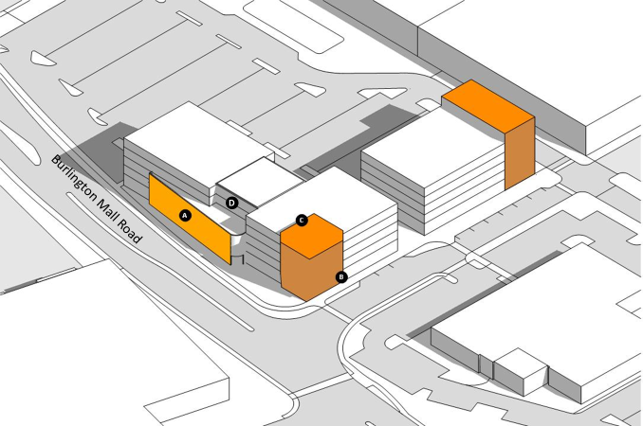
A. Building Height/Stories, B. Building Bulk | A. Façade Articulation, B. Corner Emphasis, C. Height Variation, D. Upper Floor Setback
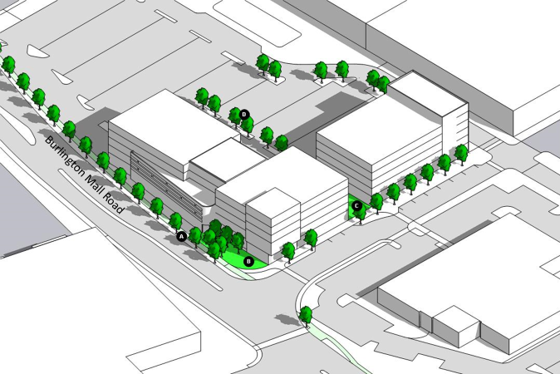 | 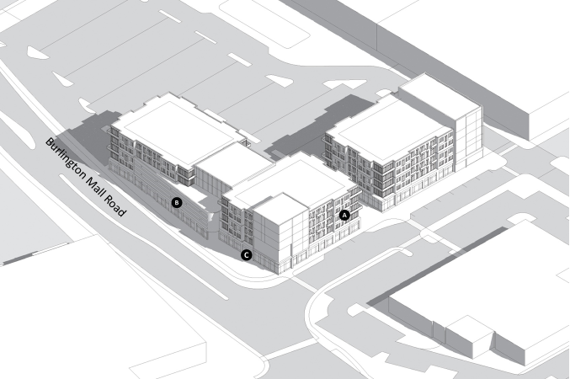
A. Streetscape/Complete Streets, B. Outdoor Amenity Space, C. Ped. Connections, D. Parking Lot Shade Trees, Landscaping, Screening, and LID | A. Fenestration, B. Signage, C. Entrances
    - SITE ACCESS AND CONNECTIVITY.
Site access shall provide clear and legible routes for all modes of transportation including pedestrians, bicycles, vehicles, and public transportation where available. The Complete Streets standards in Section 1.6 emphasize multimodal connectivity between the public street system and internal site circulation systems.
- Access and Mobility. When designing access and parking, developers shall consider pedestrians, cyclists, and transit users well as the automobile. Site access shall provide clear and legible routes for all modes of transportation to connect to the site and to enter internal site circulation systems. Parking should be conveniently located to the building entries while maintaining pedestrian safety, attractiveness, and aesthetics of the site. Attention shall be paid to the appearance of the exterior areas where landscape screening may be appropriate. For specific parking requirements refer to the Parking Regulations in Section 7.2.0 of the Zoning Bylaw.
- Minimize Site Access Points. The number and width of vehicular access points into and out of the site shall be minimized. Where vehicular access drives cross pedestrian routes, pedestrian crossings should be marked and differentiated with variations in paving materials (for example by using stamped concrete or asphalt). Access driveways that cross a public sidewalk should address pedestrian and cyclist safety and located so as not to adversely affect traffic. Refer to Section 1.7 Public Realm Activation of these Design Standards & Guidelines and the Burlington Department of Public Works for additional requirements.
- Connect to Public Frontages. Sidewalks or pathways shall be provided along all internal street frontages and along the perimeter street frontages. Additionally, sidewalks and paths should link street frontages to all building entries.
- Internal Connections. While roads and sidewalks are the primary way people access a site, connections to adjacent buildings and parking areas increase efficiency and remove traffic from the streets and shall be made where appropriate.
- Pedestrian Connectivity. Inviting and efficient sidewalks should be provided along any and all street frontages at the site perimeter. Sidewalks and paths should be provided linking public sidewalks to all building entries, parking areas or structures, and outdoor amenity spaces. Dedicated walkways within the parking area leading to building entrances should be provided for safe and convenient access for pedestrians.

FIGURE 4. EXAMPLES OF PEDESTRIAN ACCESS
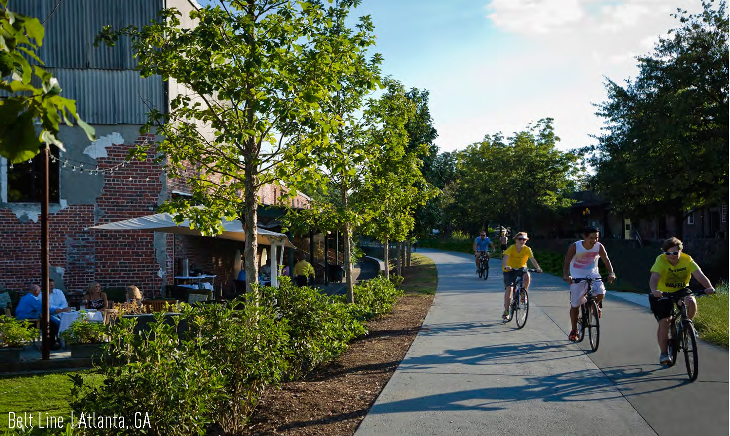 | 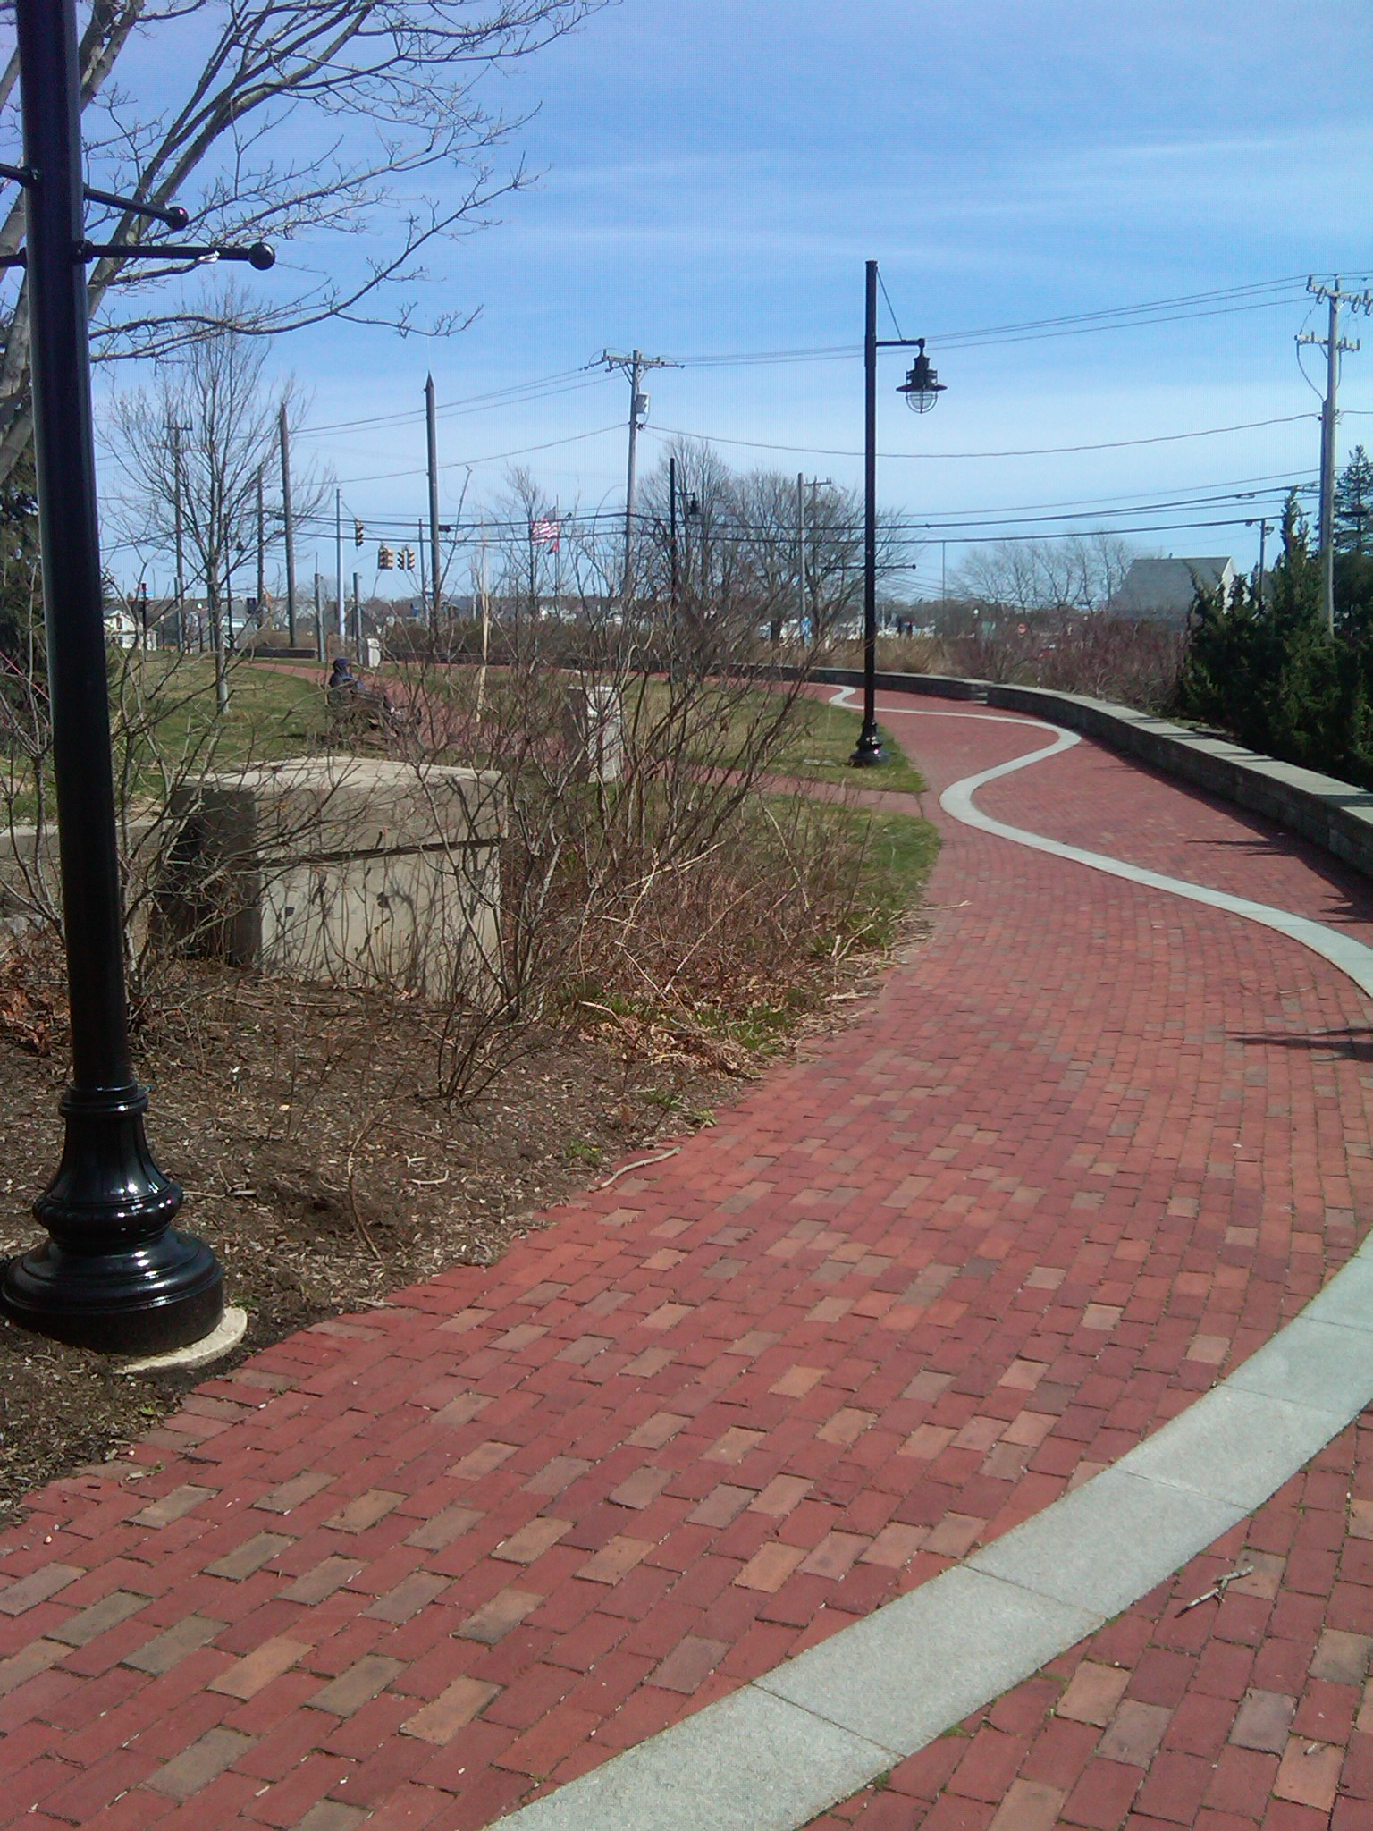 | 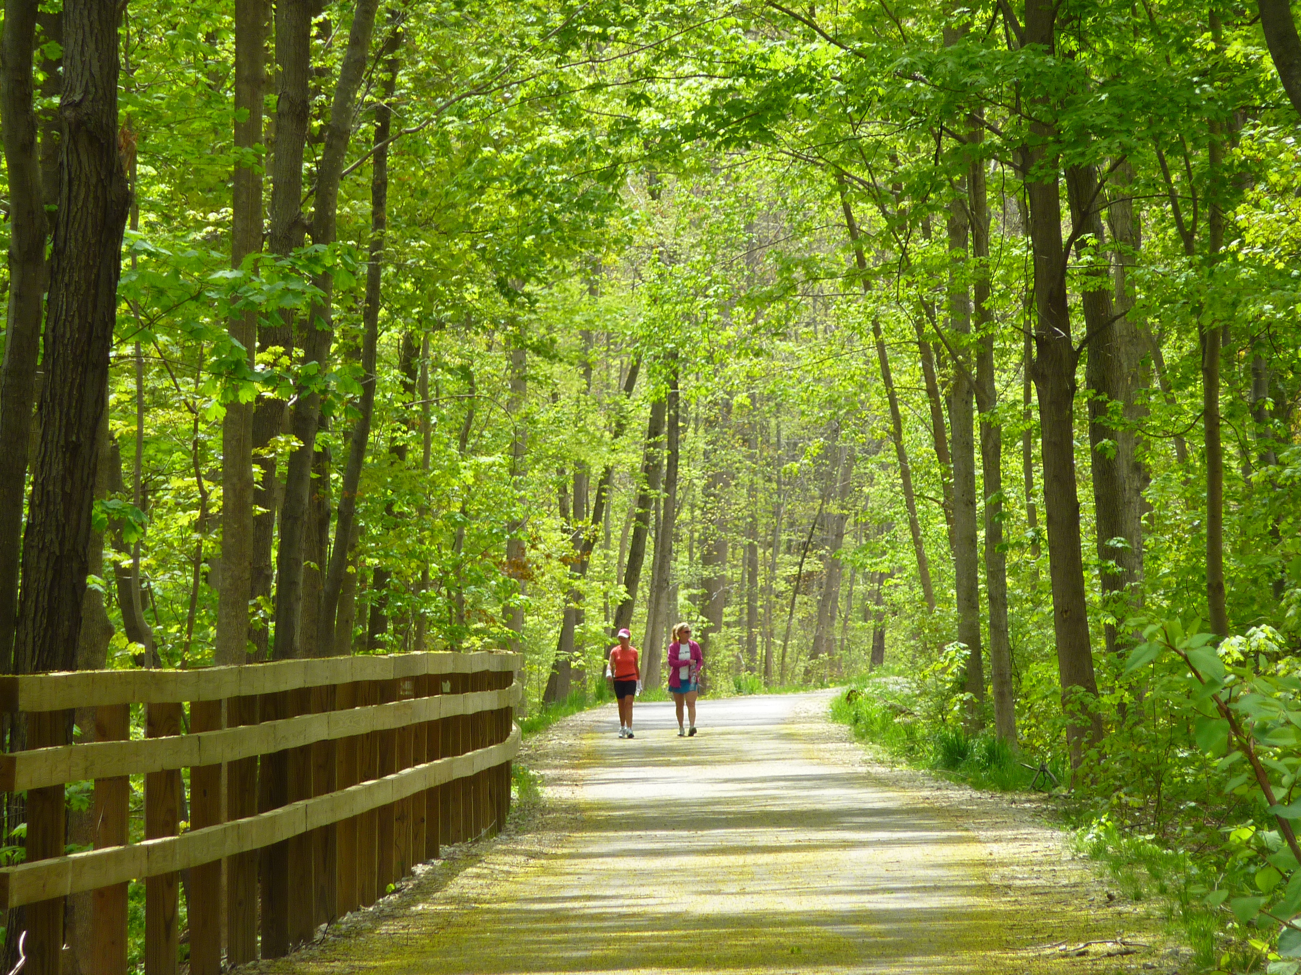
Multi-Modal Corridors | Pathway Connecting Adjacent Districts | Nature Path for Connection  and Recreation

- Multi-Purpose Paths. Efforts shall be made by developers to include pedestrian and bike paths within or adjacent to a site where the opportunity exists. Developments should anticipate future connections to other multi-purpose paths, such as Vine Brook, the Minuteman Bikeway, and to residential and commercial sites to encourage non-motorized access and incorporate them in the site plan.
- Coordinate Service, Delivery and Loading Access. If separate service, delivery or loading access is required for site development operations it shall be clearly distinguished from other points of site access. Functional access that is required for appropriate site operation should not be combined with other uses but should be coordinated with safe pedestrian routes and crossings on the site. Loading zones/docks shall be located so as not to be visible from the a public street or primary private street. They should be visually shielded using attractive, high-quality fencing and/or vegetation.

    - INTERNAL SITE CIRCULATION.
Circulation internal to the site shall provide clear and legible routes for all modes of transportation to connect to the streets, building entries, and other site components.
- Complete Circulation System. A complete access system for all modes of transportation, pedestrians, bicycles, and vehicles, shall be integrated into the site design. The vehicular street network should provide connecting routes between adjacent parcels as appropriate to enhance connectivity within the MIX District.
- Promote Pedestrian Circulation. Internal site vehicular circulation routes shall be designed with traffic calming, such as narrow travel lanes and marked pedestrian crossings, to slow vehicular traveling speeds and reinforce a safe and welcoming pedestrian environment. Pedestrian crossings shall be marked and differentiated with variations in paving materials such as stamped concrete or painted asphalt. See Complete Streets Standards in Section 1.6.
- Enhance Pedestrian Connectivity. Existing footpaths on the site shall be integrated into the site circulation system to provide access across or through the site. Site circulation that contributes to connectivity of existing trail systems (i.e., Vine Brook Corridor) shall be integrated into the site circulation system and become part of the district’s civic amenities.
- Integrate Bicycle Circulation and Connections. Access, circulation, and safety for cyclists on site including pathways, pavement markings, bicycles racks near community amenity spaces and buildings, and other amenities should be integrated into the site circulation system.
- Create Efficient Parking and Circulation. Shared driveways for adjacent developments are encouraged. Efficient parking and access configurations should be employed that minimize repetitious infrastructure and impervious surfaces. Clustered infrastructure and access should be used to reinforce clustered building patterns.

FIGURE 5. ILLUSTRATIVE EXAMPLES OF SITE CIRCULATION
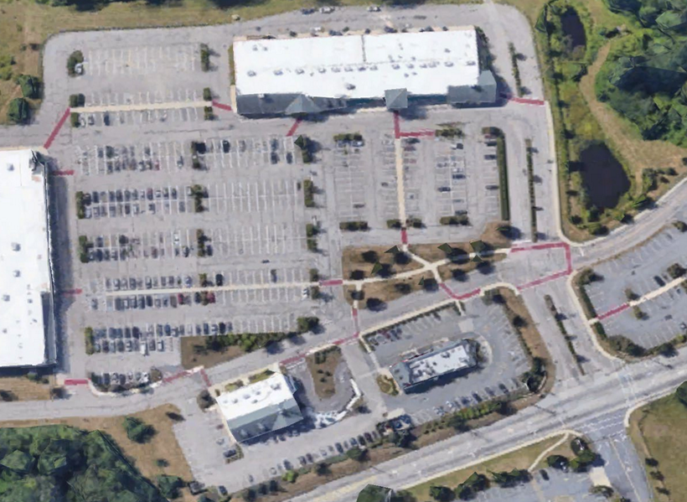 |  | 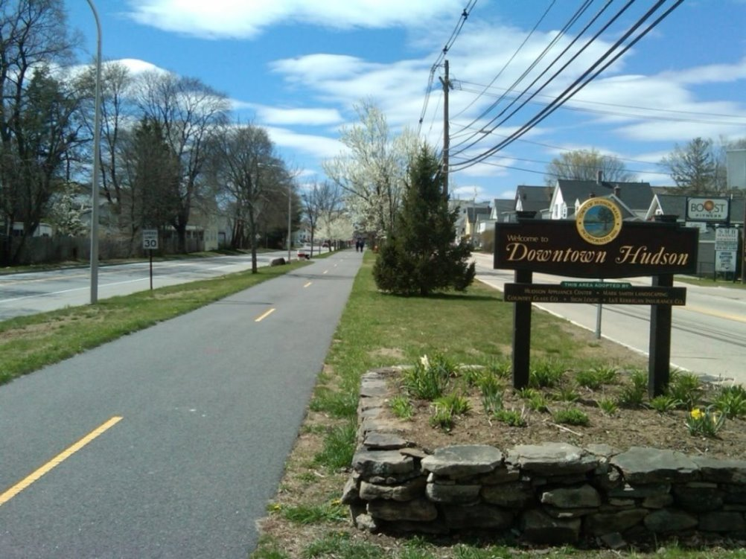
Development Site Sidewalk Network and Public Realm Connection | Provide multimodal access and connectivity for drivers, cyclists, and pedestrians.

    - PARKING.
Parking is necessary to support the function of a development, but it should not be viewed as utilitarian only. Parking should be conveniently located near building entrances while maintaining pedestrian access, safety, and aesthetics of the site. Specific zoning requirements for parking are in Section 7.2 of the Zoning Bylaw.
- Distribute Parking Areas. Where feasible, parking areas shall be distributed on the site in a central location or in multiple smaller parking areas for larger developments. Parking areas shall be integrated within the building layout and site amenities to reduce the overall visual impact of parking on the development. Distributed parking areas should be located to the rear and side of buildings with access provided by primary streets or rear access streets.
- Create On-Street Parking in Pockets. Where feasible, on-street parking is encouraged in pockets and integrated within the overall site circulation and landscape plan.
- Provide Visitor Parking. Visitor parking should be provided where needed for a development beyond that required for unit parking. Visitor parking should be located in a central area convenient to primary buildings or near common open space.
- Reinforce Parking Screening. When adjacent to a common open space, parking shall be screened from view through the use of native trees, tall shrubs, landscape beds, and/or low fences or walls.
- Integrate Parking Landscape. Large parking areas should be broken into smaller areas by means of landscaped islands containing native low plantings and deciduous trees. Such islands should be placed at regular intervals across the parking lot to reduce the visual impact of the parking area and to create a more pleasant pedestrian environment. Pure mulch or crushed stone islands are not allowed.
FIGURE 6. PARKING PLACEMENT, ACCESS, AND LANDSCAPING
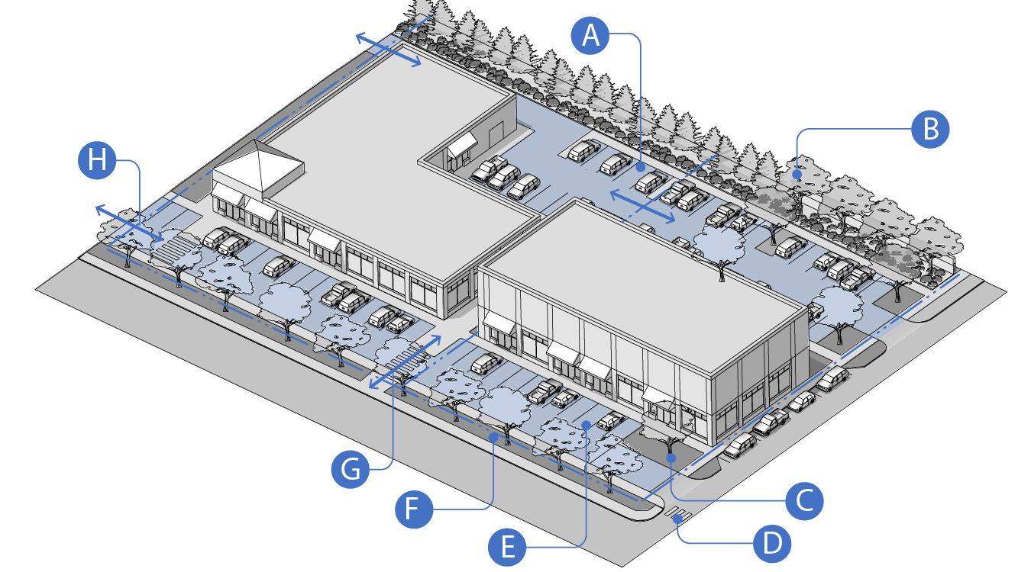
A. Parking to the Rear; B. Rear Landscaping and Screening; C. Building Frontage Landscaping; D. Crosswalks; E. Teaser Parking in Front; F. Street Trees and Tree Belt on Street Line; G. Pedestrian Connection Between Public Sidewalk and Building; H. Internal Connections to Adjacent Parking Lots.

    - Parking Placement, Access and Screening.
- Parking Placement. Surface parking lots should be located at the middle or rear of a development site and shielded from the public right-of-way by the building, street trees, and native landscaping. Parking in front of primary buildings is not permitted without a waiver from the Planning Board. Parking placement shall also consider existing or potential future shared parking opportunities with adjacent properties.
- Parking Perimeter Buffers and Screening. Provide a mix of deciduous and non-deciduous plantings of adequate height and density to visually screen surface parking lots from the public sidewalk and adjacent residential neighborhoods where applicable.
- Parking Interior Landscaping and Access. Landscaping required for parking areas in Section 7.4.0 of the Zoning Bylaw must be adhered to. Additional landscaping guidelines for parking areas include the following:
- Incorporate native shade trees and native, drought-tolerant plants of varying heights/species at parking islands and along edges to diminish the heat island effect.
- Include dedicated irrigation where feasible. Employ plantings of adequate height and density to visually buffer parking when it is unable to be located in a manner that makes it less visible from the public way.
- Include internal walkways and curb extensions between the parking lot, building, and public sidewalks.
- Provide curb extensions where pedestrians are required to cross driveways and parking aisles.

    - Structured Parking. Structured parking includes parking decks (one story above the ground), parking garages (three levels or more), pedestal parking (integrated into the primary building on the lower floors), and underground parking (located below grade underneath a building or the development site. Structured parking can be a stand-alone structure or integrated or attached to a building.

FIGURE 7. STRUCTURED PARKING ACTIVATION
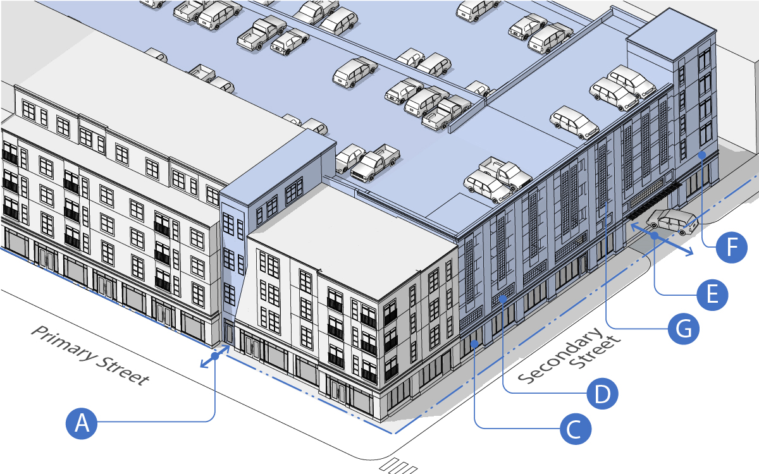
B
A. Place Parking Structure to Rear of Building with Access from the Sidewalk; B. Connect Garage Directly to the Building; C. Activate Ground Floor Space with High Percent Fenestration and Uses; D. Design Façade to Blend with Building; E. Provide Acess on Secondary Streets; F. Provide Sign Bands for Ground Floor Uses; G. Create Voids in Façade for Natrual Light and Ventelation.

- Placement and Screening. Parking structures should not face the primary frontage unless it is designed to appear like a building, but instead be located towards the rear of a building and shielded from public view where possible. Exposed portions should be naturally ventilated and visually softened with landscaping, architectural screening, open spaces, and pedestrian entrances. Parking structures may be shared by multiple properties to meet off street parking requirements.
- Access. Pedestrian access to structured parking should be made directly to the primary building and to a public sidewalk as applicable. Parking structures that are attached to primary buildings allowing pedestrians to enter directly into the building is highly encouraged.
- Design and Construction. Where a structured parking facility is visible from a public street, the design of the visible façade(s) should meet the follow guidelines:
    - The facade area masking the floors occupied by motor vehicle parking should be seamlessly integrated into the architectural design of the building’s facade.
    - Facade door and window openings should be vertically and horizontally aligned and all floors on the front side of facade facing the street should be level (not inclined).
    - The facade should appear transparent or translucent on the ground floor. Non-reflective glass or openings designed to appear as windows should be used for fifty percent (50%) of exposed facade wall area.
- Commercial and Amenity Uses. The ground level and top level may be used for commercial purposes such as retail stores, restaurants, offices, and outdoor amenity space accessory to commercial or public uses.
- Below-Grade Structured Parking. Below-grade structured parking is located partially or fully underground. Where possible, below-grade parking should be naturally ventilated, and any portions that are visible above grade should be clad in high-quality materials.
- Structured Parking for Attached Residential Units. For Townhouses, Live/Work Studios, and Garden Apartments with structured parking, the garage door should not be located on the primary building façade or street frontage. On secondary building facades, the location and design of garage doors should be integrated with the design of the façade so that the garage door is not the prominent feature of the façade.

FIGURE 8. STRUCTURED PARKING ACTIVATION
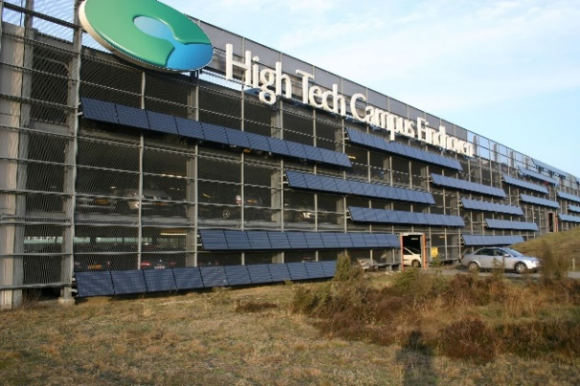 | 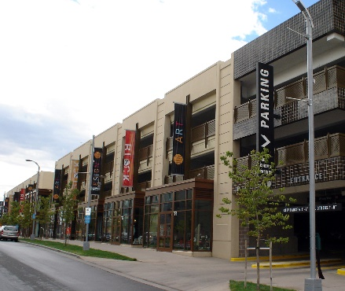 | 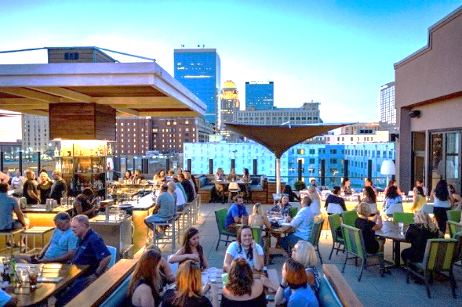
Structured Parking with Solar Panels | Ground Floor Commercial Use | Parking Garage Rooftop Commercial Use

    - Shared Parking. Shared parking increases development efficiency and potential while diminishing the overall impact of the automobile. Developers must investigate shared parking opportunities with adjacent property owners. The Planning Board may approve a parking reduction where shared parking is available under Section 7.2.0. of the Zoning Bylaw. Share parking manuals published by the Urban Land Institute (ULI) and the Institute of Transportation Engineers (ITE) are good resources for determining the potential for shared parking.
    - Off-Site Parking. The Planning Board may allow required parking to be provided off-site for employees, except for any required handicapped parking, as permitted according to the provisions of and when conforming to the following:
- A lot featuring the off-site parking should be located within a comfortable walking distance (typically 700 feet), measured from the nearest point of the off-site parking along walkways to the principal building entrance served.
- Pedestrian access between the use and the off-site accessory parking area must be via paved sidewalk or walkways.
- A lease, recorded covenant, or other comparable legal instrument, executed and filed with the Town of Burlington, guaranteeing long term use of the site must be provided to the Planning Board.
    - Car Sharing and Charging Stations. Parking areas shall incorporate spaces reserved for car sharing programs as well as vehicle charging stations. Developers shall consider installing shading devices with imbedded solar cells to provide power and reduce solar gain. The Planning Board may approve a parking reduction where an active car-sharing program is made available to residents and/or employees of a development site; and where the car-share facility is on site or within a 700-foot walking distance of the site.
    - Special Parking Types
- Street Side Parking. The Planning Board may allow parallel or angled parking on a privately-owned lot directly adjacent to the public street right-of-way under the following conditions:
- The parking lane is installed in combination with a minimum five (5) foot wide planting strip with street trees planted 40 feet on center.
- The parking lane is installed in combination with a minimum five (5) foot sidewalk connecting to public sidewalks on abutting lots and to the primary building on-site.
- The parking spaces are privately owned but accessible to the public, effectively functioning as on-street parking.
- On a public street, an access easement is required by the Town of Burlington allowing for public access to the privately-owned parking and sidewalk.

- Teaser Parking. The Planning Board may allow a limited amount of off-street surface parking to be placed between a public street and the street facing façade of a primary building. Where this is permitted, the parking area should be setback a minimum of fifty (50) feet from the street line and streetscape treatments including street trees, landscaping, and a minimum 5-foot sidewalk should be placed adjacent to the street line. The sidewalk should also be connected to the front door of the primary building by a dedicated pedestrian connection. The portion of the parking lot located in front of the primary building should be limited to two (2) rows of vehicles and one (1) parking aisle.

FIGURE 9: SPECIAL PARKING TYPES
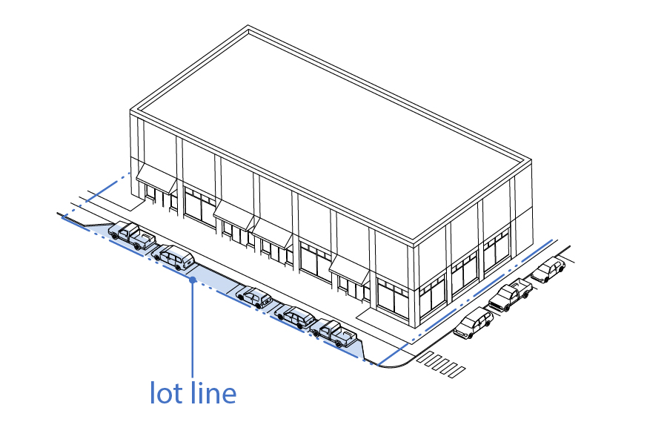 | 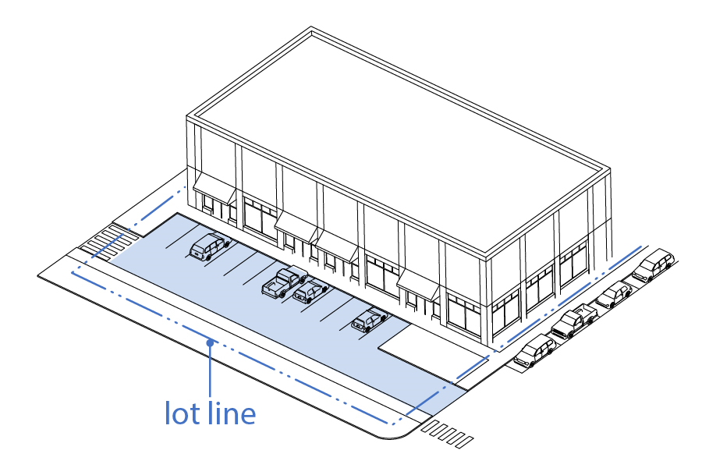
Street Side Parking (Paralell On- Street Parking  on Private Frontage) | Teaser Parking (One Row of Parking in  Building Frontage Zone)

    - Bicycle Storage. All developments shall include externally located bicycle racks easily accessible from the public way as well as protected and secure bike storage for employees and residents.
    - Parking Waiver and Alternative Compliance Criteria. Where a waiver is sought for relief from the parking standards, the Planning Board shall consider the following:
- The supply and demand of public and private parking on the development site, as determined through a parking demand study.
- Transportation and mobility management programs and services are provided by the applicant to reduce the demand for parking.
- Parking provided in excess of the minimum requirement does not result in underutilized spaces, excessive impervious surfaces, and lost opportunities for building or outdoor amenities spaces.

FIGURE 10. ILLUSTRATIVE EXAMPLES OF PARKING PLACEMENT AND DESIGN
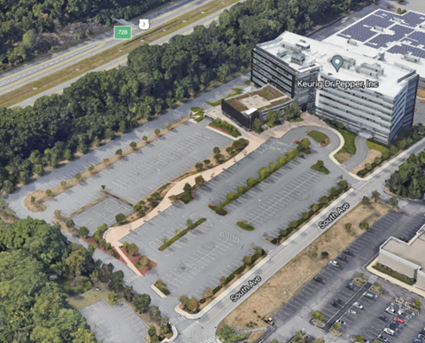 | 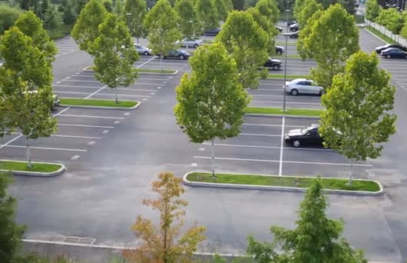
Organize common parking areas where possible and provide landscaping,
shade trees, screening, and connection to the buildings and public sidewalk.

    - OPEN SPACE.
Development projects shall provide common open space integrated within the overall site plan design. Several characteristics of this type of open space are important to the character and quality of all developments in the MIX District. The goal for outdoor amenity space in the MIX District is to create a broad range of quality private and publicly oriented open spaces that contribute to the vitality of the district and provide opportunities for employees, visitors, and residents to enjoy passive and active recreational spaces.
- Design Common Open Spaces and Amenities. In the context of new development, common open space is open space that is shared by all users on site. It is an amenity and resource shared among workers, customers, visitors, and residents on the development site. Depending on the scale and use of the common open space, this area could include natural park areas, small pedestrian plazas, playgrounds, community gardens, outdoor seating, landscape, trails, community buildings, and other amenities.
- Create Publicly Accessible Open Space. Different from a Common Open Space, a Publicly Accessible Open Space is common open space that is made accessible to the general public beyond the uses on site.
- Define Public and Private Space. Create clear and distinct boundaries between public space and private space. This can be accomplished through the configuration of buildings, paths, fences, and landscape.
- Create Open Space Connections. Common and Publicly Accessible Open Spaces should link to existing or proposed trails or pathways in and around the property, creating a network of connected open spaces and walking/biking routes.
- Create Private Open Space on Residential Developments. In addition to common open space, private open space should also be provided in a residential development. These spaces would be dedicated for use by a single unit with clear boundaries and potentially associated with ownership, leases, or deed restrictions. Private open spaces could include yards, gardens, greenhouses, patios, terraces, decks, porches, balconies, and other amenities.

    - OUTDOOR AMENITY SPACE TYPES AND STANDARDS.
1) Outdoor Amenity Space Types. Outdoor Amenity Spaces (OAS) include the following types:
  - Civic Space (CS). This OAS includes publicly owned or controlled parks, active and passive recreation areas, civic buildings, and other gathering spaces that are fully accessible to the general public.
  - Publicly Oriented Private Spaces (POPS). This OAS includes gathering spaces on private land primarily serving the residents, businesses and patrons of the principal building or Development Site, and generally available to the public.
  - Private Open Space (PS). This OAS is associated with individual dwelling units and multi-family buildings and developments and is not intended for public access.
  - Required Outdoor Amenity Space. The required percentage of a building lot dedicated to Outdoor Amenity Space is identified for each building and development type in Section 14 of the Zoning Bylaw. Where multiple lots or buildings are assembled to form a Development Site under Section 14, the required amount of Outdoor Amenity Space is the cumulative land area of Outdoor Amenity Space required for the total number and types of building of which the site is composed.
- Outdoor Amenity Space Design Standards and Guidelines. Outdoor Amenity Space types and associated Design Standards and Guidelines are identified in Figure 11 below:

FIGURE 11. OUTDOOR AMENITY SPACE TYPES AND DESIGN STANDARDS
- Private Yards and Dooryard (PS) | Description: A private open space where the building façade is aligned close to the Street R.O.W. Line and defined by a low wall, decorative fence or hedge providing a strong spatial definition from the public sidewalk. The result is a small semi-private dooryard containing the principal entrance in the front yard. This type is commonly associated with ground-floor residential use.  Design Standards: The dooryard shall be slightly raised, sunken, or at-grade, and shall be planted or landscaped. A paved walkway from the sidewalk to the front door is required.
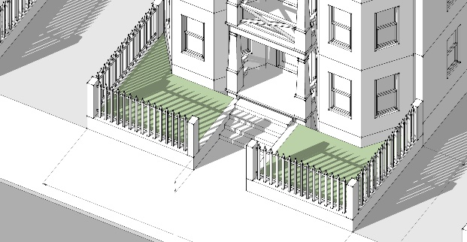
- Forecourt (POPS, PS) | Description: A private open space where a portion of the façade is aligned close to or at the Street R.O.W. Line, and the central portion of the façade is set back to create a courtyard with a principal entrance at-grade and space for gathering and circulation, or for outdoor shopping or restaurant seating. The forecourt shall be planted or paved to join with the public sidewalk.  Design Standards: Forecourts shall be a minimum width and depth of 12 feet; a maximum ratio of building height to forecourt width of 2:1; and enclosed by walls on 3 sides. Larger dooryards shall incudes planting that reduce the heat island effect.
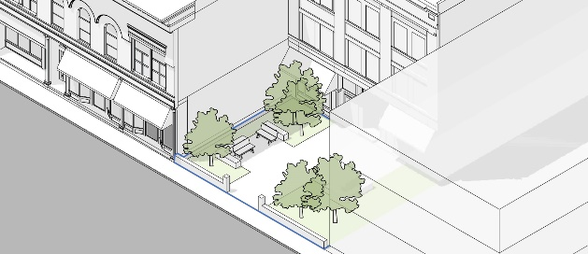
- Community Garden (CS, POPS, PS) | Description: An open space designed as individual garden plots available to residents for horticultural purposes, including storage facilities for necessary equipment. Community gardens may be freestanding or incorporated as a subordinate feature of a community park, neighborhood or pocket park, or Development Site.  Design Standards: Community gardens shall be a minimum of 5,000 S.F.; 90% permeable surfaces; and 1 New England native tree/500 SF on average. Pesticides and herbicides are not allowed in CS and POPS gardens.
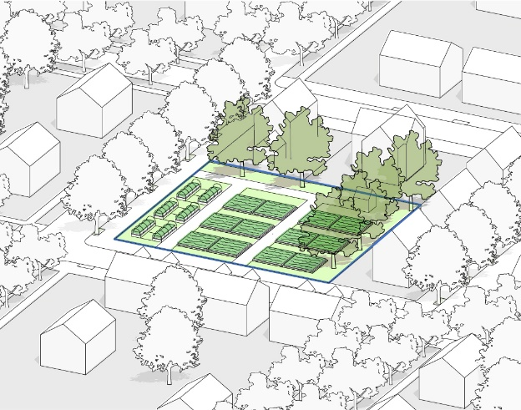
- Courtyard (POPS, PS) | Description: A courtyard (or court) is an enclosed open space that is open to the sky. They are often surrounded by a building or framed by buildings on at least 2 sides. Courtyards may include a variety of passive recreational activities, community gardens, and other amenities for community gatherings.  Design Standards: Courtyards shall be a minimum of 3,000 S.F. in area, 40 feet in width, fronted with buildings on at least 2 sides, and enhanced with native New England trees and plantings.
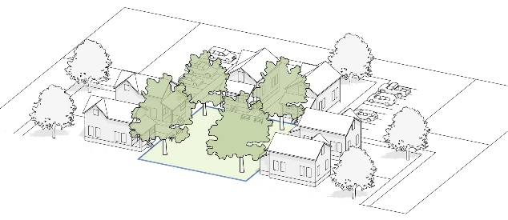
- Common or Green (CS, POPS) | Description: A common or green is a free-standing site with streets on all sides and landscape consisting of lawns, paths, and trees. This open space type is for active and passive recreation and gathering purposes.  Design Guidelines: Commons should be a minimum of 10,000 S.F.; 85% permeable surfaces; and 1 native New England tree/2,000 SF on average.
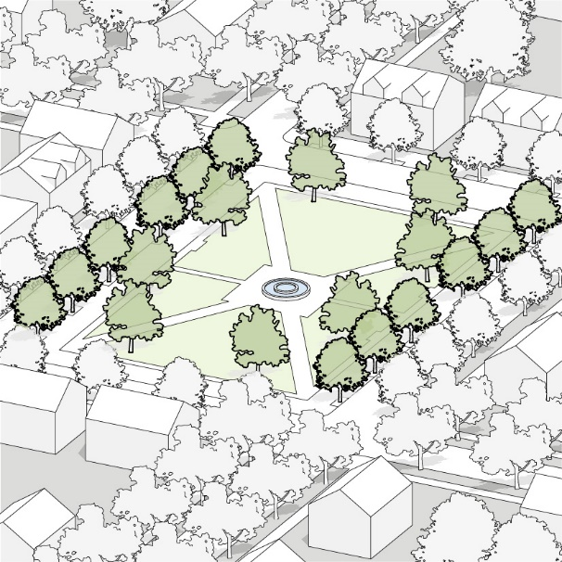
- Plaza or Square (CS, POPS) | Description: An open space type designed for passive recreation, civic purposes, and commercial activities, with landscape consisting primarily of hardscape. Plazas are generally located in activity centers or the nexus of major circulation routes.  Design Standards: Squares shall be a minimum of 5,000 S.F.; 50% permeable surfaces; 1 native New England tree/2,000 SF on average; and include public seating.
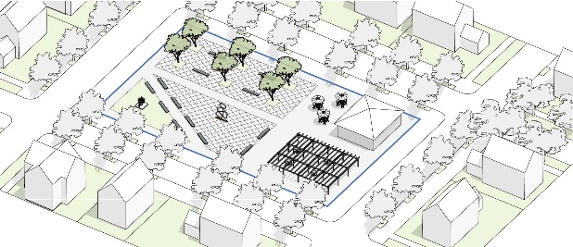
- Pocket Park or Playground (CS, POPS, PS) | Description: An open space type designed for passive recreation consisting of vegetation, a place to sit outdoors, and playground equipment.  Design Standards: Pocket Parks shall be a minimum of 800 S.F.; 80% permeable surfaces; and a minimum of 1 native New England tree/200 SF on average; and include seating and recreational equipment.
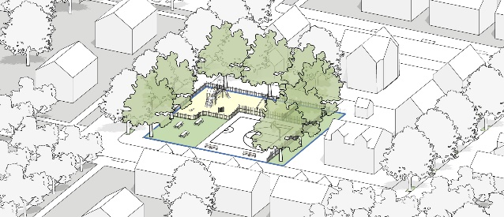
- Athletic Field or Ball Court (CS, POPS) | Description: A publicly accessible open space designed and equipped for active recreation and organized sports. Playing fields and courts may include grass, clay, dirt, stone dust, concrete, asphalt, ice or other pervious or impervious materials to support various sporting organizations and events.  Design Standards:  Size of Space: 7,500 S.F. Min.; 5 Acres Max.  Furnishing: Seating: 1 Seat/275 S.F. Min.  Landscape: Landscaped Area: 20%
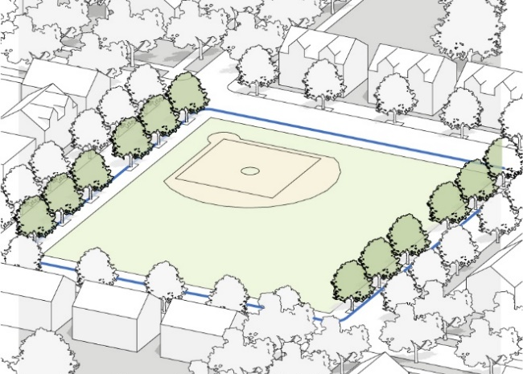
- Neighborhood Park (CS, POPS) | Description: An open space designed for active and passive recreation with features and facilities that support the community or immediate neighborhood. Parks can include other Outdoor Amenity Spaces such as community gardens, recreation fields and courts, trails and pathway, swimming pools and water features, and other facilities intended for public events, gatherings, and organized activities.  Design Standards: Neighborhood Parks shall be a minimum of 8,000 S.F.; 80% permeable surfaces; and 1 native New England tree/350 SF on average. Herbicides and pesticides are not allowed to be used in public spaces. Pathways must meet ADA and US Forest Services accessibility standards.
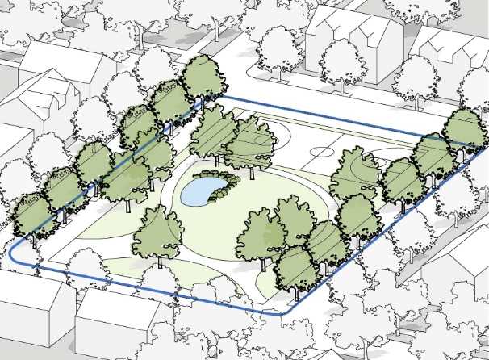
- Streetside Plaza and Terrace (POPS) | Description: An open space type designed for passive recreation, civic purposes, displays, and commercial activities, with landscape consisting primarily of hardscape. Plazas are generally located in activity centers or the nexus of major circulation routes.  Design Standards:  - Streetside terraces shall be a minimum of 2,000 S.F.; 50% permeable surfaces; 1 native New England tree/2,000 SF on average; and include public seating.  - A terrace must not obstruct access to the principal entrance of a building.  - At least 20% of the terrace must be directly accessible to the adjacent pedestrian throughway or public frontage
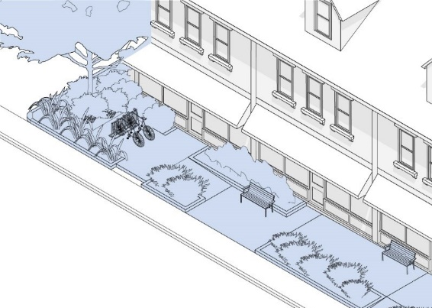
- Sidewalk Dining Terrace | Description: An open space where the building façade is setback from the Street R.O. W. Line and the space between is occupied by a hardscape intended for use as an extension of the public sidewalk and outdoor amenity space such as for outdoor seating or displays. The space may also allow for public circulation along the façade and can be used to provide at-grade access or a grade change along a Street R.O.W. Line.  Design Standards:  - A dining terrace must not obstruct access to the principal entrance of a building.  - At least 20% of the front edge of a dinning terrace must be directly accessible to the adjacent pedestrian throughway or public frontage zone.
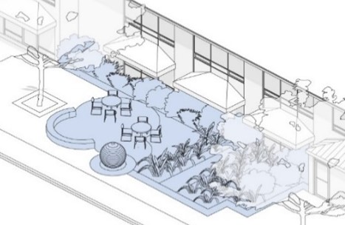
- Rooftop Terrace (POPS, PS) | Description: A roofless, raised platform on the roof of a building that provides community gathering space such as a terrace, community garden, food and entertainment, or other outdoor amenities.  Design Standards: Terrace shall be setback a minimum of 5 feet from any building wall and secured by a perimeter fence at least 4 feet tall.
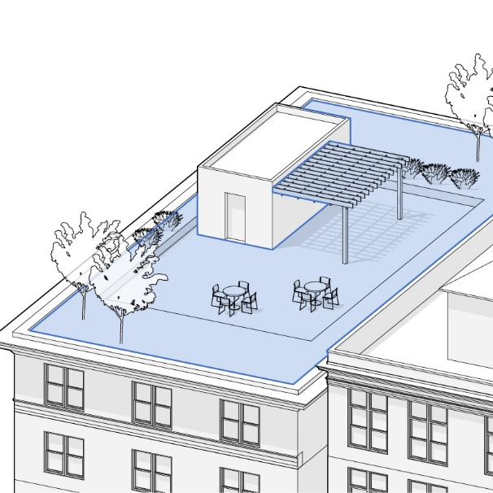
- Pedestrian Passage (CS, POPS) | Description: A paved or brick pedestrian connector between buildings. Pedestrian Passages provide direct connections between parking areas, buildings, streets, and sidewalks. Pedestrian Passages may be covered by a roof, trellis, and may be lined by shopfronts.  Design Standards:  - Mid-block passages must connect the sidewalk to an internal parking or a parallel street on opposite side of the building.  - Mid-block passages may be designed with a covered atrium providing continuous protection from the elements or as an open air passage between buildings.  - Open air mid-block passages must be at least ten (10) feet in width, with a minimum eight (8) foot wide paved walkway designed as a continuation of the sidewalks they connect, including materials and sidewalk furnishings.  - A covered mid-block passage must be at least twenty (20) feet in width.  - All mid-block passages must be lighted using footlights, bollard lights, building lights, or street lights to provide for safety and visibility at night.
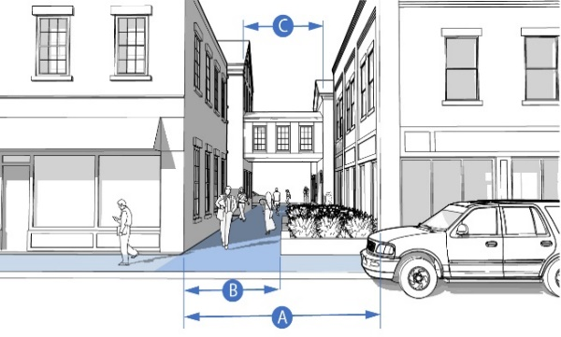
- Pathway (CS) | Description: A linear open space that may follow natural corridors providing unstructured and limited amounts of structured recreation. A pathway may be spatially defined by segment and include access to pedestrians, bicyclists, and other designated modes of non-motorized transportation. Pathways may provide access and connections between natural areas, neighborhoods, villages, public facilities, and other points of interest.  Design Standards: Pathways must meet ADA standards.
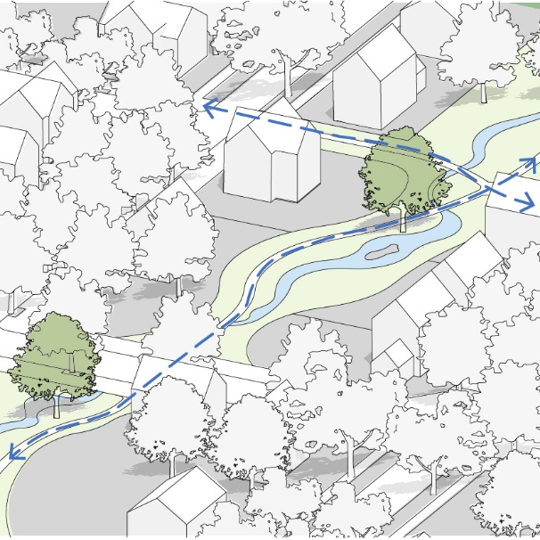
- Other Outdoor Amenity Space Types | Permitted by Special Permit by the Planning Board

    - SITE FURNISHINGS.
Site furnishings should enhance community activity and the residents’ experience. Site furnishing may include benches, trash and recycling receptacles, bike racks, fire pits, picnic benches, shelters, gazebos, playground equipment, exercise stations, and other components appropriate to the use and scale of the development.
- Coordinate Location of Furnishings. Site and open space furnishings should be located appropriately based on the areas on site where higher activity is most likely to occur.
- Coordinate Design of Furnishings. The character and design of the site amenities selected should be consistent with the overall character of the site and building design.
- Integrate Furnishings. Site amenities should be integrated within the site design to allow appropriate clearances, space, and circulation around them to allow busy areas to function appropriately.

    - LANDSCAPE AND STREETSCAPE.
Development sites in the MIX District should include a hierarchy of landscapes that contributes to the overall site design and integrates landscapes on adjacent properties as applicable.
- Define Entry and Gateway Landscape. Entry and gateway landscape should be used to define site access and reinforce a sense of arrival to the development. The gateway landscape may be integrated with signage throughout the development. This type of feature shall be simple and balanced within the overall development.
- Integrate General Site Landscape. Landscaping on the development site shall be used to provide privacy, frame views, and reinforce a sense of character by incorporating a diverse selection of New England native plants.
- Coordinate Scale of Landscape. The type and maturity of plantings selected shall be carefully considered relative to the overall scale of the development and individual buildings. New plantings shall be selected for reasonable maturity at the time of installation to achieve a more rapid appearance of fullness. At least 60% of plantings shall be native to the region and selected for drought-tolerance and non-invasive plant materials. Trees should have a minimum caliper of 12 inches at dba height.
- Define Building Landscape. Building landscape should be used to integrate the buildings into the overall site plan, soften building edges, enhance public sidewalks and building entries, and complement common open spaces and community buildings.
- Highlight Featured Spaces. In locations that are significant in the overall site design such as community open spaces and buildings, the landscape should be used to reinforce the importance of this site component. An additional the number of plantings, unique composition or variation in planting species, or plant species with special seasonal variation should be used to reinforce common site features.
- Provide Landscape Screening and Buffers. Landscape should be used to integrate and conceal dumpsters, recycling areas, and other equipment or service uses from public view, by residential units, or pedestrian areas. Additional landscape buffering should be provided where the property abuts another type of use to reinforce the distinction between the properties.
- Coordinate Landscape at Street Frontages. Streetscape along public street frontages should contribute to the character of the district and reinforce the transition to the public realm context. A native tree belt should be located on both sides of the street separating the travel lanes from the sidewalk, and deciduous native street trees should be planted in a regular pattern. The landscaping along public street frontages shall respect and reflect the character desired for the MIX District.
- Landscape in Cul-De-Sacs. Where applicable, the center of a cul-de-sac shall be landscaped with a combination of native trees and landscape beds.
- Integrate Functional Features into the Landscape. Stormwater retention areas shall be integrated within the site landscape and treated as a naturalized environment. These site features shall be sustainable from a New England native plant material and maintenance perspective. Retaining walls, fencing, guardrails, and other utilitarian or screening features shall be integrated within the overall landscape design and contribute to the overall site character. Functional site features should consider views from adjacent properties.
- Integrate Functional Materials. The materials used for functional features such as retaining walls, drainage structures, or other required site elements shall be integrated within the overall site design and material palette. For example, a functional retaining wall should include stone facing to reflect the landscape qualities envisioned for the MIX District.
- Water Conservation Measures. Lawns are the biggest users of water in most landscapes. To ensure adequate soil quality and depth needed to effectively hold water and sustain lawns and landscapes, loam, (soil with adequate organic material), at a minimum of 6 inches in depth is required for any new lawn/turf installations. Lawn Irrigation Systems should include water conservation equipment, such as smart sprinkler controllers, rain shutoff devices, flow sensors that are set to meet the types of outdoor water restrictions imposed by the Town.
- Residential Privacy Landscaping. Building landscape should be used to establish zones of privacy for residential units with a pattern of plantings and landscape design that reinforces the interconnectivity between streets, buildings, private open spaces, and common open spaces, and which includes a diverse selection of native plant species.

FIGURE 12. ILLUSTRATIVE EXAMPLES OF LANDSCAPE AND STREETSCAPE DESIGN
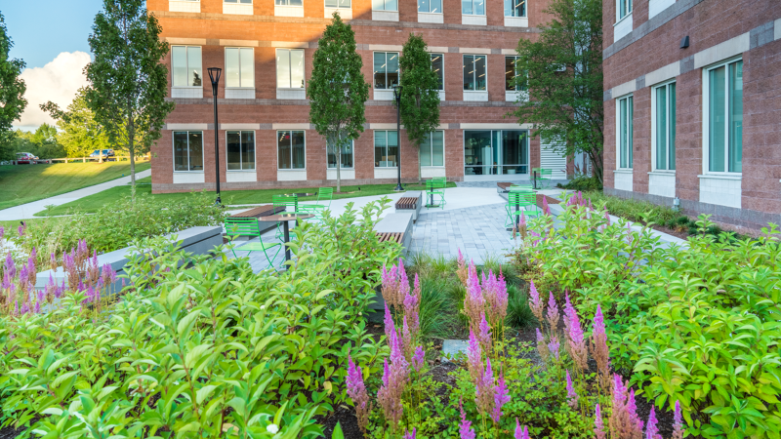 | 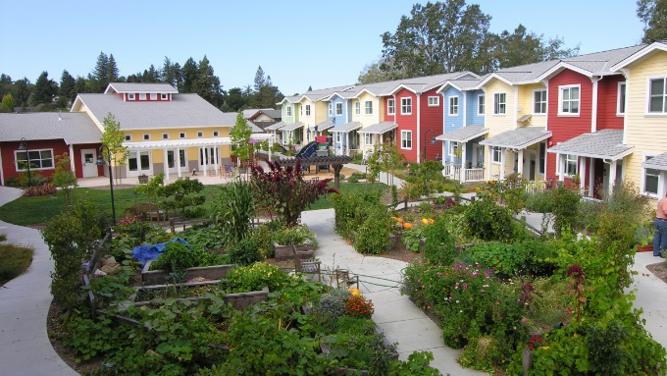
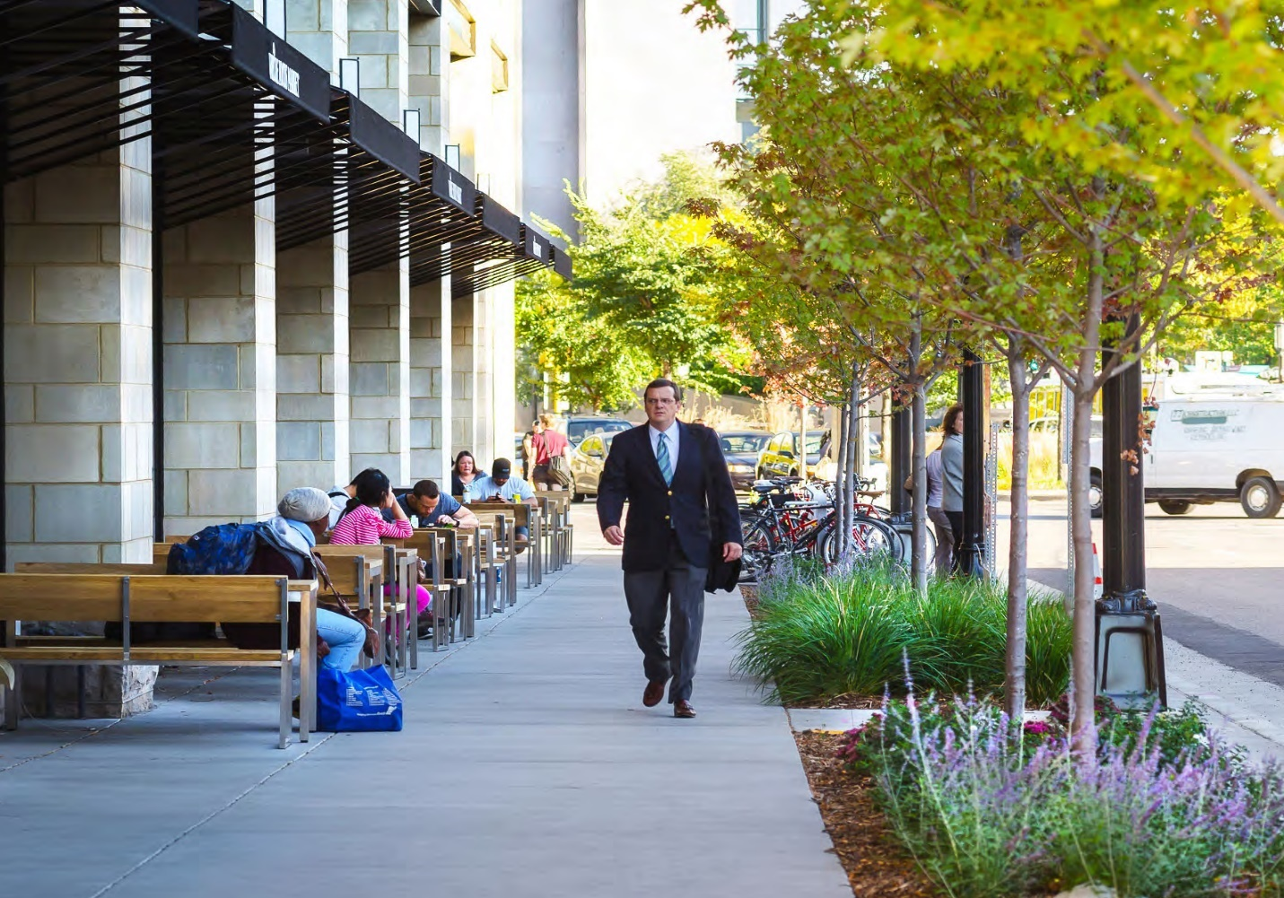 | 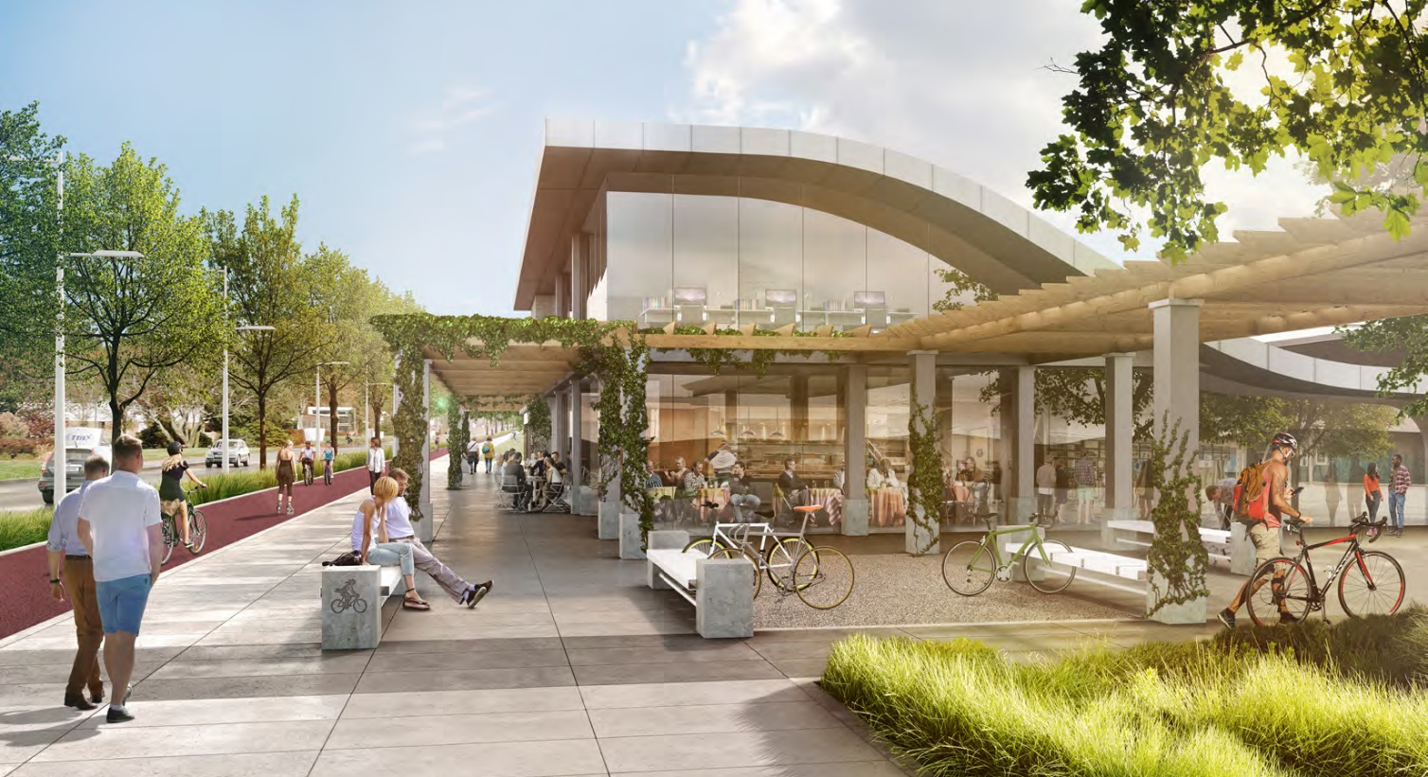
Integrate and coordinate landscaping, screening, stormwater facilities, and streetscape features
into the residential development to enhance aesthetic appeal and recreational enjoyment

    - TRANSITIONAL BUFFERS.
Along the perimeter of the lot or development tract abutting residentially zoned and occupied properties, the Planning Board may determine that certain buildings and uses may need to be buffered to create a compatible transition with the surrounding neighborhoods or other properties.
- Landscape Buffer. Where necessary, buffers may include a combination of natural or landscaped screening and fencing that provides an opaque visual barrier to a minimum height of six (6) feet above the ground.
- Building Buffers. Where necessary, primary building height at the side or rear yard setback line should be increased to ensure that the development does not impose on adjacent neighborhoods outside the MIX District.

FIGURE 13. TRANSITIONAL BUFFERS
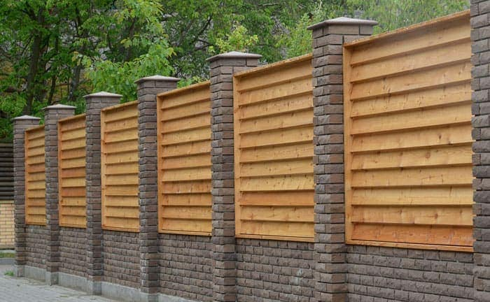 | 
Transitional Landscape Buffer and Screening

    - SITE LIGHTING.
Site lighting is intended to provide safety in areas with evening activity, particularly near street and building entries, across parking lots, and on paths and open spaces. Lighting levels and fixtures must comply with the requirements in the Zoning Bylaws.
- Minimize Lighting. Site lighting shall meet the minimum lighting standards in the Zoning Bylaw but should not provide lighting in excess of IES recommendations. Downward-directed, dark-sky compliant or “fully shielded” lighting should be provided to minimize glare, skyglow and spillage off the development site. In general, site lighting shall not exceed 1.25 lumens/ft2 of hardscape. Sites that contain or border a parcel that contains conservation land, threatened species, or existing residential neighborhoods should maintain lighting levels no greater than 0.5 lumens/ft2.
- Integrate Lighting Fixtures within the Overall Design. Lighting fixtures should be selected to contribute to the overall character of the streets, buildings, and consistent with the overall design and sense of place. Lighting color temperature (CCT) should be selected between 2200 K and 2700 K and shall not exceed 3000 K.
- Create Multiple Layers of Site Lighting. Site lighting should perform multiple functions for multiple areas and users. Site lighting should be designed for vehicles, pedestrians, building entry areas, and site features. Each of these areas should be designed in coordination to complement the overall character of the site.
- Define Entry and Gateway Lighting. Gateway lighting may be used in the foreground of elements to accent entry features such as a sign, a wall, landscape plantings, or other gateway elements. Said lighting shall be turned off when not in use.

    - SUSTAINABLE DESIGN.
The goal of sustainable design applications in the MIX District is to effectively balance environmental, economic, and aesthetic objectives through a range of best practices.
- Low Impact Development / Sustainable Development Certification. All new developments are encouraged to meet certification standards under Leadership in Energy and Environmental Design (LEED) or similar sustainable development rating systems for neighborhoods, development sites, and buildings.
- Plant Native Trees. Trees reduce solar gain, provide shade for pedestrians, filter the air, convert CO2 to oxygen, provide habitat for wildlife, and absorb stormwater on site. Development sites should provide ample canopy trees that are located to allow them to grow to their mature size and specify measures to ensure sufficient space for water penetration and root growth. See Tree Planting Standards in Section 1.6.8 below.
- Rain Gardens, Bioswales, and Permeable Pavers. Stormwater, flooding, and ground water recharging are important site planning issues in the MIX District. New developments shall incorporate natural elements to create resilience such as rain gardens that temporarily retain stormwater until the ground can adequately absorb it. Permeable paving is also recommended to allow rainwater to naturally leach into the ground and recharge the water table. These sustainable applications reduce flooding and stress on public infrastructure, replenish aquifers, filter out pollutants, and help keep trees healthy.
- Sustainable Outdoor Amenity Spaces. As applicable, outdoor private and public amenity spaces shall incorporate light imprint techniques that address the quantity and quality of stormwater on site.
- Latent and Renewable Energy Sources. In a climate with large seasonal temperature swings, efficient methods for heating and cooling buildings are critical to reducing a building’s carbon footprint. Buildings should meet the state’s energy stretch code standards, including any opt-in standards adopted by the Town. Buildings that use no on-site fossil fuel combustion are strongly encouraged. As applicable, developers should utilize the latent energy of their sites to meet energy needs.

FIGURE 14. SUSTAINABLE BEST PRACTICES
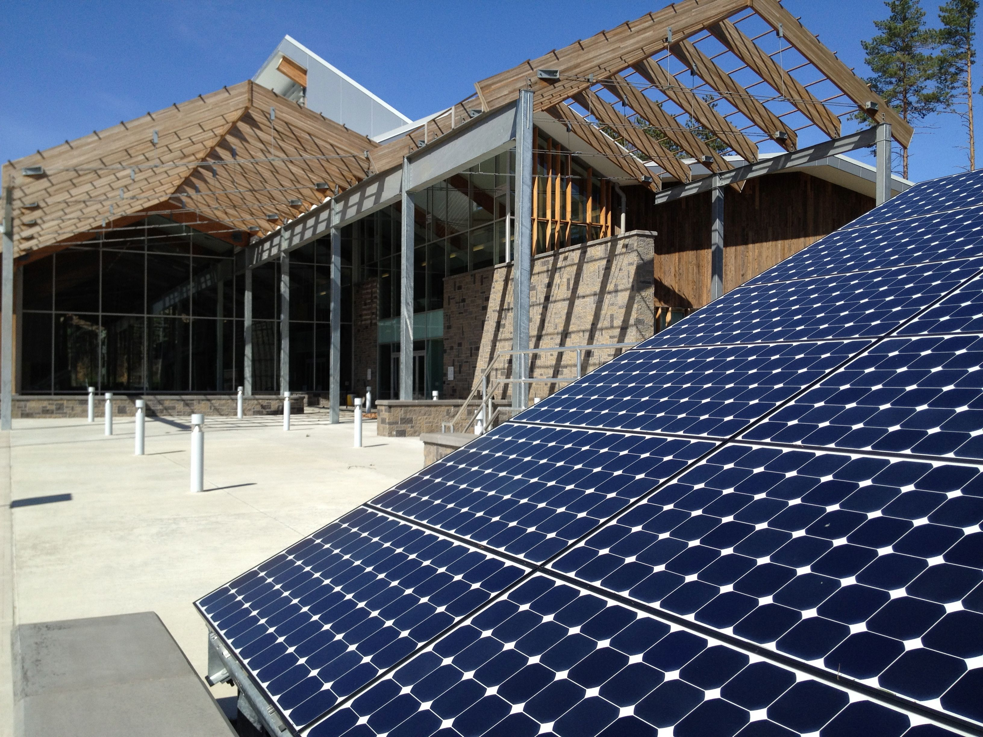 | 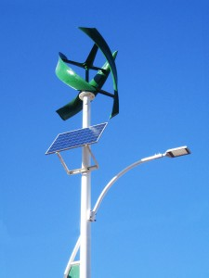
Solar Array | Wind and Solar Light Fixture
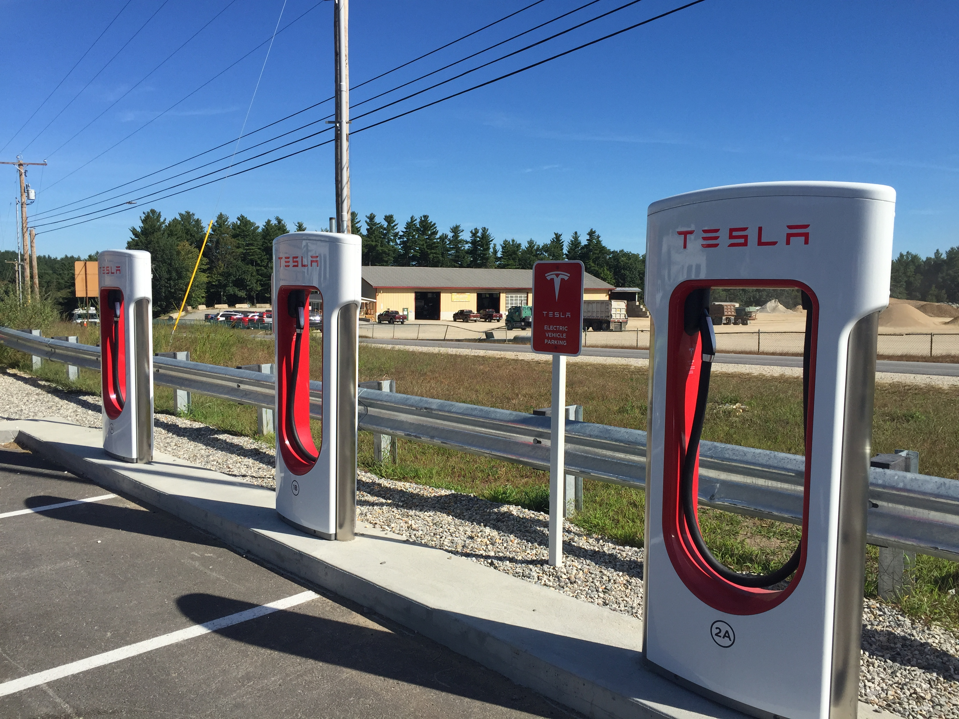 | 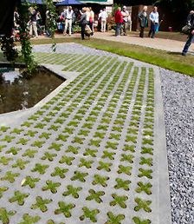
Electric Vehicle Charger Station | Grasscrete Pavers

  - BUILDING TYPES AND DEVELOPMENT STANDARDS
The following standards and guidelines outline the general building types and architectural design elements that shall be viewed as a baseline for well-designed buildings and architecture in the MIX District.
    - BUILDING TYPES.
The building types permitted in the MIX District are identified below. The specific design specifications are provided in Section XIV of the Zoning Bylaw. If a new building is proposed that cannot be classified as one of the allowed building types of this section by the Building Commissioner, the building type is subject to special permit review by the Planning Board

FIGURE 15. MIX DISTRICT BUILDING TYPES
TOWNHOUSE (TH): A small footprint attached single family residential building with narrow massing and located on a private or common lot with other units. Each unit is separated by common walls and groups of buildings may be separated by a common driveway or community space. | 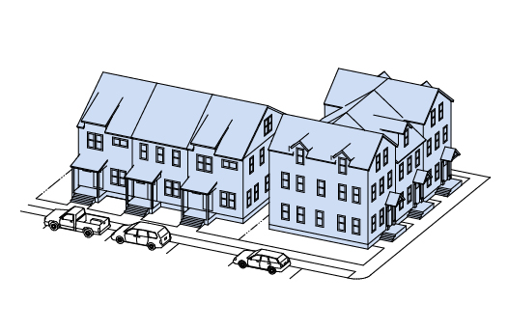 | 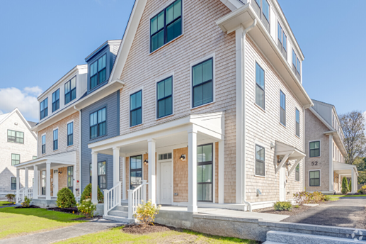
MULTI-FAMILY BUILDING (MF): A building designed and used as living quarters and habitation by four (4) or more families, containing separate cooking, bathroom and sleeping facilities in each of the living quarters. | 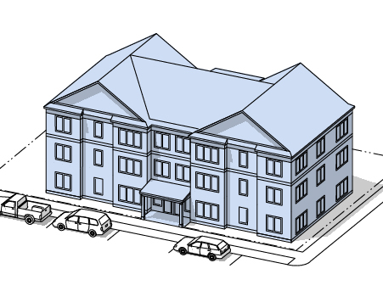 | 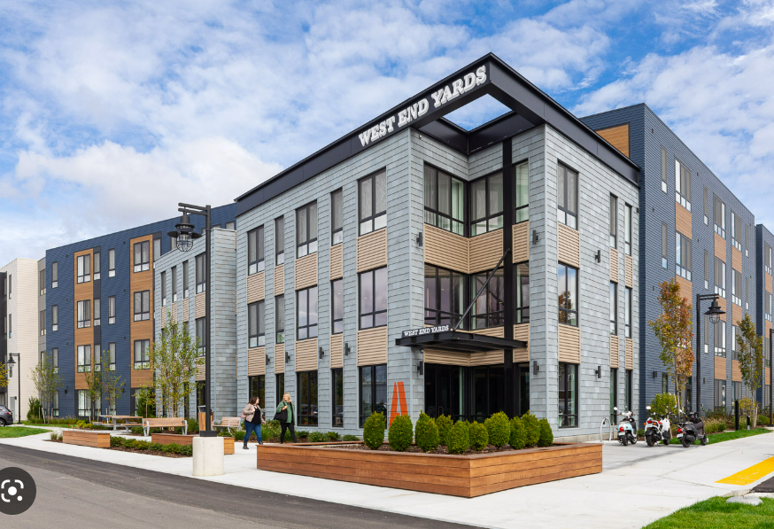
LIVE-WORK BUILDING (LW): A small floor plate attached residential building type with one owner-occupied dwelling unit and one ground floor commercial unit. | 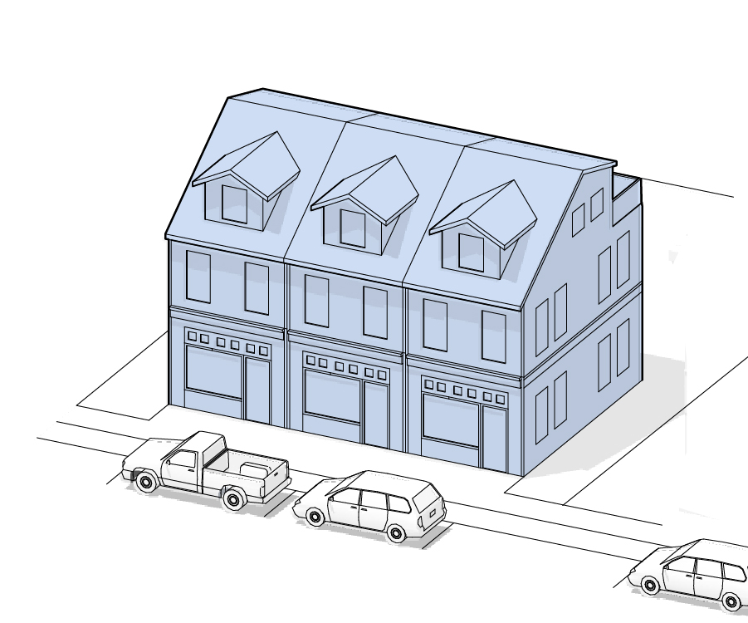 | 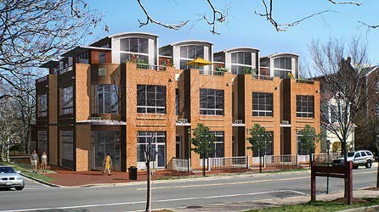
MIXED USE BUILDING (MUB): A building that typically accommodates a variety of ground floor commercial uses and upper residential and office uses at a scale that is compatible and complimentary to its given district. | 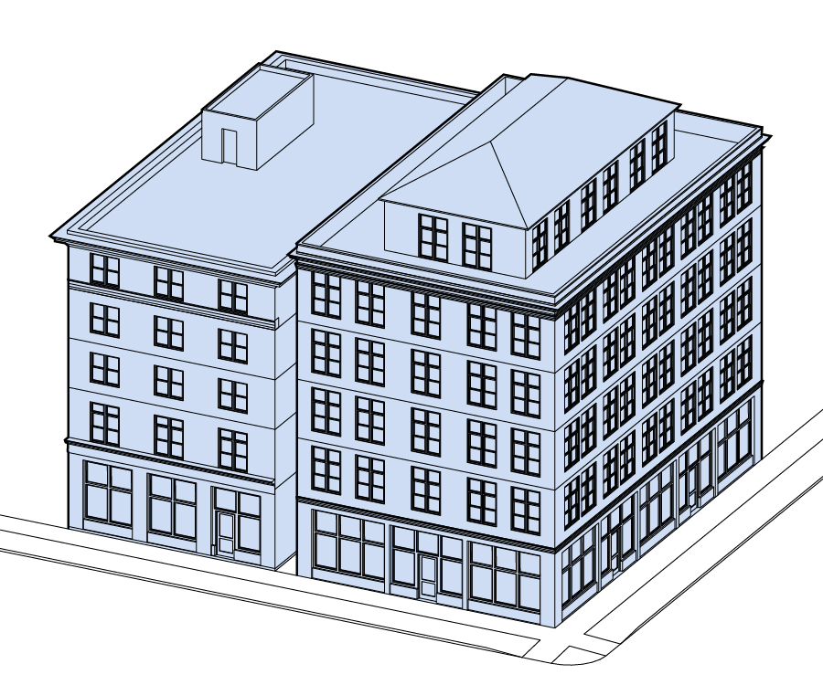 | 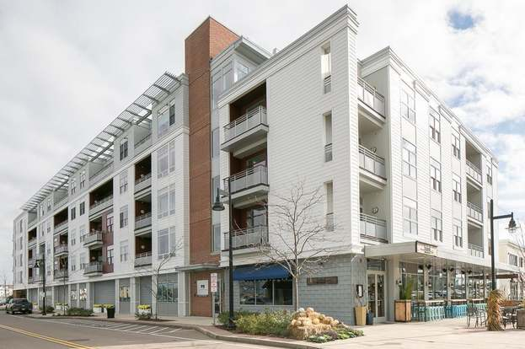
GENERAL COMMERCIAL BUILDING (GCB): A building that typically accommodates a variety of ground floor commercial uses and upper floor office uses, or all office uses, at a scale that is compatible and complimentary to its given district. GC Buildings do not include residential uses. | 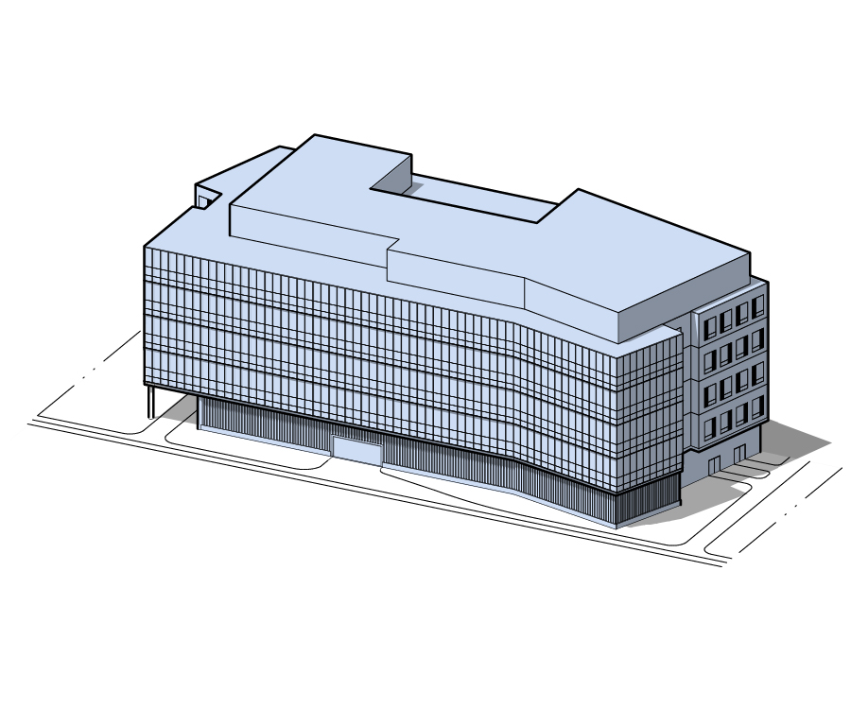 | 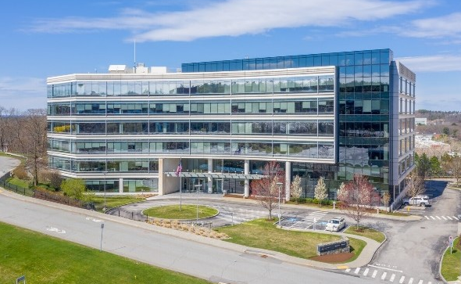
FUELING STATION/CONVENIENCE STORE (GB): This building type reverses the conventional site layout for gas stations with convenience stores by placing the storefront along the street line and the gas pumps and canopy behind. This reverse layout highlights the building, shields the pumps and canopy and pulls the curb-cuts away from the street, creating easier access. | 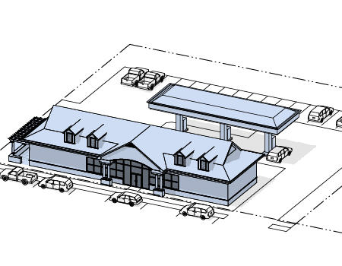 | 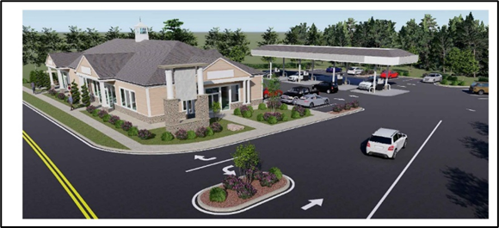
FABRICATION/FLEX BUILDING (FFB): A building located and designed to accommodate a variety of fabrication, trades and general industrial uses and related support services such as office, storage, distribution, and sales. Flex buildings also support these uses and provide affordable space to small and creative business enterprises. | 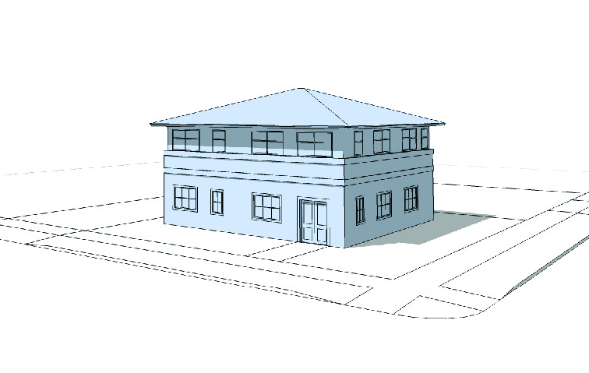 | 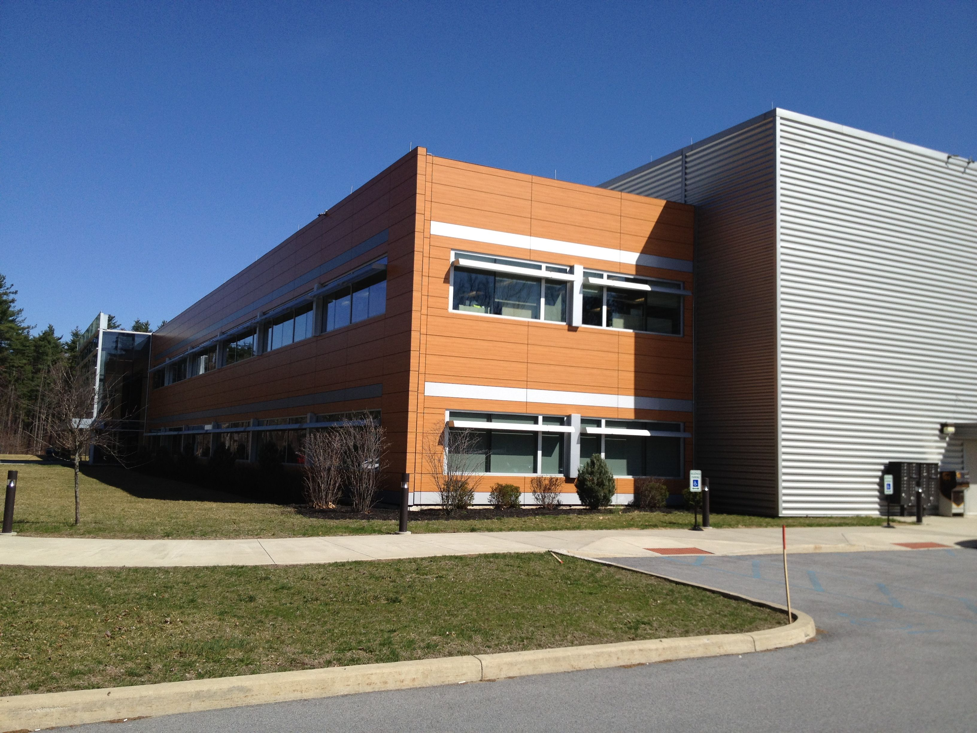
LABORATORY BUILDING (LAB): A designated area within a building equipped to conduct scientific experiments, tests, investigations, research, prototype manufacture, experimental and testing activities including, but not limited to, the fields of biology, life science, chemistry, electronics, engineering, geology, medicine, and physics. | 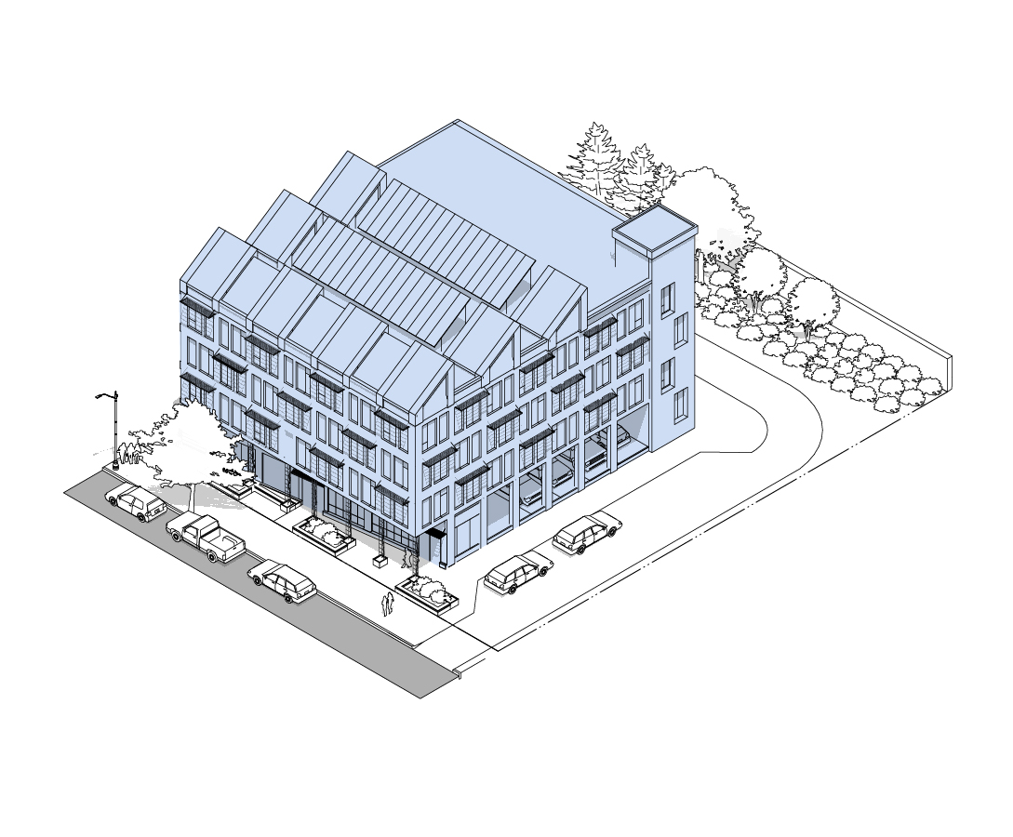 | 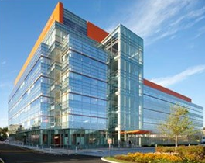

    - ARCHITECTURAL STANDARDS AND GUIDELINES.
      - Building Massing. Building massing should be designed to reduce the overall perceived scale and provide simple and evocative forms that reinforce a sense of a human-scaled environment. Larger building masses are appropriate in the MIX District, however, development sites closer to established residential areas should taper down the building’s mass to provide a more compatible transition in character.
- Scale to Context. The scale of a building is related to the proportion of the components, the overall size, and its relationship to its context. New buildings should reveal different aspects of themselves from different distances and vantage points through articulation and modulation of vertical and horizontal components.
- Break Building Mass into Smaller Forms. New buildings in the MIX District should be composed of smaller aggregated volumes or a single larger volume that is influenced by adding and subtracting space to and from it. The overall volume of larger buildings should be broken down into smaller masses to create a more visually interesting building. Adding or subtracting elements helps to create depth and shadows and lends the building a more human scale. Additive elements include projecting bays, terraces, and balconies. Subtractive elements include recessed terraces or forecourts alcoves, and other stepbacks, and serve to punctuate the facade and create depth using shadows. By varying the roof height, façade plane, setbacks, and floor-to-floor height, a large, monotonous building can be made to appear as a collection of smaller ones that are more pedestrian appropriate in their scale. These various elements and applications should be scaled and detailed to blend with the overall aesthetic of the building.
- Strengthen Prominence of Building Entry. Building massing should reinforce the purpose and readability of the building. For example, building massing should emphasize and highlight the location of the primary building entrance.
- Visually Reduce Larger Building Scale. Large building masses should be broken down through variations in the roof lines, bays, setbacks, upper-level stepbacks, and other types of architectural articulation. Larger buildings should look like smaller component parts put together.
- Simplify Smaller Buildings. Smaller building masses should remain simple and not overly complicated.
- Reinforce Consistency with Context. Building massing and scale should be developed to be consistent with the surrounding context. Building scale should respect the scale of the development site prototype on which it is based.
- Design Variation in Type and Scale. Developments with multiple buildings should vary the building scale and building type. Building types should include enough variability in building massing and scale that repetition is not immediately apparent.

      - Façade Treatments. The character of a building facade depends on several factors: the proportion and orientation of openings, the composition of the fenestration, the color and patterning of the exterior skin, and the relationship between the various parts of the exterior. Preferences in architectural style vary but what matters most in a building’s elevation is quality and consistency. Durable, high-quality materials will add to an expression of the quality and character of a building.
- Break Up Building Lines. Long, monotonous facades can lack a human scale. New buildings should break up vertical and horizontal building lines so that large masses appear to be composed of smaller, discrete volumes. These can be achieved through variations in the depth, changes in material, aggregating architectural elements, and by additive/subtractive processes. Stepbacks, bands of windows, awnings, canopies, and balconies can also visually divide a building into smaller masses.
- Create Solids and Voids in the Facade. Windows, recesses, and similar elements are visually read as “voids” that have been subtracted from the “solid” volume of the building. The ratio of solid to void should be calibrated to the needs of the uses within the building.
- Create Projections and Recesses in the Facade. Commercial and mixed use buildings should be designed to create depth and variety in a façade. This should be achieved through the introduction of projections and recesses. Projections can take the form of bay windows, balconies, and solar shading. Recesses encompass subtractive elements such as alcoves, balconies, terraces, stepbacks, galleries, and arcades.
- Emphasize Corners. Corner conditions are an important part of a facade. Creating multi-story facets, vertical corner elements, bays, or subtractions help to punctuate the corner. Increased height may be appropriate to further emphasize the importance of a critical corner of the building.
- Emphasize Entrances. Where appropriate, entrances should be located frequently along the primary street frontage and be designed in a way that is welcoming to the general public. Entrances should provide protection from the elements and be clearly designated with appropriate signage.
- Ground Floor Windows and Glazing. As appropriate, windows on the ground floor facing the street shall be large and highly transparent to provide views within the buildings from the sidewalk and allowing for natural light to penetrate the interior space.
- Upper Floor Windows and Glazing. Windows on upper levels should be arranged and aggregated to create larger patterns along the façade and a sense of order and visual rhythm while serving to break down the scale of the building.
- Add Balconies and Terraces. Creating depth in the facade adds interest through the interplay of light and shadow, as well as visually breaking down the massing. This can be achieved through additive or subtractive means. Balconies are additive elements that need to be carefully integrated into the architecture so as not to appear “tacked-on” or an afterthought. Terraces act in the opposite way, carving out the volume from a building to provide exterior spaces. These appear as voids if subtracted from the middle portion of a building, and as stepbacks if carved from uppermost levels.

      - Façade Composition and Components. Composition of building facades shall include architectural features and building components that reduce the scale of large building masses, reinforce the building character to reflect a variation of traditional New England styles as well as contemporary forms the MIX District, and provide detail and articulation of the overall building.
  - Emphasize Façade Rhythm and Patterns. Building façades should be broken into vertical and horizontal parts that reinforce a rhythm and pattern in the architecture. Building facades, the pattern of windows and doors, and the roof forms should be integrated as a cohesive design. Variation in the façade is encouraged through decorative components, or functional elements such as terraces or entryways.
  - Highlight Architectural Detail. Additional architectural detail should be used to reinforce the residential character through the use of roof overhangs terraces, covered entries, window and door surrounds, and pediment or parapet detail.
  - Integrate Utilitarian Components into the Façade Design. All functional, utilitarian, or mechanical components of the building facade should be integrated into the façade or screened so as to be part of the composition of the overall building design. Mechanical vents, service elements, and similar components of buildings should be hidden to match other materials and colors of the façade.

FIGURE 16. FRONTAGE ZONE BUILDING COMPONENTS
- Balcony | Description: A platform with a railing mounted on the exterior of the upper story of a building. A balcony is accessible from the building’s interior.  Design Standards:  - A balcony may be recessed, projecting, a combination of the two, or attached to the roof of a portico, porch, or bay.  - A balcony must not be fully enclosed by walls.  - A balcony projecting over the sidewalk of a public street shall have twelve (12) feet of height clearance to the sidewalk grade, eight (8) feet in clearance from the curbline and requires a permit from the Select Board.
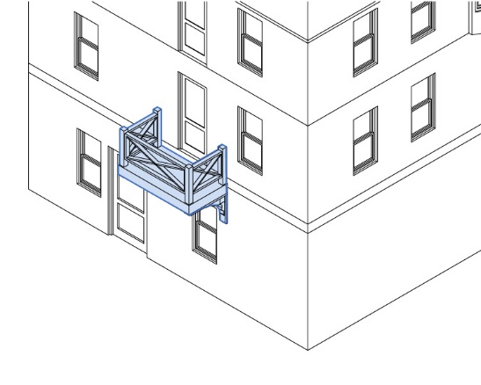
- Bay Window | Definition: A window assembly extending from the main body of a building to permit increased light, multi-direction views, and articulate a building’s facade.  Design Standards: Bay windows projecting over the sidewalk of a public street shall have twelve (12) feet of height clearance, 8 feet in clearance from the curbline. Bay windows in the Building Frontage Zone require a permit from the Select Board if above the public R-O-W.
- Gallery | Definition: A gallery is an attached cantilevered shed or lightweight colonnade within the Building Frontage Zone or overlapping the sidewalk of a public street and providing shelter for pedestrians. The structure is attached to the front façade of a building that is supported by columns. It provides outdoor space adjacent to the public realm.  Design Standards:  - It may be more than one story, but it may not be enclosed on more than three sides.  - The space between the columns and the front façade is wide enough to allow for pedestrian passage along the building façade and the minimum height from above the street must be a minimum of 12 feet.  - Exterior stairs to a gallery may not be located in the Building Frontage Zone  - A Gallery requires a permit from the Select Board if above the public R-O-W.
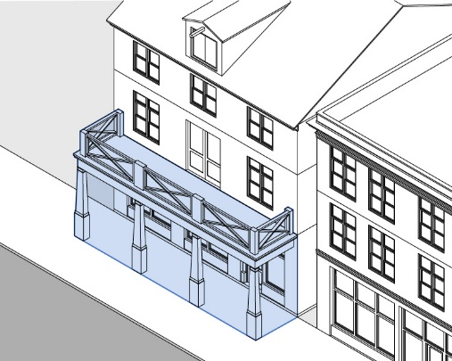
- Arcade | Definition: A ground floor colonnade with habitable space above. An arcade sits in front of the front façade of a building and is deep enough to allow for pedestrian passage along the building facade.  Design Standards:  - It may be more than one story, but it may not be enclosed on more than three sides.  - The space between the columns and the front façade is wide enough to allow for pedestrian passage along the building façade and the minimum height from above the street must be a minimum of 12 feet.  - Exterior stairs to a gallery may not be located in the Building Frontage Zone  - An Arcade requires a permit from the Select Board if above the public R-O-W.
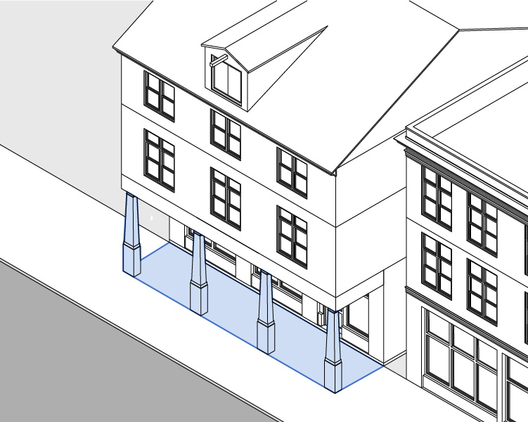
- Canopy (Soft or Hard) | Definition: A lightweight wall mounted covering extending from a building to provide shade and weather protection for pedestrians.  Design Standards:  - An awning must be securely attached to, and supported by, the building and secured such that it does not permanently impact the architectural elements of the building.  - An awning must be made of durable, weather-resistant material.  - An awning must be approximately the same width as the windows or doors with which the awning is associated.  - For soft canopies, canvas is strongly preferred over vinyl.  - An awning projecting over the sidewalk of a public street shall have eight (8) feet of clearance in height to the sidewalk grade, eight (8) feet in clearance from the curbline and requires a permit from the Select Board.
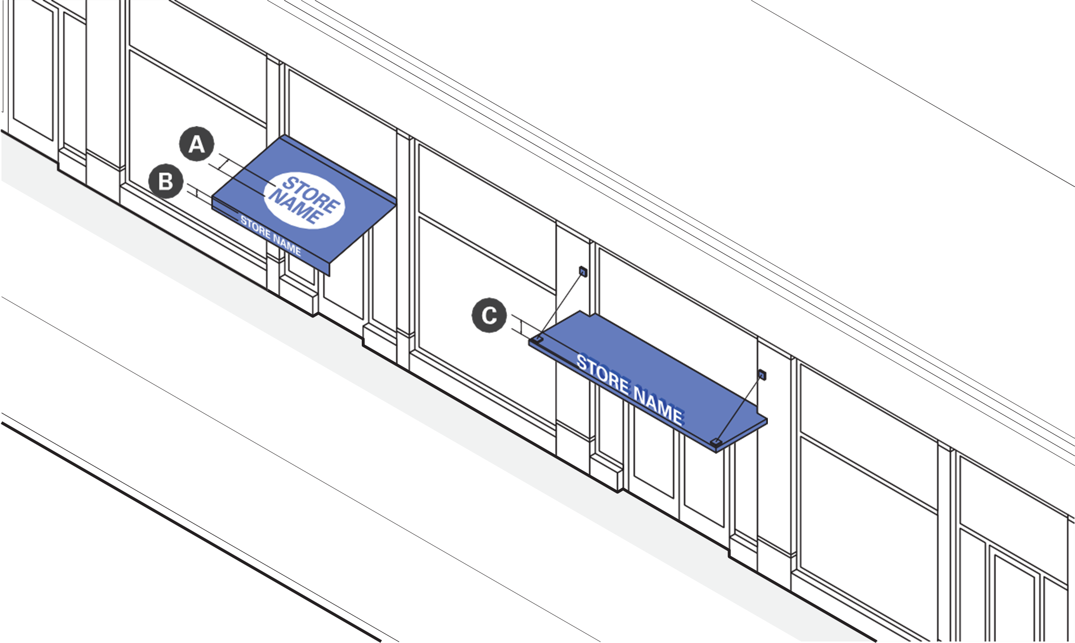

      - Building Roof Forms. Roof form has a significant impact on the character and style of the architecture. Roof forms should be both authentic to the type of building they are part of and strive to reinforce a sense of character and scale in the MIX District.
- Develop Roof Variation. Variation in roof pitch and heights contribute to residential character. Variation in roof types could be used across different buildings in a development but should not be used in combination on a single building.
- Reinforce a Human-Scale to Buildings. Large uninterrupted roof forms shall be avoided and articulated with roof gables, dormers, brick or stone chimneys or other roof forms that provide variety and interest to the overall building form.
- Integrate and Screen Utilities. Mechanical equipment on rooftops shall be screened from visibility of pedestrians standing at grade on surrounding walkways by means of walls, decorative grilles, or roof parapets. Screening features should be a part of the building composition and design. Selected materials shall complement the overall roof and façade design. Other utilities, such as solar panels, shall be integrated into the design of the roof.

FIGURE 17. ILLUSTRATIVE EXAMPLES OF ARCHITECTURAL APPLICATION
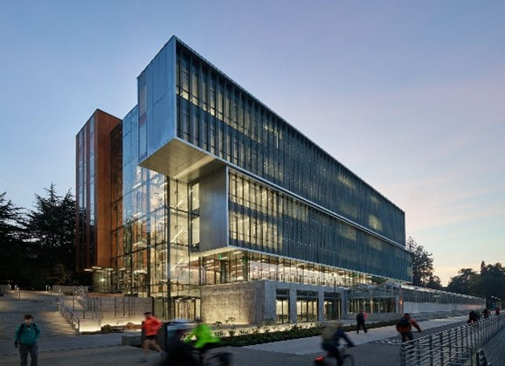 | 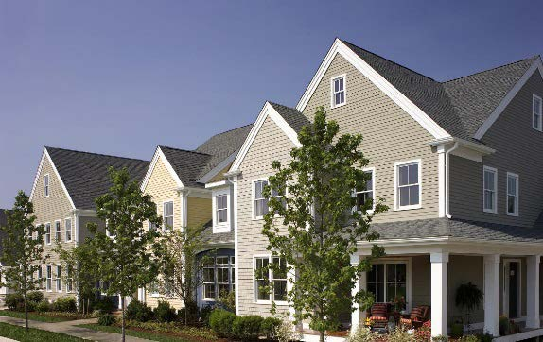
Break up building massing, apply architectural elements, use natural materials,
include quality light fixtures.

    - RESTORING AND REPURPOSING HISTORIC STRUCTURES.
When historic structures exist and are to be retained, the building(s) should integrate and leverage the value of a historic structure within the design and layout of the development plan. Reuse of existing historic structures should follow the U.S. Secretary of the Interior’s Standards for Rehabilitation as appropriate.
- Integrate Historic Structures. Existing historic structures should be integrated into any new development plan. New buildings and additions should complement and reflect the structure and style of any existing older structures. Historic structures should be considered for adaptive reuse, preservation, sensitive rehabilitation, or restoration as may be appropriate to the historic structure and nature of its reuse.
- Emphasize Compatible Development. The reuse of the existing historic structure should be compatible with the ability of the structure to accommodate intended uses. New construction or additions should also be compatible with and complementary to the architectural style of the historic structure.
- Pursue Thoughtful Renovation. When a historic structure is being renovated to residential use, that renovation should retain the integrity of the historic structure and be sensitive to its underlying design characteristics or historic significance.
- Create Authenticity to Current Time. New construction or additions should be authentic to the current time in which they are built.

    - SUSTAINABLE BUILDING MATERIAL AND APPLICATIONS.
Products and materials that are specified for construction should be selected based on their durability, maintenance and recyclability characteristics, energy sources and consumption profile, and with respect to their performative and sustainable qualities. Durable and natural materials ensure that the building is built for the long-term. General guidelines for material selection and application in the Commercial and Industrial Districts are as follows:
- Locally Sourced Materials. Whenever possible, materials should be locally sourced, have a low embodied energy content, and be recyclable. Using local materials reduces the transportation and distribution costs of the product. Products that reduce raw material use should be chosen because of their resource conservation. Zero or low-emission building products should be specified to improve air quality. The durability and aesthetic value of a material is intrinsically related to its quality. Choosing high-quality materials ensures that the buildings last. Locally sourced materials offer an additional layer of benefits by supporting the local economy, reducing the energy involved in transportation, and being a product of the region.
- Recyclable, Low Embodied Energy Materials. The carbon footprint of a material is a product of the cumulative amount of energy invested in it over its lifespan, including the harvesting of raw materials, refinement, production, transportation, and disposal. Choosing materials that require lower levels of energy at each stage of this process can substantially lessen its environmental impact. If the product is designed to be recycled, it reduces the energy needed to harvest raw materials in its next iteration.
- Texture, Variation and Tactility. Natural materials such as wood, glass, and stone are recommended in commercial and mixed use buildings. These materials read as monolithic from a distance but revealing variations in tone and texture as one moves closer towards them. Selecting the right combination of materials for the façade of a building requires a balance between too few which may look uninteresting and stark, and too many which can appear overstimulating and busy.
- Ground Level Materials. The quality of materials and detailing at a building’s ground level should be the highest, as this is the level that the public will primarily interact with. It should incorporate large amounts of glazing, attractive signage, and deploy awnings and canopies to protect people from the elements and visually denote entrances. The glazing should ideally be low-e and low-iron, and mullions should be placed to reinforce horizontal and vertical composition lines.
- Upper Levels Materials. In the upper levels of taller buildings with detailed eaves, materials should be selected that complement the level of detail on the ground level and draw the viewer’s eye upward. In the upper levels of buildings that visually downplay height with stepbacks, sloped roofs, or structural breaks, materials should be chosen that visually recede with more restrained details.
- Paving. Paving materials used to create sidewalks, plazas, terraces, and other hardscapes should be natural materials such as stone, or patterns using colored concrete. This can foster a stronger sense of place and create a more interesting pedestrian experience. These surfaces and material selections should facilitate movement for persons with disabilities.
- High-Performance Building Skin. As applicable, new buildings should use low emissivity windows, high R-value spray insulation, reduced thermal bridging, adequate depth exterior walls, solar shading, and sustainable cladding which all contribute to a high-performance building envelope.
- Green Roofs and Walls. Green roofs and walls reduce storm water runoff by absorbing and then slowly releasing rainwater. They protect the underlying roof, reduce solar gain during the summer months, and provide habitat for wildlife. If located on a lower roofs or walls of the building, they can also be a visual amenity. These sustainable applications are highly recommended in the MIX District.
- Latent and Renewable Energy Sources. In a climate with large seasonal temperature swings, efficient methods for heating and cooling buildings are critical to reducing a building’s carbon footprint. As applicable, developers should utilize the latent energy of their sites to meet energy needs such as through the following applications:
- Roof-installed solar panels and solar shades over surface parking lots which produce energy and reduce solar gain.
- Geothermal energy can be captured to offset the large temperature variations between seasons and reduce the thermal loading of the building.
- Small roof mounted or pole mounted wind turbines that harness latent energy on site.
- Installing energy efficient mechanical systems, appliances, and other devices as a priority.

FIGURE 18. ILLUSTRATIVE EXAMPLES OF SUSTAINABLE BUILDING APPLICATIONS
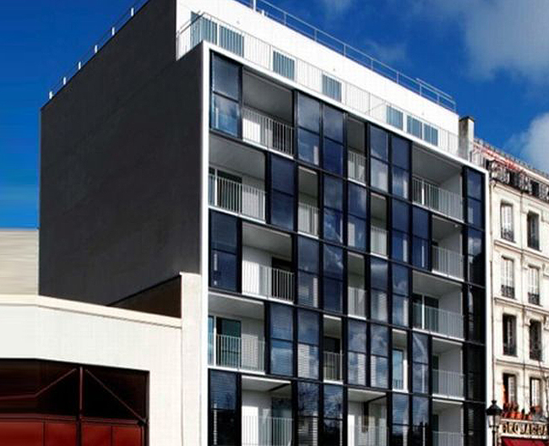 | 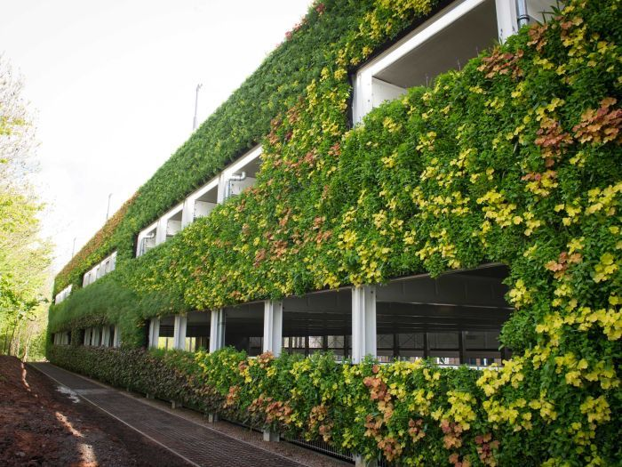 | 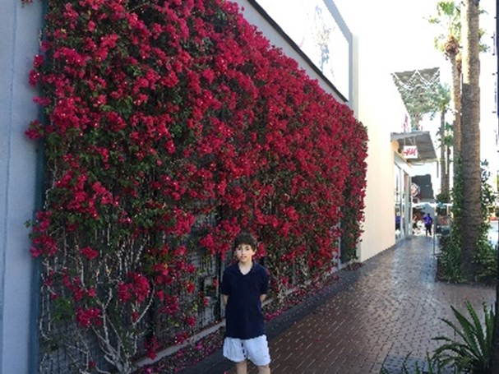
Solor Building Skin | Green Facades
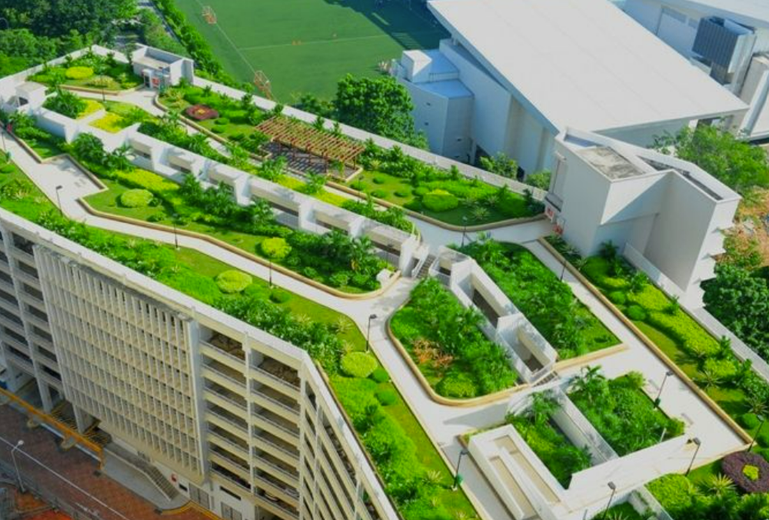 | 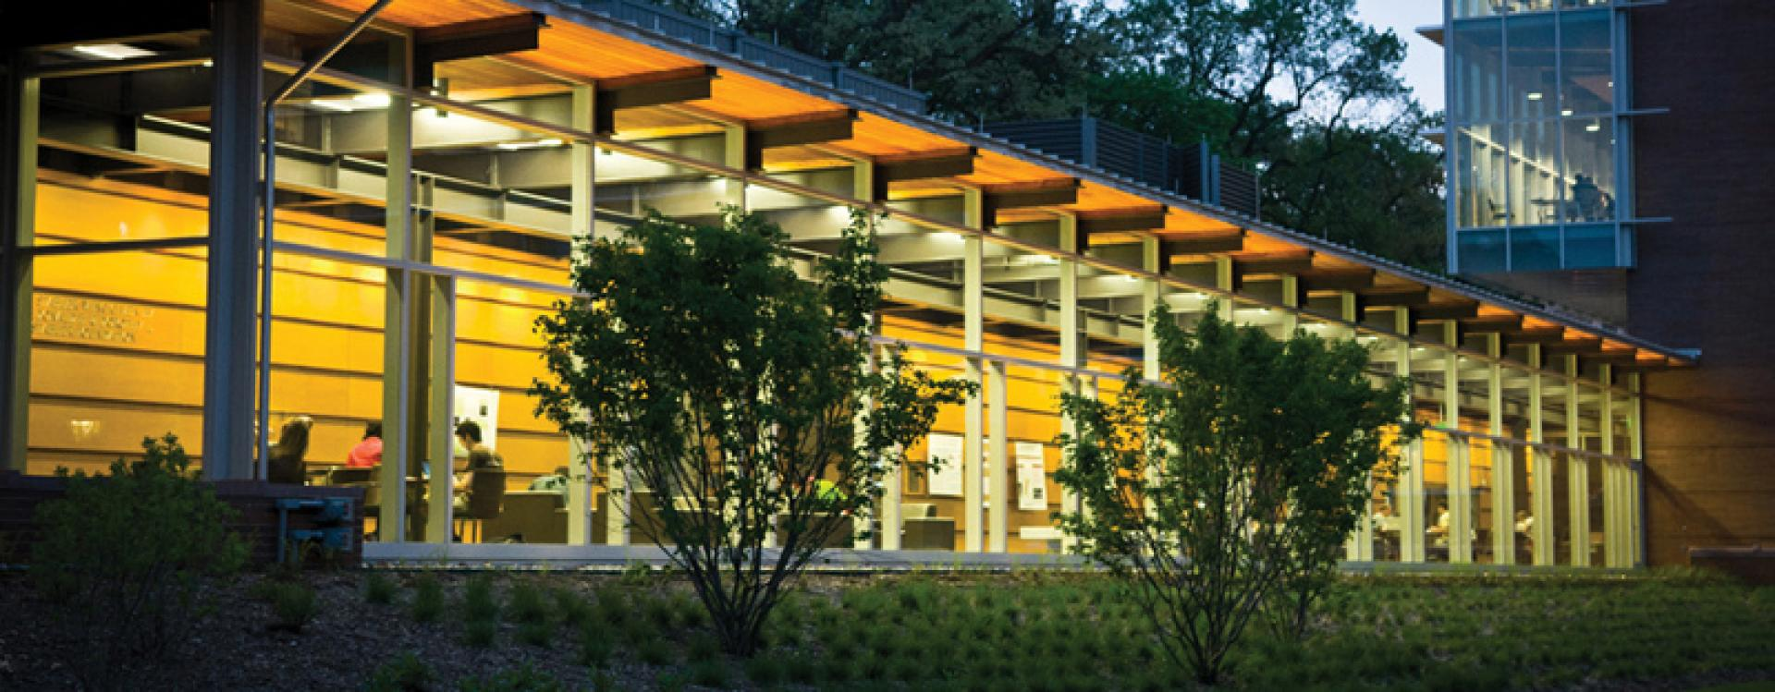
Break up building massing, apply architectural elements, use natural materials, include quality light fixtures.

    - BUILDING LIGHTING.
Building lighting should be used to highlight and emphasize functional and decorative aspects of the building’s massing and facades. Building lighting shall be energy efficient and designed to be minimized and focused on key components of the building. Lighting design must comply with any lighting requirements in the Zoning Bylaw.
- Define Hierarchy of Lighting. Building entries should be a primary focus of building lighting to reinforce safety, security, and convenience for access to the building. Lighting to highlight building features, key architectural elements, accents, or signage should be a secondary focus of building lighting.
- Minimize Quantity of Lighting. Building lighting shall meet the minimum lighting standards in the Zoning Bylaw but not provide lighting in excess of IES recommendations. Downward-directed, dark-sky compliant or “fully shielded” lighting shall be used to minimize glare, skyglow and light trespass (spillage) beyond the development site.
- Coordinate Light Fixture Design. Lighting fixtures shall be selected to contribute to the overall character of the building, and consistent with the overall design of the site development. Lighting color temperature (CCT) should be selected between 2200 K and 2700 K and shall not exceed 3000 K.

  - SITE AND BUILDING SIGN STANDARDS
Signage for developments in the MIX District shall be functional and attractive. Site signage must comply with the Sign Regulations in Article XIII of the Zoning Bylaw. These guidelines focus on well-designed signage in the context of compliance with applicable regulations.
    - SIGN STANDARDS AND GUIDELINES.
    - General Guidelines. Signage for residential developments shall identify the community, promote a positive image, and harmonize with its surroundings.
- Reinforce Quality and Character. Sign design should be appropriate to the varied type and scale of developments in the MIX District. The use of colors, font styles, and sign faces, materials, and lettering should reflect a compatible blend of traditional and contemporary designs in the reflect the diversity of the MIX District.
- Emphasize Legibility and Clarity. A sign shall be readable, simple, and legible, with careful consideration of the proportion of lettered and graphic areas to the overall size and location of the sign, and consideration of the purpose and intended audience of the sign. Lettering should be concise and graphically balanced. Generally, a sign’s text and graphic elements should not occupy more than two-thirds of the sign panel area.
- Focus Signage Content. Signage messaging should be simple and brief. Signage should communicate only the name of the development and/or wayfinding within the community.
- Use Signage Color. Signage color should complement building materials and color palette.
- Coordinate Signage Materials. Signage materials should be selected for durability, ease of maintenance, and compatibility with building materials and design.

    - Sign Harmony.
      - Reinforce Compatibility with Context. Signs should be designed to be compatible with adjacent properties through sign style, height, type, scale, and location. Illumination should be designed to minimize impact on adjacent properties.
      - Coordination with Building Architecture. Sign design and placement should relate to and harmonize with the building architecture. Signs should not overwhelm or obscure building features.

    - Site Signage.
      - Integrate Signage Design with Landscape. Site signage shall be integrated with site landscape design and be used to reinforce gateway locations and site entry points. Landscape plantings should be included to anchor and integrate signage into the site plan.
      - Simplify Development Signage. Signage should indicate the overall development name and branding features. This type of signage should be balanced and in scale with both the overall scale of the development and the surrounding context.
      - Minimize Wayfinding Signage. Simple directional signage may be provided on the site to inform visitors and customers of entries, parking areas, or other information. Wayfinding signage should be consistent and compatible with other development signage. Wayfinding signage shall not obstruct or cause conflict with regulatory or traffic-related signage.

    - Sign Illumination. External signage illumination is encouraged and shall be targeted only onto the sign, not onto adjacent buildings or towards vehicles or pedestrians.
      - Signage Lighting Design. Externally illuminated signs should be lit from the top or bottom of the sign, pointing directly at the sign, using fully shielded fixtures. All sign lighting shall be designed and installed to prevent light from spilling beyond the physical edges of the sign or creating glare. Light fixtures should be simple and unobtrusive and should not obscure the sign’s message and graphics. Raceways, conduits, and other electrical components should be concealed from public view.
      - Provide Consistent Lighting Levels. Lighting should provide a consistent and even wash of light across the sign. Luminance levels should not exceed 100 cd/m² nits at any location on the sign and measured under conditions of a fully lite display.
    - Signage. Signage for MIX District development must comply with the requirements in Article XIII of the Zoning Bylaw. The design objective for signage in the MIX Districts is to communicate a positive and clear identity, be part of the building and façade design, and harmonize and reflect the character of its surroundings.
  - Promote Legibility and Clarity. Signage shall be readable, simple, and legible, with careful consideration of the proportion of lettered and graphic areas to the overall size and location of the sign. Consideration shall be given to the purpose and intended audience of the sign. Signage should be concise, graphically balanced, and optimize communication.
  - Define Hierarchy of Signage and Purposes. The primary sign is most important, and its information should be prominent. Secondary and supporting information should defer to the most important information.
  - Coordinate Signage Type and Scale. Signs shall be scaled to their use and intended viewer. Sign lettering and graphics should be clear, simple, and legible from a distance, under different lighting conditions. The scale of signs should be appropriate for their intended audience and its location on a building or site. Automobile-oriented signs shall be legible at posted driving limits.
  - Free-Standing Signs. Free-standing signage shall be designed to complement the overall character and design of the other site and building components.
  - Building Signage. Signage shall be specifically integrated into elements of a building’s architecture. Careful attention shall be given to placement, detailing, material palette, scale, and proportions to effectively integrate into the building’s architecture.
  - Monument Signs. These freestanding signs are the most appropriate for business parks and large-scale commercial office or retail buildings. Monument signs have a low profile with no open space between the ground and the sign. The foundational structure should be constructed of masonry materials and the sign board should be integrated into the foundational structure or on top of the foundation but within the overall height limit of five (5) feet. Sign boards should have a maximum length of fifteen (15) feet, constructed of durable materials, and illuminated by an external source of light. The front edge of a monument signs should be located no closer than five (5) feet from the front and side property line and integrated with the streetscape and landscape treatments.
  - Pedestrian-Oriented Projecting Signs. Projecting signage encompasses all signs that are permanently affixed to a building along the street line and project out toward the street and sidewalk. They are highly visible to motorists, pedestrians, and cyclists, and create a more interesting and engaging public realm. They can be attached to building elements such as an awning or canopy. Projecting signs are highly encouraged pedestrian oriented commercial and mixed use districts. Their scale, level of detail, and proportions should be calibrated with that of the building and scaled to enhance the pedestrian experience.
  - Integrate Signage Design with Landscape. Signage should be integrated with landscape design on site and be used to reinforce gateway locations and site entry points. Landscape plantings should be included to anchor and integrate signage into the site plan.
  - Coordinate Signage Placement. Sign locations shall consider site characteristics regarding roadway and access points, building location, views in and out of the property, pedestrian and vehicular circulation, and vehicular safety and visibility.
  - Materials and Colors that Complement the Building. Signs should be conceived of as an integral part of a building’s architecture, and as such designed with the same degree of consistency and attention to detail that is employed for the larger building. The colors, materials, and the overarching aesthetic of a sign should work seamlessly with the architecture to create a visually harmonious façade. The design and materials employed in signage on a development site and building shall be illustrated on renderings for Planning Board review.

    - Sign Lighting. Lighting should be from fixtures that prevent unwanted light from spilling onto adjacent properties. The fixtures chosen to light the signs should be either hidden from view or complement the architecture of the building. Internally lighted or animated signs are discouraged.
- Signage Lighting Design. Externally illuminated signs should be lit from the top of the sign, pointing downward at the sign, using fully shielded fixtures. All sign lighting shall be designed and installed to prevent light from spilling beyond the physical edges of the sign or creating glare. Light fixtures shall be simple and unobtrusive and shall not obscure the sign’s message and graphics. Raceways, conduits, and other electrical components shall be concealed from public view.
- Provide Consistent Lighting Levels. Lighting shall provide a consistent and even wash of light across the sign. For internally illuminated signs, illuminance levels should not exceed 100 cd/m² nits at any location on the sign and measured under conditions of a full white display.

FIGURE 19. ILLUSTRATIVE EXAMPLES OF SIGN DESIGN
 | 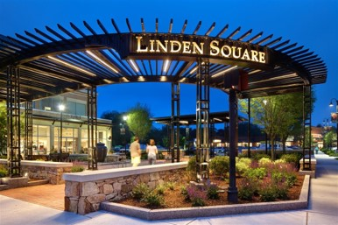 | 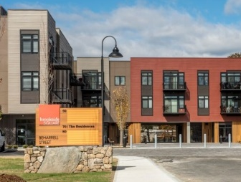
Entrance signs for different forms of residential and mixed-use developments.

  - COMPLETE STREETS STANDARDS
    - PURPOSE.
- To encourage the development of a well-connected travel network, composed of direct and convenient routes that reinforce a walkable and bikeable mixed use environment.
- To encourage “Complete Streets” that accommodate multiple modes of transportation, consistent with the character of commercial, industrial, and mixed use districts, and attractive to pedestrian and bicyclists.
- To promote pedestrian and motor vehicle safety, economic vitality, enhance the character of the public realm along primary and secondary streets, and promote the social, environmental, and health benefits provided by walkable development patterns.
    - APPLICATION.
- Public Infrastructure Projects. These standards shall be considered in the design and utilization of new or redesigned public streets.
- Private Participation. Applicants for site plan approval for a development project, subdivision approval, building permits, or change of use should participate in partnership with the Town of Burlington on the construction of Complete Streets improvements planned for public and private streets in the MIX District including the areas within the public right-of way between the vehicle lane and street line along the applicant’s property frontage. All improvements shall be approved by the Select Board in consultation with the Planning Board and Department of Public Works.
    - STANDARDS FOR ALL THOROUGHFARES.
- Complete Street Zones and Components. Figure 18 below identifies complete street components are allowed in each segment of public realm zone which includes the public right-of-way and the Building Frontage Zone.
- Complete Street Design and Construction Standards. Public streets must be engineered and constructed in accordance with the Town of Burlington Subdivision Regulations. In the absence of official standards, Thoroughfares must be designed and constructed according to the standards deemed to be appropriate by the Town Engineer and Planning Board. Figure 18 below provides design guidelines for new public streets in the MIX District.

    - STREET TYPES AND DESIGN ALTERNATIVES.
- Applicability. Figure 18 below identifies the types of streets and design standards allowed in the MIX District. Consistency with the Town of Burlington Complete Streets Guidelines and Subdivision Regulations construction standards shall apply as follows:
- All new streets, whether public dedicated or privately held;
- The reconstruction of elements within the public right-of-way when improvements have been disturbed by development; or
- Substantial street reconstruction of a street.
- Waiver and Alternative Compliance. The Planning Board may waive requirements or allow for an alternative compliance application for a particular street type or component when it finds that applying the requirements of Figure 18 in a particular instance is either practically infeasible or detrimental to the safety of pedestrians or cyclists and these detrimental effects cannot be mitigated.

FIGURE 20A. COMPLETE STREET TYPES AND DESIGN OPTIONS
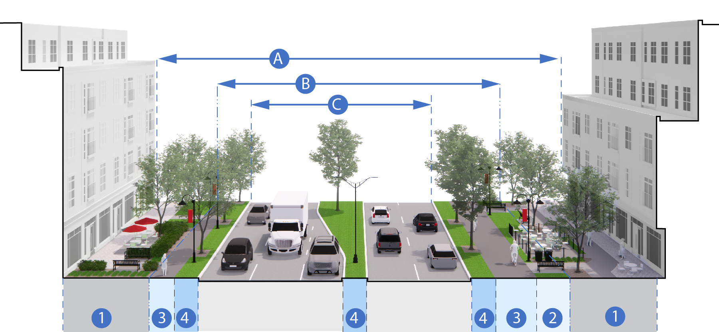
Gateway Boulevard
Street Component | Specifications
(A) Street/Building Enclosure Ratio | Varies
(B) Right-Of-Way | 100 Ft. Min.
(C) Travel Lane | 12 Ft. Min.
(C) Bike Lanes | Required/5 Ft. Min. and 3 Ft. Buffer
(1) Building Frontage Zone | Required/30 Ft. Min.
(2) Furnishing/Utility Zone | 5 Ft. Min.
(3) Throughway Zone | 5 Ft. Min.
(3) Sidewalk | See Multi-Purpose Pathway
(3) Multi-Purpose Path | Required/ Min. 8 Ft.
(4) Street Enhancement Zone | Required/8-Ft. Tree Belt
(4) Parking Lane | Optional/ Min. 8 Ft Wide and 22 Ft. Long

FIGURE 20A. COMPLETE STREET TYPES AND DESIGN OPTIONS
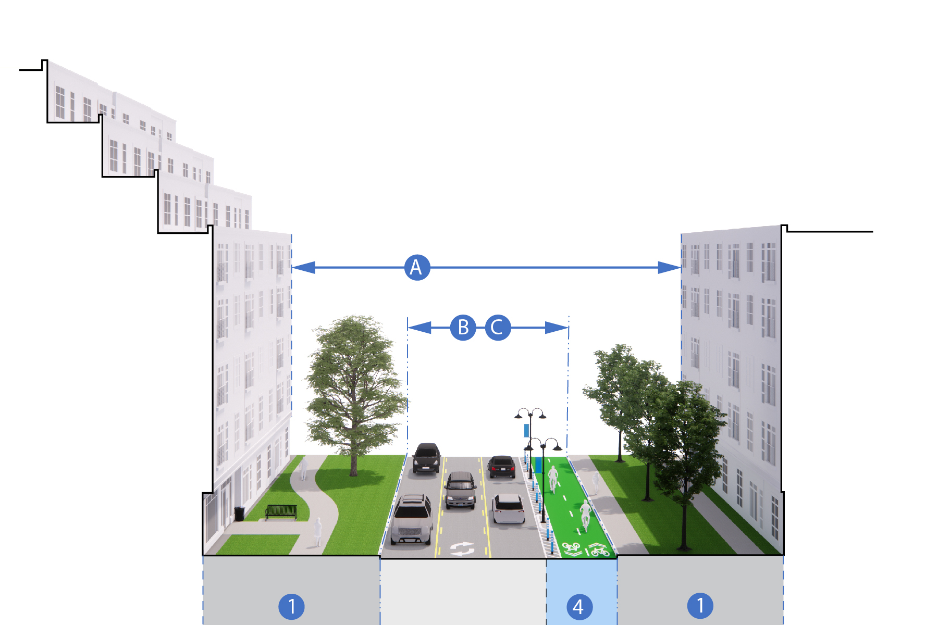
Collector Street
Street Component | Specifications
(A) Street/Building Enclosure Ratio | Varies
(B) Right-Of-Way | 100 Ft. Min.
(C) Travel Lane | 12 Ft. Min.
(C) Bike Lanes | Required/5 Ft. Min. and 3 Ft. Buffer
(1) Building Frontage Zone | Required/30 Ft. Min.
(2) Furnishing/Utility Zone | 5 Ft. Min.
(3) Throughway Zone | 5 Ft. Min.
(3) Sidewalk | See Multi-Purpose Pathway
(3) Multi-Purpose Path | Required/ Min. 8 Ft.
(4) Street Enhancement Zone | Required/8-Ft. Tree Belt
(4) Parking Lane | Optional/ Min. 8 Ft Wide and 22 Ft. Long

FIGURE 20B. COMPLETE STREET TYPES AND DESIGN OPTIONS
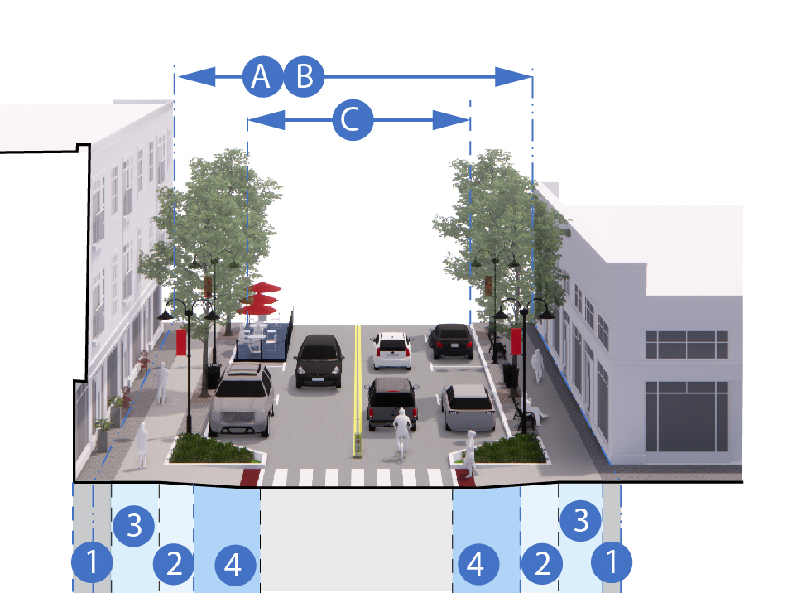 | 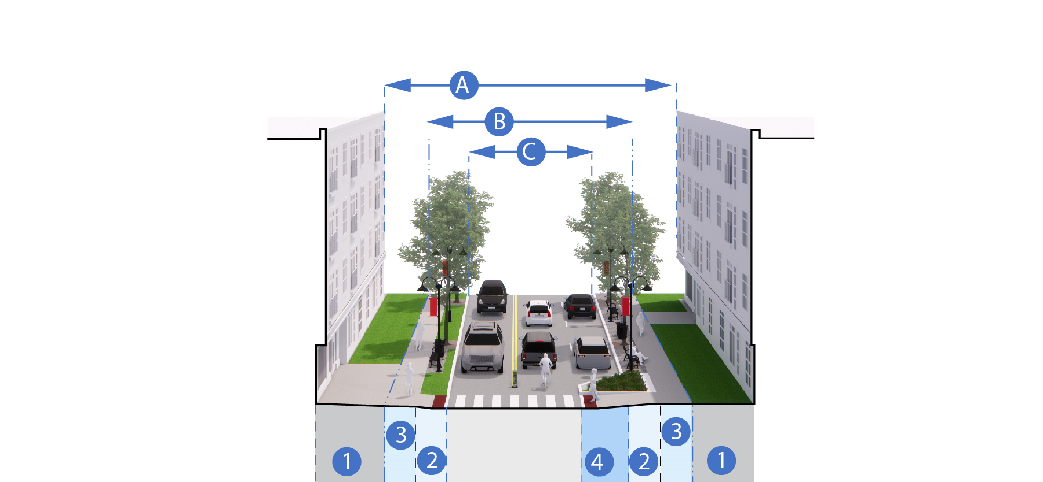
 | Local Street
Street Component | Commercial Street | Local Street
(A) Street/Building Enclosure Ratio | Varies | Varies
(B) Right-Of-Way | 50 Ft. Min. | 40 Ft. Min.
(C) Travel Lane | 11 Ft. Min. | 11 Ft. Min.
(C) Bike Lanes | Required/5 Ft. Min. and 3 Ft. Buffer | Optional/Sharrows or Informal
(1) Building Frontage Zone | 30 Ft. Minimum | 30 Ft. Minimum
(2) Furnishing/Utility Zone | 5 Ft. Min | 4 Ft. Min.
(3) Throughway Zone | 5 Ft. Min. | 4 Ft. Min.
(3) Sidewalk | Required/Min. 5 Ft. | Required/Min. 5 Ft.
(3) Multi-Purpose Path | Optional/Min. 8 Ft. | Optional/Min. 8 Ft.
(4) Street Enhancement Zone | Required/8-Ft. Tree Belt | Required/5-Ft. Tree Belt
(4) Parking Lane | Optional/ Min. 8 Ft Wide and 22 Ft. Long | Optional/1 Side or Informal

FIGURE 21. COMPLETE STREET ZONES AND COMPONENTS
COMPLETE STREET ENHANCEMENTS | C. Vehicle Throughway Zone (ROW) | 1. Building Frontage Zone | 2. Furnishing & Utility Zone | 3. Pedestrian Throughway Zone | 4. Street Enhancement Zone
Sharrows
Bicycle Facilities (Stands, Corrals, Public Bikes)
Crosswalks
On-Street Parking Lanes
Curb-Extensions
Bus Facilities (Stop, Shelter, Pull Outs)
Utilities/Green Infrastructure
Street Trees and Tree Belts/Pits
Public Seating
Bicycle Parking
Sidewalks/Multi-Purpose Path

    - VEHICLE THROUGHWAY ZONE.
- Design and Construction. A Vehicle Throughway must be designed and constructed in accordance with the Town of Burlington’s Street and Sidewalk Design Standards and/or the Subdivision Regulations. In the absence of official standards, Thoroughfares must be designed and constructed according to standards deemed to be appropriate by the Town Engineer and Planning Board in accordance with the following standards.
- Number of Travel Lanes. Motor vehicle travel lanes may have a width between ten (10) feet and twelve (12) feet. No more than two (2) motor vehicle travel lanes may be combined for any single direction of traffic flow. See Figure 20.
- Construction Materials. Materials must be as follows unless otherwise specified by the Department of Public Works:
  - Pavement must be hot mix asphalt.
  - The surface course must be 1.5” deep.
  - The binder course of the pavement must be Geotextile plus 2.5” asphalt.
  - The subbase must be 24” for poor to fair soils and 12” for good to excellent soils.
- Pervious Pavement. This alternative pavement may be acceptable on private streets if planned and implemented in consultation with the Department of Public Works (DPW) and an engineer who has experience with pervious pavement, and established specifications such as those provided by the University of New Hampshire Stormwater Center Design Specifications for Porous Asphalt Pavements and Infiltration Beds.

    - BICYCLE TRAVEL FACILITIES.
- Bicycle Travel Facilities may be located within the Vehicle Throughway Zone, or the Street Enhancement Zone. (For example, a separated bike lane may be located between on-street parking and the Furnishing and Utility Zone).
- Separated Bicycle Lanes must be designed in accordance with the 2015 MassDOT Separated Bike Lane Planning and Design Guide or the latest version.
- Bicycle throughways (bicycle lanes) may be constructed of hot mix asphalt or porous asphalt. Porous asphalt must be planned and implemented in consultation with the DPW and an engineer who has experience with pervious pavement, and established specifications such as those provided by the University of New Hampshire Stormwater Center Design Specifications for Porous Asphalt Pavements and Infiltration Beds.

    - CROSSWALKS.
- The Continental Crosswalk pattern is preferred by the Town of Burlington.
- Crosswalks must be aligned with the pedestrian throughways to which they are connected, unless granted a waiver by the Planning Board under Site Plan Approval.
- Where an adjacent pedestrian throughway is wider than the prescribed width of the crosswalk, the crosswalk markings should be widened to match the adjacent pedestrian throughway.
- Crosswalks must be thermoplastic unless epoxy is approved by the DPW. The Planning Board may allow flush granite and a mix of materials such as stamped concrete with flush granite to create visual cues and reinforce a specific design character.

FIGURE 22. PEDESTRIAN CROSSWALK DESIGN STANDARDS
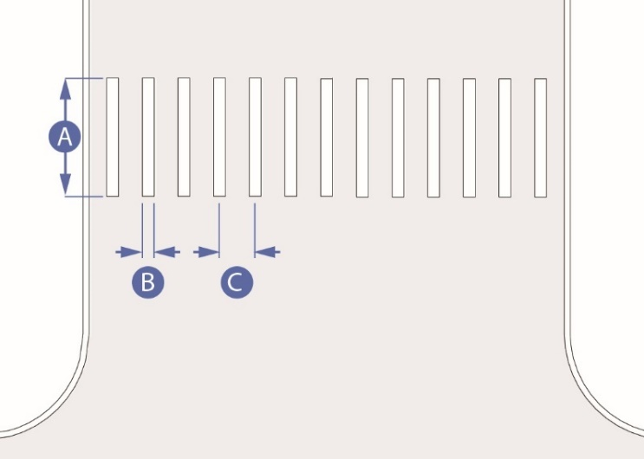
 | Stripe Width (Min.) | 10 feet
 | Stripe Thickness | 1 feet
 | Stripe Length | 10 feet
 | Stripe Offset (baseline, to be customized based on expected tire positions) | 3 feet on center

    - STREET ENHANCEMENT ZONE
FIGURE 23. STREET ENHANCEMENT ZONE
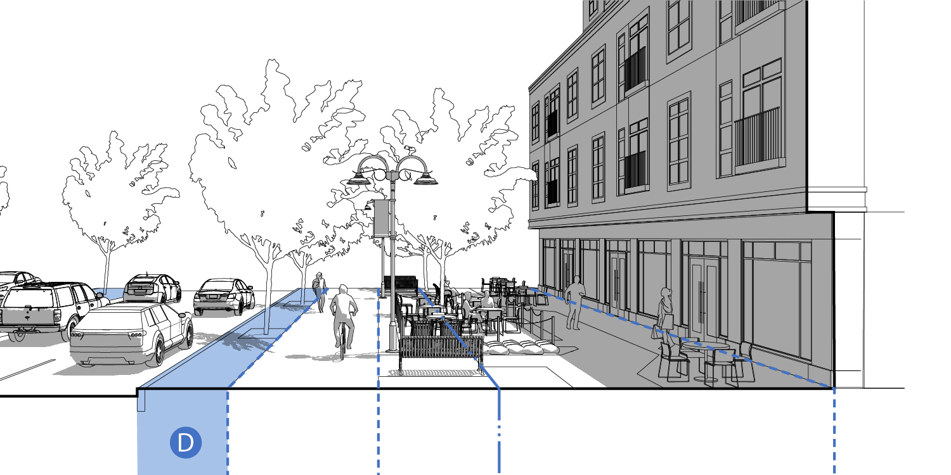

- Overview. The Street Enhancement Zone includes the area between the Furnishing & Utility Zone and the edge of motor vehicle and bicycle travel lanes. Components in this zone include permanent components such as tree belts and street trees, landscaping, on-street parking spaces, stormwater infiltration areas, curb extensions, and crosswalks. The Street Enhancement Zone can include some of the same elements as the Furnishing & Utility Zone, such as public seating, bike racks and corals, bus stops and shelters, and plantings.
- On-Street Parking Lanes.
- Where motor vehicle parking lanes are desired, they must be eight (8) feet wide minimum and twenty-two (22) feet long maximum for parallel parking spaces; and nine (9) feet wide and eighteen (18) feet long for angled parking spaces.
- Angled on-street parking may be 60⁰ or 90⁰ angle parking. Sixty degree (60⁰) angle parking may be head-in or reverse-angle parking per the recommendation of the DPW.
- Gutter seams, drainage inlets, and utility covers must be flush with the pavement surface and oriented to prevent conflicts with bicycle tires.
- Curb Extensions. Curb extensions are required at mid-block crossings and may be required at intersections as deemed necessary by the DPW based on traffic volumes, visibility, accident history, and required vehicle turning radii. Curb extensions should only be installed where motor vehicle traffic deflection is provided through on-street parking, a parklet, another curbside use, or pavement markings.

FIGURE 24. CURB EXTENSION DESIGN STANDARDS
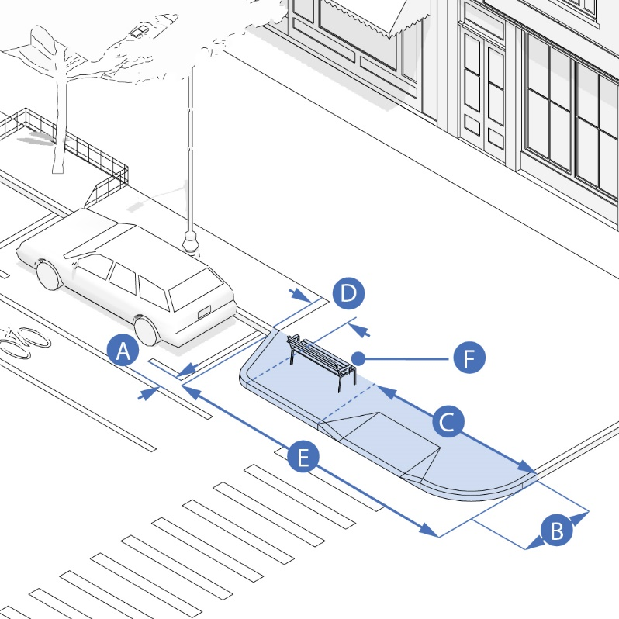
 | Buffer between curb extension and travel lane (Min.) | 1 foot
 | Width (Recommended Min.) | 6 feet
 | Minimum length of curb extension | Site specific. From intersecting street to far edge of crosswalk.
 | Curb return | Should located outside of width of crosswalk
 | Recommended width of curb extension (Min.) | 20 feet
 | Placement of street furniture, trees, green infrastructure in curb extension is encouraged, but must not interfere with sight lines or travel pathways

- Curb extensions should occupy as much of the width of the parking lane as is practicable, while providing a minimum of 1 foot between the edge of the curb extension and adjacent motor vehicle or bicycle lanes. The recommended minimum width of a curb extension is 6 feet. When a curb extension includes a streetside gutter adjacent to a bicycle lane, the curb extension must be set back so that the gutter does not extend into the bike lane.
- A curb extension should be, at a minimum, as long as the width of the adjoining crosswalk with the curb returns from the curb extension located outside of the width of the crosswalk. Where possible, a curb extension should be 20 feet long to restrict parking within 20 feet of an intersection.
- Where a sidewalk extension includes a bus stop, the design of the sidewalk extension must follow the guidelines for Boarding Bus Stops found in the latest edition of the NATCO Transit Street Design Guide.
- Incorporation of street furniture, trees, and/or green infrastructure into curb extensions is encouraged. However, these elements must not interfere with pedestrian flow, emergency access, or visibility between pedestrians and other roadway users.

- Bus Facilities.
- Where bus stops exist, site design and ancillary improvements to the public realm should ensure:
          - Adequate sight lines for bus stop signage.
          - Minimization of circulation conflicts between bus stops users and vehicles or pedestrians using the adjacent public realm or site.
          - Attractive surroundings and amenities for bus riders, including where appropriate covered bus shelters with illumination and adequate seating for anticipated riders, bicycle racks, and information kiosks.
- Bus Pullout design should be consistent with the guidelines found in the latest edition of the NATCO Transit Street Design Guide. The “Curbside Pull-Out Stop” is the preferred bus stop type in the Town, except when the DPW and Planning Board find another bus stop type is preferable.

- Public Utilities.
- The design and construction of all water and sewer utilities, stormwater management infrastructure, public lighting, and public furniture is subject to review and approval by relevant Town departments and/or adopted standards by the Planning Board and/or Department of Public Works.
- All new electrical, communications, and cable utilities must be located underground.
- Street Trees and Tree Pits Installation Requirements. Refer to requirements in the Furnishing & Utility Zone below.
- Green Infrastructure. Green Infrastructure is encouraged wherever possible, subject to the standards found in Town of Burlington Subdivision Regulations and Planning Board Rules & Regulations.

    - FURNISHING & UTILITY ZONE
FIGURE 25. FURNISHING & UTILITY ZONE
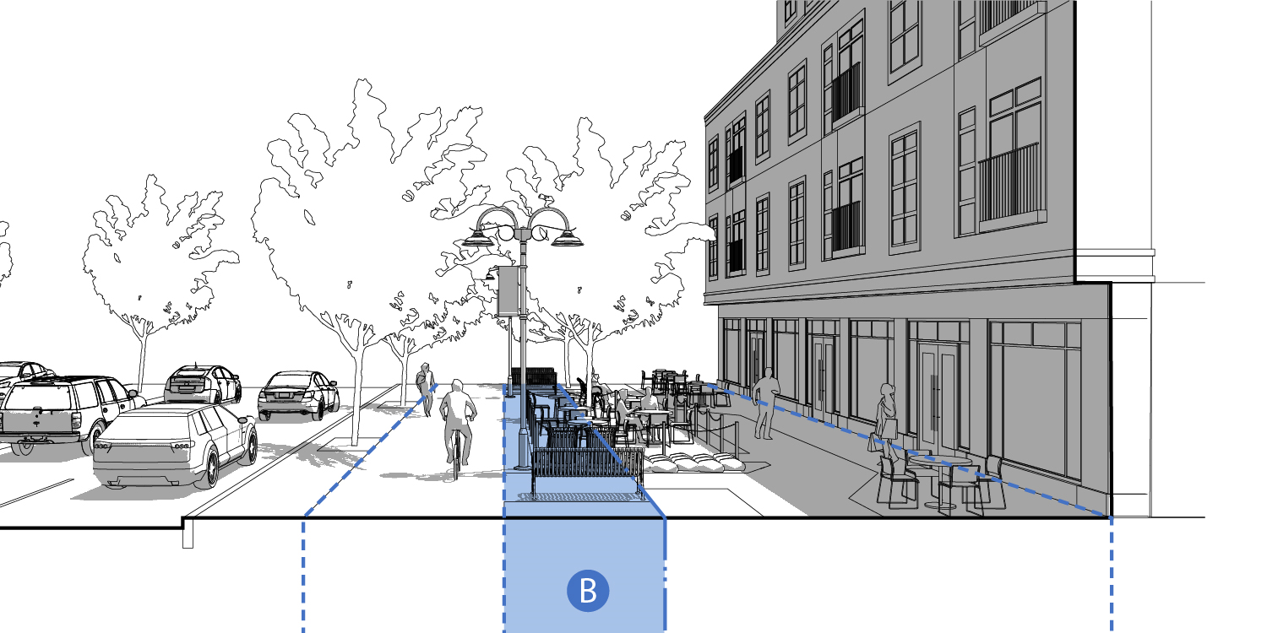

- Overview. The Furnishing & Utility Zone is the area of the sidewalk where pedestrians might pause or rest on benches or cafe seating and where utilities such as lighting and hydrants, may be located. This area may also be planted with street trees and landscaping. The Furnishing & Utility Zone varies in width.
- Width. The required width of the Furnishing & Utility Zone is determined by street type. See Figure 18.
- Surfacing. Unless otherwise specified in these regulations or in specifications adopted by DPW, the Furnishing & Utility Zone must be surfaced with concrete and edged with a granite curb on the streetside where no Street Enhancement Zone exists. Pervious concrete unit paving, per the specifications of the DPW, may be used over areas contributing to street tree minimum recommended soil volumes (see Street Tree and Tree Pit Standards).
- Street Trees and Tree Pits Installation Requirements.
- New street trees should be planted within the Furnishing & Utility Zone to fill any gaps greater than 50 feet long between existing street trees. The Planning Board may grant a waiver from this requirement based on numbers d), e), f), and g) below.
- Street trees should be planted in a regularly spaced pattern with trees aligned parallel to the curb. Trees should generally be spaced thirty to forty (30 - 40) feet on center depending on species, and no greater than forty (50) feet on center.
- When trees are planted both in the Furnishing & Utility Zone and in Street Enhancement Zonee Zone or the Building Frontage Zone, the trees on either side of the Pedestrian Throughway should be aligned in an allee pattern, when possible.
- Spacing of trees planted in the Furnishing & Utility Zone or Building Frontage Zone may be adjusted to avoid obscuring windows, doors, and signage.
- A tree must not be planted in a location where it will block passage to a doorway or stairs, or where it will narrow a Throughway Zone to less than the minimum dimensions required by these standards and guidelines.
- The Planning Board may, at its discretion, grant a waiver or alternative compliance application for street tree requirements when the tree would obstruct a terminated vista or when a tree would obstruct views to or into a civic space.
- Street Trees must be planted at least five (5) feet from fire hydrants, six (6) feet from street signs, seven (7) feet from curb cuts, and thirty (30) feet from stop signs. The edges of tree planting beds must be at least two (2) feet from gas, electric, water, and sewer lines, and at least four (4) feet from oil fill pipes.
- A tree pit must be a minimum of five (5) feet wide (dimension perpendicular to curb) and ten (10) feet long (dimension along curb). The Planning Board may grant a waiver from these specific dimensions, if this configuration is not possible due to site constraints, and an alternate configuration that amounts to a minimum of 50 square feet of surface is provided.
- A tree should be planted generally in the center of its surrounding soil area.
- The soil area around a street tree must be protected from compaction due to foot traffic. When the adjacent throughway is five (5) feet or wider, a tree guard (a metal fence) at least 18 inches tall, must be installed around three sides of the tree (the curbside remains unfenced). An acceptable alternative to a tree guard is a raised planter with block enclosure and 20 inches in height which may include seating. When the adjacent throughway is less than five (5) feet wide, the soil area around a street tree must be protected by porous rubber tree pit surfacing. To prevent tripping hazards, the finished grade of the porous rubber tree pit surfacing must be level with the grade of the surrounding pavement.
- A gap of approximately eight (8) inches must be left between any mulch or porous rubber tree pit surfacing and the trunk of the tree to avoid mounding above the trunk flare.
- When planted, street trees must be a minimum height of ten (10) feet and/or two and one half (2.5) inches in caliper.

FIGURE 26. STREET TREE PLANTER DESIGN STANDARDS
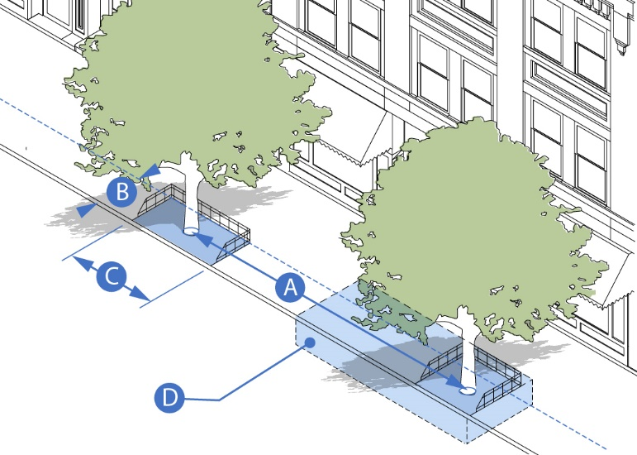
 | Tree Spacing (Recommended Min./Max.) | 20 to 30 feet/40 feet
 | Tree Pit Width (Recommended Min.) | 5 feet
 | Tree Pit Length (Recommended Min.) | 10 feet
 | Recommended Soil Volume | 600 cubic feet (min.) for small tree or 1,000 cubic feet (min.) for large tree
 | Minimum soil surface area for alternate tree pit dimensions | ≥50 square feet

- Recommended Techniques for Achieving Adequate Soil Volume. Urban soils beneath sidewalks are often compacted and deprived of water and nutrients, significantly compromising tree health, stability, and lifespan. When those conditions exist, the following techniques are strongly encouraged:
- The use of a modular suspended paving system, like Silva Cells, beneath the surrounding concrete sidewalk. The structural units in these systems are designed to bear the load of the concrete surface above, while providing void space which is filled with planting soil. Besides offering an environment for a tree’s roots to grow, the more loosely compacted soil in these systems also offers bioretention of stormwater, which enters the system through permeable paving or through the tree pit.
- Adjacent tree pits’ soil volumes should be connected as a continuous trench, paved with permeable pavers or porous rubber surfacing.
- Structural soil is not a substitute for modular suspended paving systems. The space for planting soil within structural soil is limited to the void spaces among the aggregate (only about 20% total). This is significantly less than the soil volume in a modular suspended paving system. Therefore, structural soil, while less expensive per cubic foot, ultimately restricts tree growth and health compared to a modular suspended paving system and so it should only be used as a supplement (around the backs and edges).

FIGURE 27. RECOMMENDED ELEMENTS OF A
MODULAR SUSPENDED PAVEMENT SYSTEM
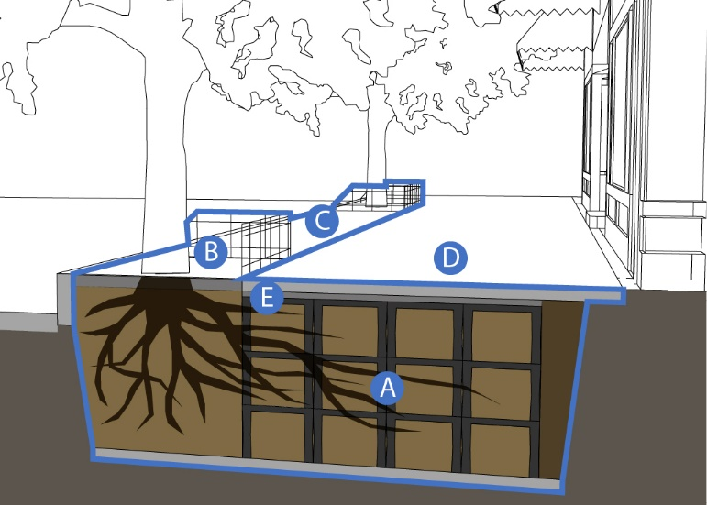
Modular suspended pavement system filled with planting soil that supports concrete sidewalk and aggregate base while allowing tree root growth and stormwater infiltration. The diagram above shows a system that provides 1,000 cubic feet of soil volume (5 feet deep, 10 feet wide, and 20 feet long).
Soil pit protected by tree guard fencing or permeable rubber mulch walking surface.
Permeable paving strip, over modular suspended pavement system
Concrete sidewalk and aggregate base
Edge restraint between aggregate base and tree pit opening

- Public Seating Access. (Also applies to Street Enhancement Zone, Furnishing & Utility Zone, and Building Frontage Zone).
- Public seating is an essential component of MIX District’s public realm. It should be provided whenever possible. Public seating can take a variety of shapes including chairs, benches, seating walls, or low tables.
- Any seating within the Street Enhancement Zone (e.g. in a curb extension), the Furnishing & Utility Zone will be considered public seating. Public seating must be available for public use and must comply with the standards in this section.
- Providing public access to seating in the Building Frontage Zone is encouraged. Seating in the Building Frontage Zone must comply with the standards in this section.
- Public Seating Placement and Orientation. Public seating should be sited according to the following design guidelines:
- Site benches to provide views, preferably of people walking by.
- Provide seating in a variety of micro-climates. Locate some seating where there is summer shade, preferably from street trees. Locate other seating where it will be warmed by winter sun, especially adjacent to surfaces that will hold that heat, like stone or brick walls.
- Maintain adequately spaced pathways from parked cars and loading zones.
- Where possible, provide one (1) foot between the front of the bench and any Throughway Zone so that the legs of people sitting on the bench do not obstruct the Throughway Zone.
- Where the back of the seat abuts a building, wall, or other obstruction, a 1 foot minimum clear width should be provided for maintenance and trash removal.
- Public seating should generally be oriented so that it faces the nearest Throughway Zone. When two or more seats are arranged facing each other, the benches may be oriented perpendicular to the Throughway Zone. When public seating is adjacent to a bus stop, it should face the bus stop, and be located to the right of the front door loading zone.
- Seating should be provided both with and without armrests if possible. Armrests provide stability for those who require assistance sitting and standing. Seating without armrests allows a person in a wheelchair to maneuver adjacent to seating or to slide onto it easily. Seating areas longer than 4 feet should provide armrests or other dividers to discourage reclining.

FIGURE 28. PUBLIC SEATING PLACEMENT AND ORIENTATION
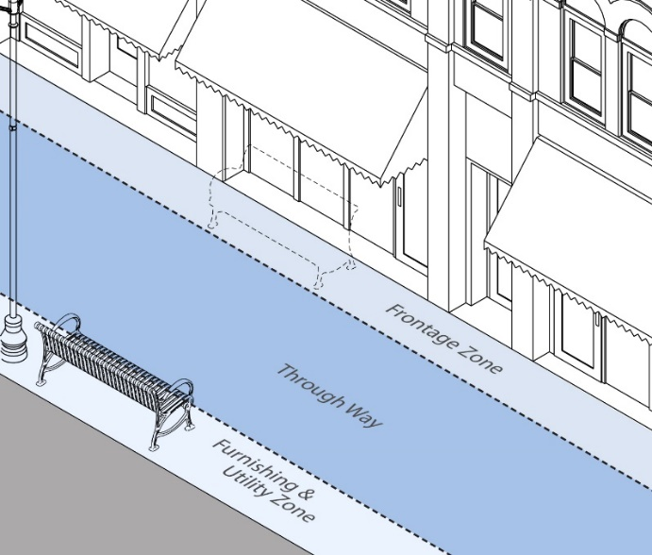 | 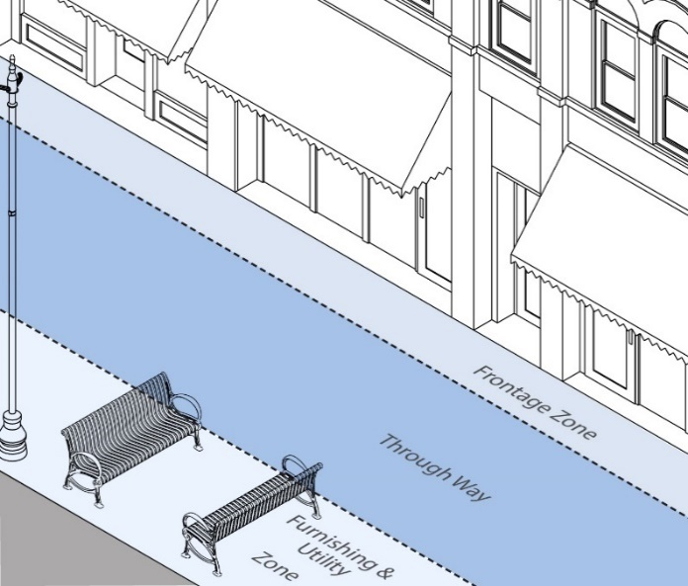

- Design Standards. Public seating must be sited according to the following design standards:
- Public seating must not be placed where it would narrow the Throughway Zone below the required minimum width.
- Public seating must not be placed where it would obstruct access to a building entrance or exit.
- Public seating must not be placed where it would obstruct access to bicycle parking, informational kiosks, fire hydrants, trash receptacles, or other street furniture.
- Public seating must be permanently affixed to the ground. Moveable furniture may be acceptable within the public realm if a responsible party agrees to maintain the moveable furniture in good working order, remove it at night and during snow emergencies, and replace it as necessary.

FIGURE 29. ILLUSTRATIVE EXAMPLES OF PUBLIC SEATING
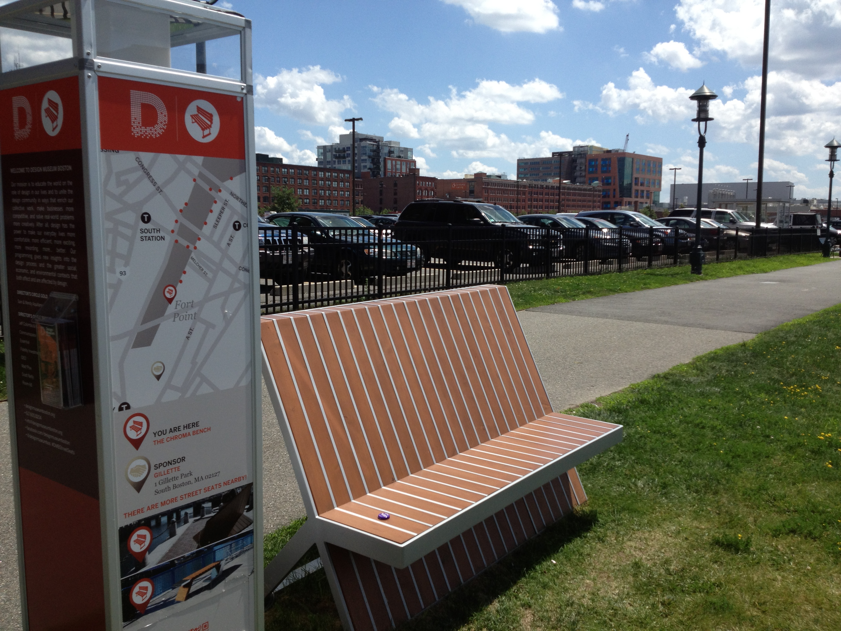 | 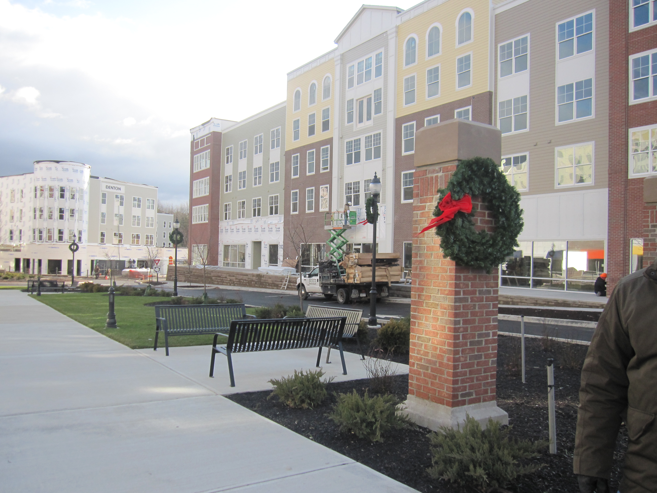 | 

- ADA Requirements. The following ADA clear widths must be maintained when installing public seating:
- Three (3) feet minimum on either side of the seating.
- Five (5) feet minimum from fire hydrant.
- One (1) foot minimum from any other amenity, utility, or fixture.

- Bicycle Parking. (Also applies to Street Enhancement Zone, Furnishing & Utility Zone, and Building Frontage Zone).
- The following list sets out the Town’s preferred locations for bicycle parking from most preferred location to least preferred location: the Furnishing & Utility Zone, the Street Enhancement Zone, and the Building Frontage Zone, beside a building, behind a building.
- Installation of a bicycle rack within the public right of way requires approval from the Select Board.

FIGURE 30. BICYCLE PARKING DESIGN STANDARDS
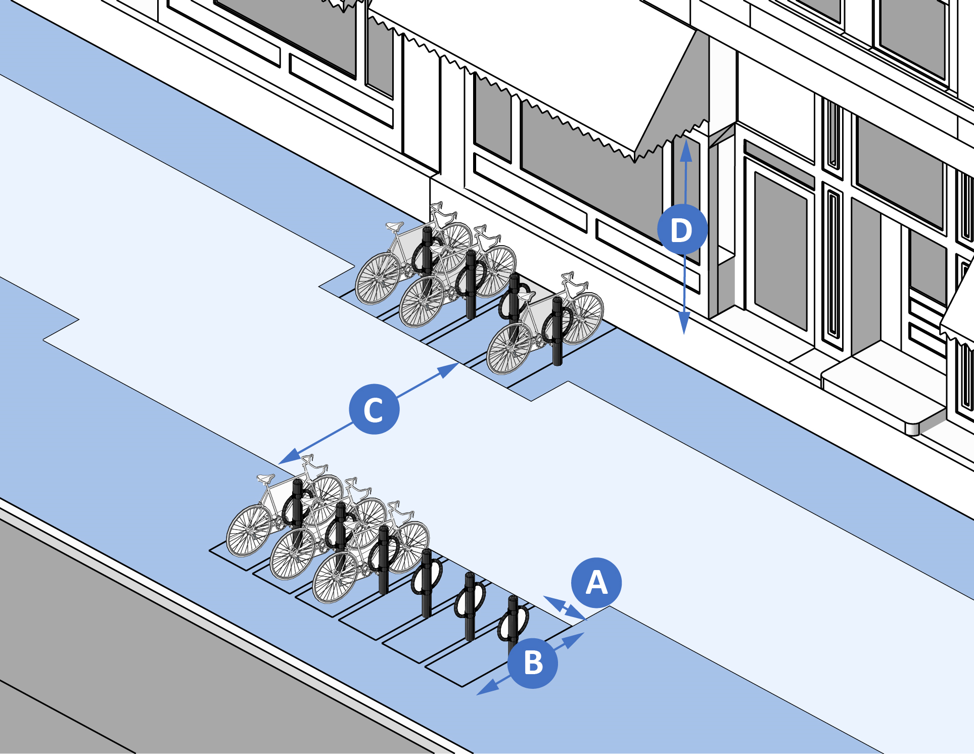 |  |  | 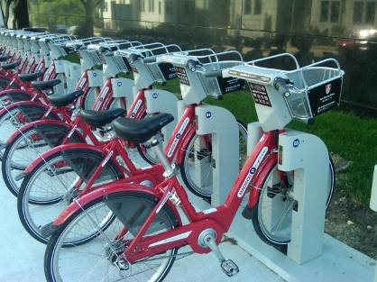
 | Minimum space between bicycle racks | 2.5 feet on center if arranged side-by-side; 8 feet if arranged end-to-end | 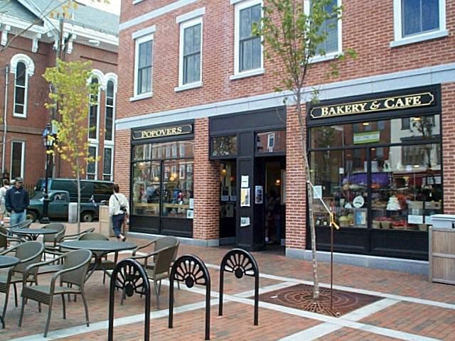
 | Minimum length of space | 6 feet
 | Minimum Pedestrian Throughway adjacent to bicycle parking | 5 feet
 | Minimum clear height above bicycle parking space | 7 feet

- Driveway and Alley Crossings.
- A driveway or alley that crosses a paved Furnishing & Utility Zone must be designed to maintain the grade and clear width of the adjacent Pedestrian Throughway and must include sloped flares on both sides of the driveway apron.
- A driveway or alley that crosses a continuously planted Furnishing & Utility Zone must be designed to maintain the grade and clear width of the adjacent Pedestrian Throughway and must include returned curbs.
- The appearance of any walkway (i.e. scoring pattern or special paving) must be maintained across any driveway or alley to indicate that, although a vehicle may cross, the area traversed by a vehicle remains part of the sidewalk.
- A curb cut may be no wider than the driveway or vehicular entrance it serves, excluding flares or returned curbs. Additional curb cut standards may be established for individual zoning districts.
- Shared driveways are permitted and encouraged.

FIGURE 31. DRIVEWAY AND ALLEY CROSSING DESIGN STANDARDS
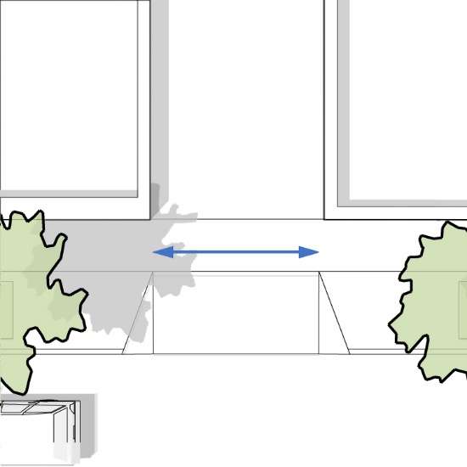 | 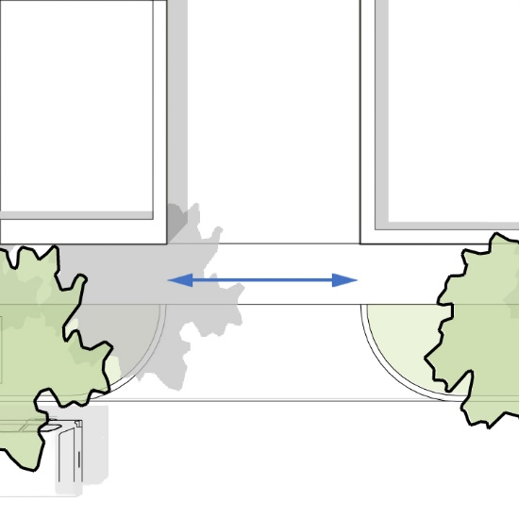
Driveway Apron with Sloped Flares | Driveway Apron with Returned Curbs

    - PEDESTRIAN THROUGHWAY ZONE.

FIGURE 32. PEDESTRIAN THROUGHWAY ZONE
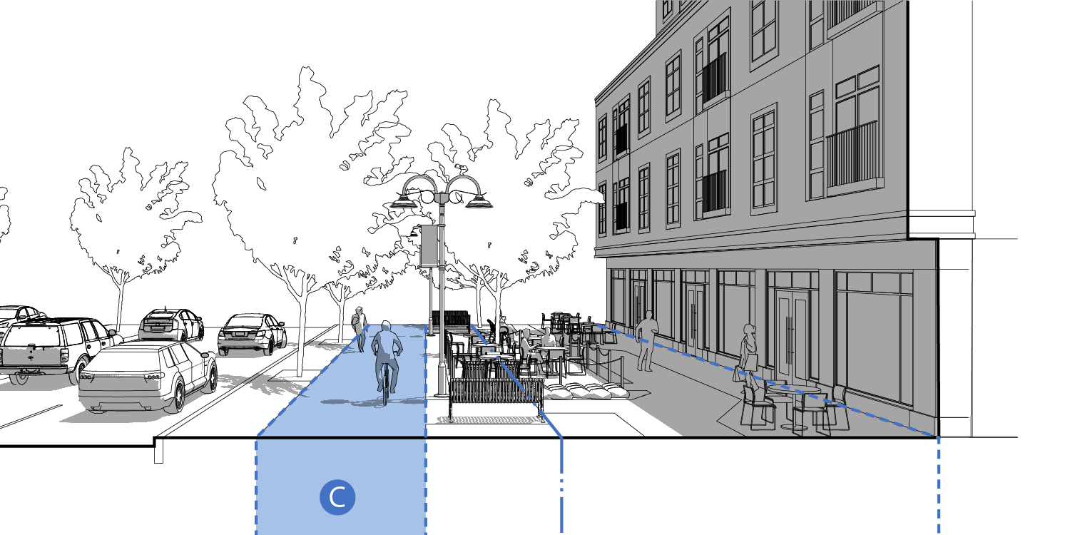

- Description. The Pedestrian Throughway Zone is also known as the sidewalk. It is the primary portion of the sidewalk used for active movement and travel by pedestrians. The Pedestrian Throughway Zone must be of an adequate width for comfortable two-way pedestrian movement, must remain clear of obstacles, and its paving surface must be relatively level.
- Width. The required width of the Pedestrian Throughway Zone must be in accordance with the appropriate Street Type found in Section 1.6.
- Accessibility. All new and reconstructed sidewalks must be accessible to and usable by persons with disabilities in accordance with the Americans with Disabilities Act and the Rules and Regulations of the Massachusetts Access Board (521 CMR), as amended.
- Construction. Pedestrian Throughways (sidewalks) must be constructed of cement concrete that is 4 inches deep. Where a driveway crosses a sidewalk, the sidewalk’s cement concrete must be 6 inches deep.
- Pavement. The pavement design of Pedestrian Throughways must be continuous for the full length of each block face.

FIGURE 33. PEDESTRIAN THROUGHWAY DESIGN STANDARDS
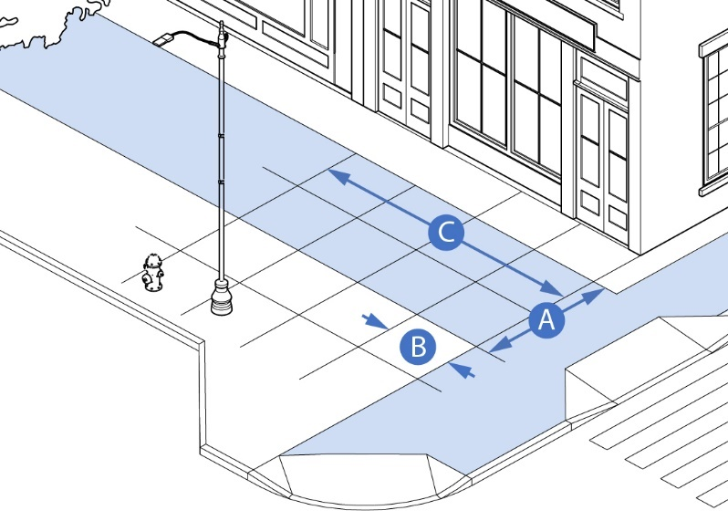
 | Minimum Width | Per Street Type
 | Control Joint Maximum Spacing | One (1) Control Joint per 5 feet
 | Expansion Joint Maximum Spacing | One (1) Expansion Joint per 25 feet. Wherever possible, align control and expansion joints with boundaries between sidewalk zones and facade segments.

    - BUILDING FRONTAGE ZONE.
FIGURE 34. BUILDING FRONTAGE ZONES
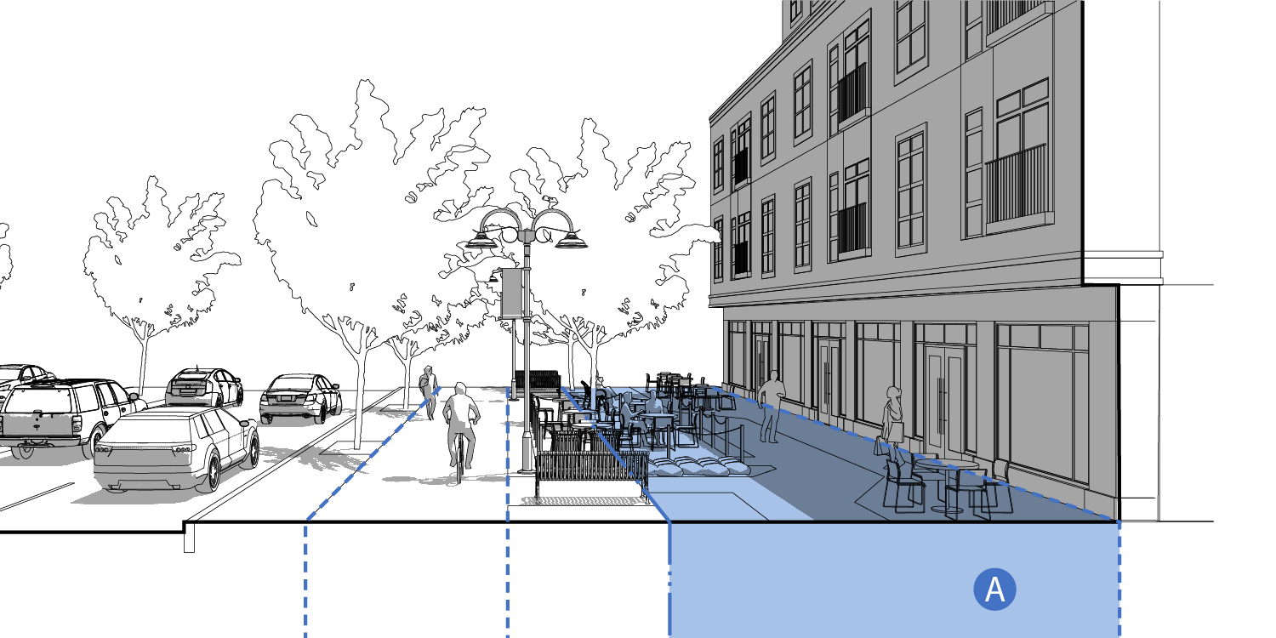

- Description. A Building Frontage Zone is the setback space between the street facing façades of the building and the street R.O.W. line. Building Frontage Zone uses provide a compatible transition and interface between the Private Realm (private buildings and land uses) and the public realm (public sidewalks, streets, and civic spaces). Outdoor Amenity Spaces are required in the Building Frontage Zone along Primary and Secondary Streets.

  - PUBLIC REALM ACTIVATION STANDARDS
    - PURPOSE.
To facilitate a vibrant “Outdoor Room” in the MIX District that promotes economic vitality, social activity, and health benefits within the public right-of-way and on properties within the Building Frontage Zone. The “Public Realm” includes all publicly-owned spaces and privately-owned spaces that are publicly accessible such as buildings, streets, open spaces such as parks, squares, plazas, courtyards, and trails.
    - APPLICATION.
- Public Realm Activation Components. The allowed type and location of public realm activation components are listed in Figure 33 below.
- Activation Permits. Activation permits may be approved by the Select Board for activation of a public street right of way under the allowed applications in this section. Applicants may include business owners with storefronts along the public right-of-way (with permission from the property owners), or operators of food trucks, pop-up stores, or similar types of activation.
FIGURE 35. PUBLIC REALM ACTIVIATION COMPONENTS
ACTIVATION COMPONENT | C. Vehicle Throughway Zone | 1. Building Frontage Zone | 2. Furnishing and Utility Zone | 3. Pedestrian Throughway Zone | 4. Street Enhancement Zone
Parklets
Tactical Urbanism
Civic and Public Art
Café Seating and Chef Stations
Storefront Displays and Signs
Pop-Up Shops
Building Frontage Treatments
Building Facade Treatments
Building Encroachments

    - PUBLIC REALM INTERFACE.
- Building Frontage Zones. The Building Frontage Zone is the setback space between the street facing façades of the building and the Street R.O.W. Line. Building Frontage Zone uses provide a compatible transition and interface between the Private Realm (private buildings and land uses) and the public realm (public sidewalks, streets, and civic spaces). Outdoor Amenity Spaces are required in the Building Frontage Zone along Primary and Secondary Streets.
- Building Interface within the Public ROW. Building interfaces such as building components, Outdoor Amenity Spaces, signs, displays, and related interactive components may be permitted by special permit from the Select Board on the “Public Frontage Zone” (2. (Furnishing & Utility Zone and 4. Street Enhancement Zone) when they contribute to vibrant spaces for the enjoyment of the public and do not interfere with the Pedestrian Throughway Zone. All building interfaces on the public ROW shall comply with all relevant Town Bylaws. Permissible building interfaces are set forth in Figure 36 below.

FIGURE 36. BUILDING FRONTAGE ZONE AND PUBLIC REALM INTERFACE APPLICATIONS
Type | Description and Design Standards
- Café Seating and Sidewalk Chef | Description: Sidewalk dining is permitted as an ancillary activity of any restaurant, pub, or other food and drink establishment. Permission is required from the Select Board for sidewalk dining in the Public R-O-W.  Design Standards:  - Allowed seating depth is 4 feet minimum to 15 feet maximum measured perpendicular to the street line.  - Sidewalk Chef stations, associated with a specific eating establishment, shall be subject to the same regulations as sidewalk food venders and food trucks.  - Café seating length she be no greater than the street frontage of the establishment it serves.  - Width of clear path of access to building entrances is 4 feet minimum.  - Table surface maximum is 3’6”.  - Standing or stooled table ledge minimum depth is 18”.  - The operator of the outdoor cafe seating maintains the cafe area, including properly disposing all trash.  - All furniture must be commercial grade and manufactured for outdoor use of safe, sturdy, and durable materials, such as wood, steel, or wrought iron.  - Awnings or individual table umbrellas are encouraged to provide protection from the weather.
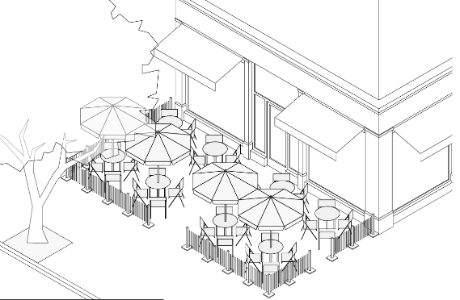
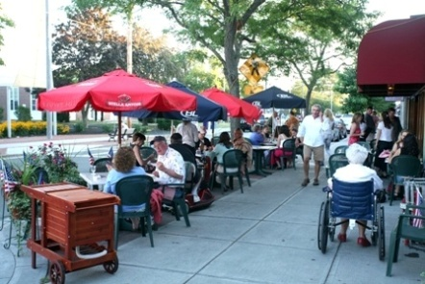
- Storefront Display | Description: The placement for display and sale of merchandise within the Building Frontage Area or the Public R-O-W adjacent to a retail business can increase the visibility and viability of businesses and can enhance the walkability of an area. Displays may be allowed without a permit from the Select Board under the following standard.  Design Standards:  - Display is out only during hours when the associated establishment is open for business.  - It does not obstruct pedestrian or vehicular traffic or corner visibility.  - It is located at least two (2) feet outside of the required width of a Pedestrian Throughway Zone.  - It does not obstruct building entrances. The passage must be 4’-6’ wide minimum adjacent to an outdoor retail display.  - Outdoor retail displays must be located 2’ from any fire hydrant, street furnishing, street tree, or other fixture, and must not infringe upon any area required for the operation of bicycle parking.  - Furniture and equipment must not be anchored to a ground surface nor be attached or affixed to any tree, post, sign or other structure.  - It must not exceed 100 square feet of ground space.
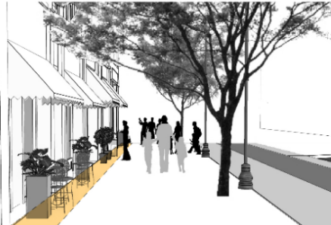
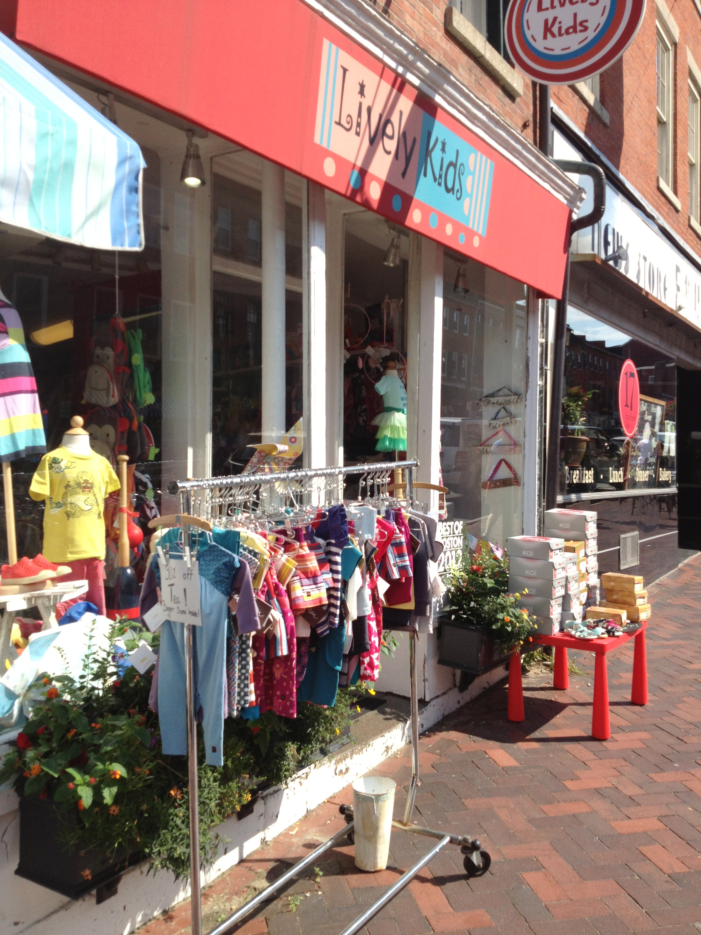
- Sidewalk Sign | Description: A freestanding portable sign, not secured or attached to the ground or any building or structure, composed of a sign panel and supporting structure or one or more panels which form both the structure and sign face, and which is intended to be placed in a sidewalk or pedestrian way.  Design Standards:  See Sign Regulations in Article XIII.
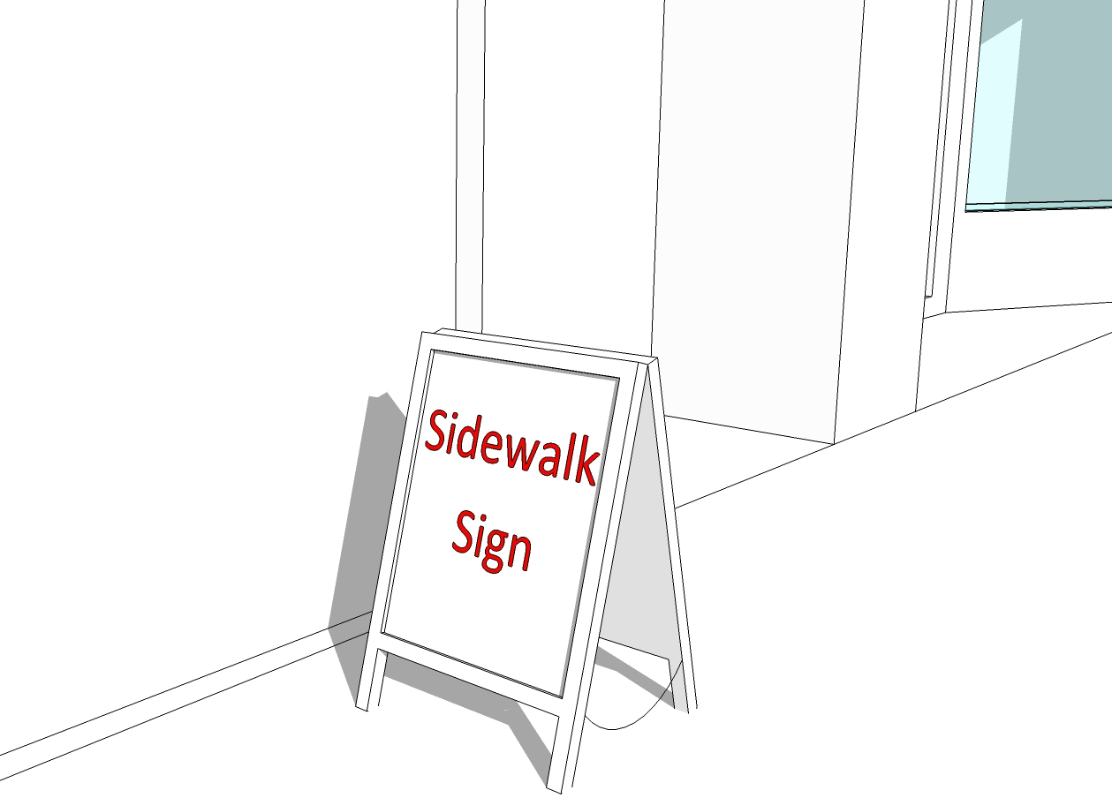
- Parklet | Description: A parklet is a Utility Zone treatment design to enhance the pedestrian environment on an on-street parking space. Parklets provide Outdoor Amenity Spaces to the general public or an adjacent building use where no space is available in the Public R-O-W or Building Frontage Zone, or where additional outdoor amenities is desirable to enhance the pedestrian environment. Parklets are installed on parking lanes and may occupy more than one parking space with approval. Parklets typically extend out from the sidewalk at the level of the curb to the width of the adjacent parking space.  Design Standards:  - Parklets may be used for public or private seating, food trucks and carts, bike corrals, exercise stations, pop up stores and other temporary retail venders, and other amenities as determined by the City Council.  - Parklets must occupy the full width of the parking lane they extend into.  - When a bike lane is present, parklets must be set back so that they don’t interfere with travel on the bike lane.  - Parklets must be setback at least fifty (50) feet from the corner of a street.  - Parklets require the approval of the Select Board.
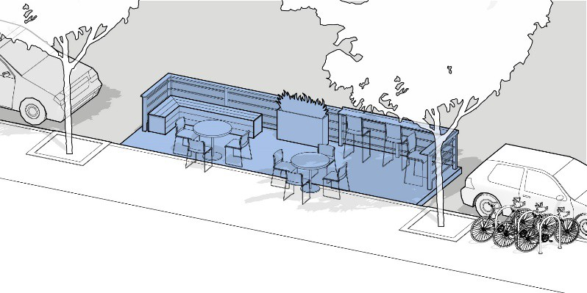
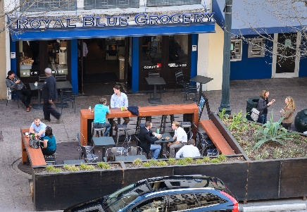
- Civic and Public Art | Description: A small civic space type designed to commemorate an important event or important person in the history of the Town, or artistic expression for the enjoyment of the general public. These civic spaces may be freestanding or incorporated as a subordinate feature of any other type of civic or recreation space. Landmarks and public art installations can take many forms including stone or metal memorials and monuments, statues, plaques, signage, or landscape designs. They should be considered as special features that bring people together and enliven the experience of visitors in exploring Burlington.  Design Standards:  - The design, size, placement should be compatible with and integrated with the site.  - The installation shall be designed as permanent fixtures and made of materials that will withstand all weather conditions and the test of time.  - Installations shall be properly maintained including any associated lighting should be considered in the design.  - Historic landmarks must be reviewed by the Historic Commission.  - Landmarks recognizing veterans must be reviewed by the Veteran’s Commission.
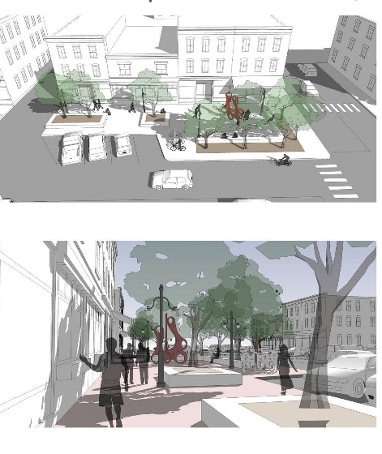
- Pop Up Shops | Description: A pop-up shop is a temporary retail space that is typically used to introduce a new product line, test a new market, generate awareness for a product or cause, or during holiday seasons when consumer spending is high.  Design Standards:  - The shop may be located in the Building Frontage Zone, Furnishing/Utility Zone, designated Outdoor Amenity Spaces, and parking lots and structures.  - The shop shall be limited to general retail sales products.  - The shop shall be limited to the ground floor and shall comply with all signage standards of the Zoning Bylaw.  - The maximum floor area of the shop shall be 150 square feet.  - Parking standards shall be based on the square footage of the permanent space hosting the vendor; no additional parking shall be required on an individual vendor basis.  - Operating hours shall be limited to 7 :00 a.m. and 10:00 p.m., unless approval of a modified permit from the Select Board.  - Pop-Up shops require a permit from the Select Board.
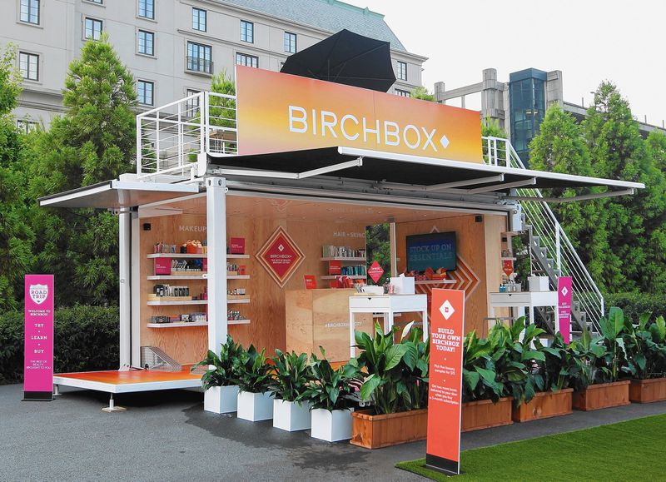

    - INFORMAL ACTIVATION APPLICATIONS.
Informal activation may include a variety of application such as Food Trucks and Street Vendors, Flower Planters and Window Box, Movable Chairs, Window Displays, Decorative Lighting (such as string lights), Projecting Lighting and Graphics, Programming and Festivals of Open Space or Parking Lots, Farmers Markets and Flea Markets, Temporary Street Closings (Shared Streets), Wayfinding Signage and Gateway Treatments, Over Street Banners and Pole Banners/Flowers, Exercise Stations and Circuits, Water Features, Bollards, Murals, and similar activities that enliven the MIX District. Activation applications within the public right-of-way or town-owned properties require approval from the Select Board.

Burlington Planning Board
25 Center Street, Town Hall Annex
Burlington, MA 01803
Phone: 781-270-1645
Planning @Burlington.org

Request for Design Waivers

Applicant: __________________________________________________________________________________

Description of Land: __________________________________________________________________________

Type of Development: ____________________________________________________________________________________________________

This form is to be submitted with the application for development.

Section of Development Regulations  (ex: 3.5.3) | Item Numbers  (ex: 1, 2 and 7) | Explanation

Signature of Applicant / Agent: _________________________________ Date: ____________________

Burlington Planning Board
25 Center Street, Town Hall Annex
Burlington, MA 01803
Phone: 781-270-1645
Planning @Burlington.org

Alternative Compliance Request Form

Date: _________________ Application Number: _________________

Project Name (if applicable): ________________________________________________________

Address: ________________________________________________________________________

The Planning Board allows for alternative compliance to the requirements of the Design Standards & Guidelines. If the Planning Department finds extraordinary hardship or practical difficulties with strict compliance with the requirements of the Design Standards and Guidelines, or if the Planning Department determines that the purposes of the Design Standards & Guidelines may be better served by an alternate proposal, then a modification to the requirements may be granted. Applicants seeking modification to the requirements of the Design Standards & Guidelines shall submit this form to the Planning Board specifying the requirement they propose to fulfill through alternative compliance.

Property Owner Information:
Name:
Address:
Telephone: _____________________ E-mail: _____________________________________
Signature:

Applicant Information (if different than Owner):
Name:
Address:
Telephone: _____________________ E-mail: _____________________________________
Signature:

Request:
List the requirement section and heading of the Design Standards & Guidelines for which alternate compliance is requested. If requesting alternate compliance for more than one requirement, list each separately (Attach separate sheet if necessary).

