ARTICLE VII: GENERAL REGULATIONS

Article XX:

RE: Amend Zoning Bylaw Article VII – Special Residential Regulations. To see if the Town will vote to amend Article XI by adding the following regulations in blue as follows:

SECTION 7.1.0. ACCESS THROUGH OTHER DISTRICTS
- No access to or egress from any other zoning district, except OS, through the RO district shall be permitted.
- No access or egress from the BN, BL, BG, BT, I, IR, IG, PD, MIX, and MIXSD districts shall be permitted in or through the RG or RC districts.
- No access to or egress from residentially zoned land in a contiguous municipality shall be permitted, except over public ways, and private ways in use as public ways on January 31, 1977.

SECTION 7.2.0. PARKING REQUIREMENTS AND STANDARDS
    - Purpose

- To promote traffic safety by assuring the adequate storage of motor vehicles off the public street and for their orderly access and egress to and from the public street;
- To prevent the creation of surplus amounts of parking spaces which contribute to additional Single Occupancy Vehicle (SOV) trips, traffic congestion and traffic service level deterioration on roadways;
- To advance the efficiency of vehicular traffic on Burlington streets to reduce excessive delay and/or congestion;
- To consider and allow for safe and convenient routes for pedestrians and bicyclists;
- To permit emergency vehicles to reach homes and businesses with a minimum of delay and to reduce motor vehicle and pedestrian accidents on Town streets;
- To prevent, reduce, and mitigate the impacts of development on parking demands, transportation system, neighborhood livability, public safety and the environment through the use of Transportation Demand Management (TDM) measures;
- To promote shared parking as a means to reduce the need for an excess pavement in an effort to curtail the heat island effect.

    - Applicability

      - General. No permit for the construction, reconstruction, extension, or alteration of any building, structure, or use of land, and no building or land, or any part of any building or land, may be occupied or used until parking has been provided in accordance with the requirements of this section.
      - Additions.
- A building or site may be renovated or repaired without providing additional parking, provided there is no increase in gross floor area or improved site area.
- When a building, use or site is increased in gross floor area or improved site area, parking is required for the additional floor or site area only.
- When the gross floor area or improved site area is increased by more than 50% cumulatively, both the existing use and the additional floor or site area must conform to the parking requirements of this section.
      - Change in Use.
- A change in use must comply with the parking requirements unless the use has the same or a lesser parking demand than the previous use.
- Where parking spaces required for the new use exceed the required parking spaces for the existing use, additional parking is only required for the difference between the current parking spaces required and the parking spaces required for the new use.

    - Parking Space and Aisle Dimensions

Parking spaces and drive aisles must meet the following dimensions. Parking spaces and drive aisles using dimensions other than those specified may be used if approved by the Town Engineer.
      - Standard Car Space. Parking spaces and aisles shall have the following dimensions unless otherwise determined by the Town Engineer:

FIGURE 7.1. PARKING SPACE AND AISLE DIMENSIONAL STANDARDS
Dimension | Parallel | 45 Degrees | 60 Degrees | 90 Degrees
Stall Width (min) | 8 feet | 9 feet | 9 feet | 9 feet
Stall Length (min) | 20 feet | 18 feet | 18 feet | 18 feet
Drive Aisle, 1 Way (min) | 12 feet | 12 feet | 14 feet | n/a
Drive Aisle, 2 Way (min) | 20 feet | n/a | n/a | 22 feet
Vertical Clearance | 7’6” (min) | 7’6” (min) | 7’6” (min) | 7’6” (min)

      - Compact Car Space: Eight (8) feet by fifteen (15) feet.
      - Retail Use Car Space: Nine (9) feet by eighteen (18) feet or width to be determined by the Town Engineer.
      - Handicapped Person Car Space: Thirteen (13) feet by eighteen (18) feet and designed in accordance with the standards set forth in the Rules and Regulations of the Architectural Access Board. The required number of handicapped parking spaces shall be in accordance with the amounts specified in the Rules and Regulations of the Architectural Access Board.

    - Minimum and Maximum Parking Space Requirements
      - Parking Ratios. Off-street parking and loading spaces in the amounts specified in Figure 7.2 below shall be provided for all uses and buildings. The minimum parking space ratios specified in Figure 7.2 below shall also be the maximum parking allowed unless the Planning Board approves an alternative requirement.
      - Multiple Uses on Site. Where the Gross Floor Area of a building or buildings is divided among various uses, the Planning Board shall apply such parking space requirements and ratios specified in Figure 7.2 which most appropriately apply to the character and proportion of uses within such building or buildings.
      - Parking Ratio Waiver. The Planning Board may approve a parking waiver which contains up to 10% less or more than the minimum parking space requirements and ratios in Figure 7.2, provided it makes the following findings and determinations:
- The amount of parking provided is adequate for the type and nature of the use proposed.
- The applicant shall undertake appropriate provisions, to the satisfaction of the Planning Board, to ensure that the subject site would have adequate area for additional parking if greater parking demands arise from the current or future use of such site, and that such additional parking could be constructed in conformity with the Impervious Surfaces requirements in Section 8.3.8.4 of Article VIII of this bylaw, and any other requirements of the bylaw.

FIGURE 7.2. PARKING REQUIREMENTS
LAND USE | Per 1,000 SF (Average Weekday) | Alternate Measurement
INDUSTRIAL
General Light Industrial | 0.75 | 0.64 | Per Employee
Industrial Park | 1.27 | 0.89 | Per Employee
Manufacturing | 1.02 | 0.97 | Per Employee
Laboratory | 1.00
Warehousing | 0.51 | 0.78 | Per Employee
Mini-Warehouse | 0.14 | 1.35 | Per 100 Storage Units
RESIDENTIAL
Single-Family Detached Housing |  | 1.83 | Per Dwelling Unit
Two Family Dwellings |  | 1.83 | Per Dwelling Unit
Multifamily Dwellings |  | 1.23 | Per Dwelling Unit
Low/Mid-Rise Apartment |  | 1.23 | Per Dwelling Unit
Rental Townhouse |  | 1.62 | Per Dwelling Unit
Residential Condominium/Townhouse |  | 1.38 | Per Dwelling Unit
Senior Adult Housing - Attached |  | 0.59 | Per Dwelling Unit
Congregate Care Facility |  | 0.45 | Per Dwelling Unit
Assisted Living |  | 0.41 | Per Dwelling Unit
Continuing Care Retirement Community |  | 1.0 | Per Dwelling Unit
Nursing Home | 0.98 | 0.35/Bed or 0.88/Employee
Dormitory |  | 1 Space/3 Beds
Hotel |  | 1.2/Guest Room and 1 Space/61 SF Function Room
All Suites Hotel
Business Hotel
Motel
RECREATIONAL
Multipurpose Recreational Facility | 6.33 | 9.5/Acre
Bowling Alley |  | 4.0 | Per Lane
Multiplex Movie Theater |  | 0.15/Seat or 36.2/Screen
Ice Skating Rink | 0.42
Soccer Complex |  | 38.3 | Per Field
Racquet/Tennis Club |  | 3.56 | Per Court
Health/Fitness Club | 5.27 | 0.13 | Per Member
Athletic Club | 3.55 | 0.07 | Per Member
Recreational Community Center | 3.20

LAND USE | Per 1,000 SF (Average Weekday) | Alternate Measurement
EDUCATIONAL
Elementary School |  | 0.17 | Per Student
Middle School/Junior High School |  | 0.09 | Per Student
High School, Suburban |  | 0.23 | Per Student
Private School (K-12) |  | 0.39 | Per Student
Junior/Community College |  | 0.18 | Per Student
University/College |  | 0.33 | Per School Population
INSTITUTIONAL
Place of Worship | 3.79 | 0.20 | Per Seat
Government Office Building | 3.20 | 0.83 | Per Employee
Judicial Complex | 3.02
Museum | 0.98
Library | 2.22
Convention Center |  | 0.31 | Per Attendee
SERVICES
Hospital | 2.5 | 4.49/Beds or 0.81/Employee
Surgery Center |  | 5.67 | Per Operating Room
Clinic | 4.94 | 0.82 | Per Employee
Animal Hospital/Veterinary Clinic | 1.6 | 1.4 | Per Employee
Office Building | 2.84 | 0.83 | Per Employee
Medical-Dental Office Building | 3.2
Day Care Center | 3.16 | 0.24/Student or 1.38/Employee
Copy, Print and Express Ship Store | 3.0
Bank | 4.0 | 1.6 | Per Employee
RETAIL
General Retail Store | 2.14
Building Materials and Lumber Store | 1.69
Free-Standing Discount Superstore | 1.85
Free-Standing Discount Store | 1.33
Hardware/Paint Store | 1.9
Shopping Center | 2.55
Automobile Parts Sales | 2.14
Automobile Sales and Service | 4.17
Motorcycle Dealership | 1.78
Tire Store | 4.17
Supermarket | 3.78

LAND USE | Per 1,000 SF (Average Weekday) | Alternate Measurement
RETAIL
Convenience Market (Open 24 Hours) | 5.5
Convenience Market with Gasoline Pumps | 8.4
Discount Supermarket | 4.13
Discount Club | 2.22
Liquor Store | 2.98
Sporting Goods Superstore | 1.78
Home Improvement Superstore | 2.23
Electronics Superstore | 3.03
Toy/Children's Superstore | 1.94
Pet Supply Superstore | 0.66
Office Supply Superstore | 0.61
Book Superstore | 0.89
Apparel Store | 1.13
Pharmacy/Drugstore w/o Drive-Through Window | 2.2 | 3.73 | Per Employee
Pharmacy/Drugstore w/ Drive-Through Window | 2.39 | 1.4 | Per Employee
Furniture Store | 1.22
FOOD & ENTERTAINMENT
Quality Restaurant | 10.6 | 0.49 | Per Seat (Friday Only)
High-Turnover Restaurant w/o Bar or Lounge | 10.6 | 0.35 | Per Seats
High-Turnover Restaurant w/ Bar or Lounge | 13.3 | 0.48 | Per Seats
Fast-Food Restaurant w/o Drive-Through Window | 12.4
Fast-Food Restaurant w/ Drive-Through Window | 9.98 | 0.4 | Per Seats
Bakery/Café w/o Drive-Through Window | 12.77
Bakery/Café w/ Drive-Through Window | 10.4
OTHER USES
When a use is proposed to be developed or implemented and is not described or specified in the parking space requirements and ratios listed above, the Planning Board shall determine the maximum and minimum parking space ratio and requirement based on the character of use proposed.

    - Parking Reduction Methods.
By Special Permit, the Planning Board may reduce the minimum on-site parking requirements in Figure 7.2 under the following conditions:
- Shared Parking.
- Where a development site includes a combination of uses with variation in peak parking demand times; shared parking lots on site; have shared parking agreements with proximate properties where uses have offset peak demand times; have a reasonable rate of parking turnover; or evidence of similar uses and location situations operating successfully with lower amounts of parking, the Planning Board may grant a Special Permit for less parking.
- In considering a shared parking reduction in a mixed use development where shared parking is proposed, the Planning Board may require that the application prepare an evaluation of shared parking potential following the procedures of the Urban Land Institute (ULI) Shared Parking Manual (latest edition), the Institute of Transportation Engineers (ITE) Shared Parking Guidelines (latest addition), or other approved procedures determined by the Planning Board.
- A formal parking evaluation may be waived for small developments where there is established experience with the land use mix and its impact is expected to be minimal.
- Off-Site Parking. The Planning Board may allow required parking to be provided off-site for employees, except for any required handicapped parking, when conforming to the following:
- A development site providing off-site parking must be located within a 700-foot walking distance, measured from the nearest point of the off-site parking area along paved public or private walkways to the principal building entrance served.
- A lease, recorded covenant, or other comparable legal instrument, executed and filed with the Town of Burlington, guaranteeing long term use of the parking area site is provided to the Planning Board.
- Proximity to Public Parking Facility. Where a development site is within reasonable walking distance to a municipally-controlled parking facility which is publicly-available during hours of operation of uses on site, has sufficient capacity, is not allocated for residential uses, and is connected by public sidewalk.
- Car-Sharing Program. The Planning Board may approve a parking reduction where an active car-sharing program is made available to residents and/or employees on a development site; and where cars for the car-share program are available on the site or within a 700-foot walking distance of the site.
- On-Street Public Parking Off-Set. Parking spaces provided to meet the minimum parking requirements may include the actual spaces located on a lot and the spaces located along the corresponding lot street frontage where on-street public parking exists on the same side of an abutting street.
- Public Transportation Off-Set. On a public street where a regular MBTA bus route is established and where a bus stop is located within 150 feet of the main entrance of a development site, the Planning Board may grant a parking reduction.
- Public Parking Reserve. In lieu of providing the total on-site parking required, the Planning Board may accept a permanent easement on the property for the purpose of constructing public parking for all or a portion of the required on-site parking spaces. The reserve easement shall be subject to review and approval by the Board of Selectmen.
- Payment to Public Parking Fund. In lieu of providing the total on-site parking required in Figure 7.2, the Planning Board may accept a one-time payment from the applicant for all or a portion of required on-site parking that would be committed to a fund for the construction of public parking within 700 feet of the Development Site. The Board of Selectmen shall establish the amount of payment required per parking space.

    - Special Permit to Increase the Required Parking Space Ratio.

- The Planning Board may grant a special permit to increase the parking space requirements specified on Figure 7.2 by more than ten percent (10%) if the Planning Board determines that all of the following findings and conditions are met:

- The applicant has submitted data and evidence to the Planning Board, including but not limited to parking accumulation and utilization data that demonstrate the demand for additional parking spaces for such use or buildings, the latest edition of the Institute of Transportation Engineers (ITE) Parking Manual, the Urban Land Institute (ULI) Shared Parking Manual, or other comparable manual or document acceptable to the Planning Board.
- The applicant, site operator, or owner who obtains a special permit to increase the number of parking space shall agree to reduce the estimated trip generation rates related to the subject development or use in both the a.m. and p.m. peak hours by 20%, based upon the latest edition of ITE Trip Generation manual, or other comparable manual or document acceptable to the Planning Board. The method or methods by which such a reduction is accomplished is subject to the approval of the Planning Board. The Planning Board may determine compliance with this condition by monitoring traffic movements at the site after project completion and occupancy. The applicant, site operator, or owner shall fund this monitoring program in an amount agreed upon when the waiver is issued.
    - Special Surface Parking Types and Standards. The following special parking types are intended to facilitate a smaller and more efficient parking footprint, multi-mobility, and context-based placement of parking.
- Stacked and Valet Parking. By Special Permit, the Planning Board may allow valet or stacked parking if an attendant is present to move vehicles. If stacked parking is used for required parking spaces, a written guarantee must be filed with the Town of Burlington ensuring that an attendant will always be present when the lot is in operation. The requirements for minimum or maximum spaces continue to apply for stacked parking. Valet and stacked parking spaces do not require individual striping and may be permitted on-site or off-site as a means of satisfying the applicable off- street parking requirements where:
- Adequate assurance of the continued operation of the valet car park is provided.
- An equivalent number of valet spaces is available to replace the number of required off-street parking spaces.
- The design of the valet parking area will not cause queuing in a vehicular travel lane.
- An attendant is provided to park vehicles during business hours.

- Tandem Parking. By Special Permit, the Planning Board may allow tandem parking under the following conditions:
- To be used to meet parking requirements for residential units only.
- Tandem spaces shall be assigned to the same dwelling unit.
- Tandem parking shall not be used to provide guest parking.
- Two parking spaces in tandem shall have a combined minimum dimension of 9 feet in width by 30 feet in length.
- Up to 75% of the total off-street parking spaces provided may incorporate tandem parking.

FIGURE 7.3. TANDEM AND STACKED PARKING
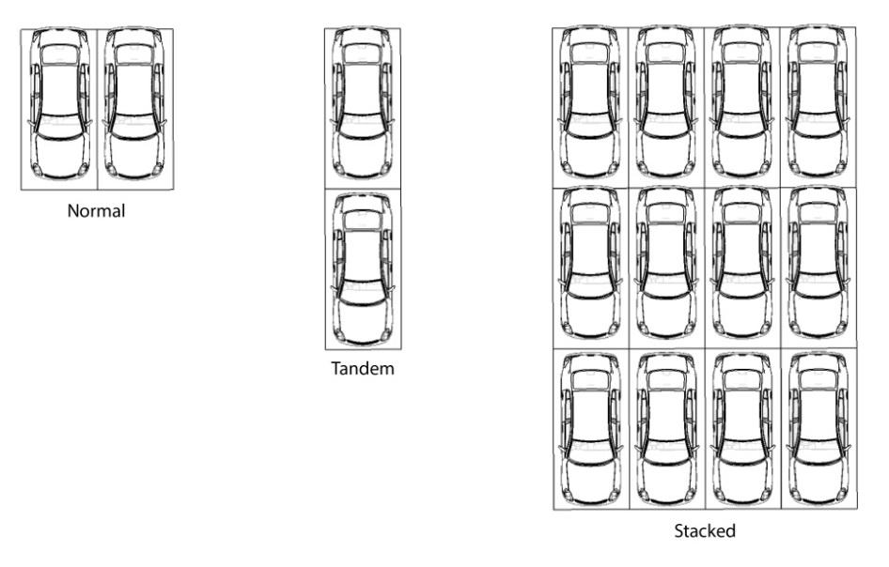

- Street Side Parking. By Special Permit, the Planning Board may allow parallel or angled parking provided on a privately-owned lot directly adjacent to the public street right-of-way in combination with a minimum five (5) foot wide planting strip with street trees planted 40 feet on center, and a five (5) foot minimum concrete sidewalk connecting to public sidewalks on abutting lots and to the primary building on-site. These parking spaces shall be privately owned but accessible to the public and shall effectively function as public on-street parking.

FIGURE 7.4. STREET SIDE PARKING (ON FRONT PROPERTY LINE)
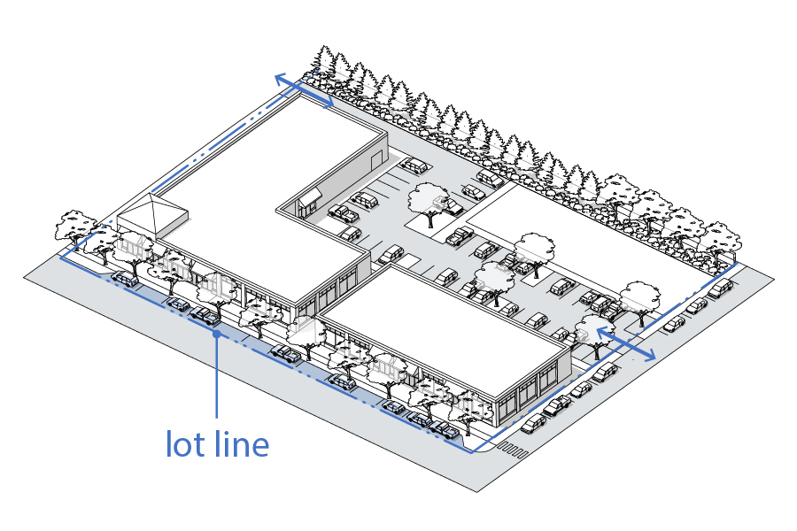

- Teaser Parking. In zoning districts where on-site surface parking is required to be located behind the front façade of a primary building, the Planning Board may issue a special permit allowing a limited amount of off- street surface parking to be placed between a public street and the street facing façade of a primary building. Where this variation is permitted by the Planning Board, the parking lot shall be setback a minimum of ten (10) feet from the street r-o-w line and streetscape treatments including street trees, landscaping, and a minimum 5-foot sidewalk will be placed adjacent to the street r-o-w line. The sidewalk shall be connected to the front entrances of the primary building by a dedicated pedestrian walkway. The portion of the parking lot located in front of the primary building shall be limited to one (1) double row of vehicles and associated parking aisle.

FIGURE 7.5. TEASER PARKING (PARKING ON FRONTAGE)
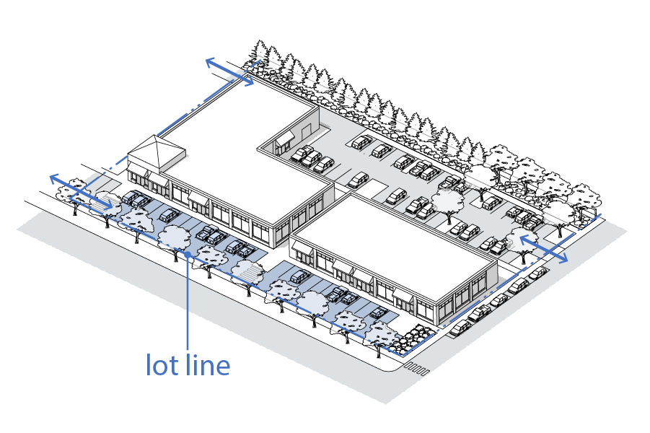

    - Shared Parking

    - Structured Parking Development and Design Standards.
- Placement and Scale. Structured parking may be constructed above ground and below ground, and attached or detached from the primary building and uses that it serves.
- Access. Pedestrian access to structured parking must lead directly to a public or private sidewalk and to the primary building. Structured parking that is attached directly to the primary building shall provide pedestrian access directly into the building.
- General Development Standards.
- Any parking structure or garage which is authorized by Planning Board site plan approval pursuant to Article IV, Section 9.3.0, shall not be included in the Maximum Aggregate Building-to-Ground Area Percentage pursuant to Section 5.2.0 of Article V of the district within which it is built.
- The parking structure or garage shall not be located within two hundred (200) feet of a Residential District without a Special Permit from the Planning Board pursuant to Article IX, Section 9.2.0.
- In addition to any required open space (or Outdoor Amenity Space) in the underlying zoning district, additional outdoor amenity space shall be required equal to 100% of the footprint of the parking structure. The additional outdoor amenity space may be allowed on-site on the ground, on the upper deck of the parking structure, or an alternative location off-site that provides a public benefit.
- General Design Standards. The street facing facade of any story of a building occupied by motor vehicle parking must be designed as follows:
- Fenestration and facade openings must be vertically and horizontally aligned and all floors fronting on the facade must be level (not inclined). The facade must include windows of transparent or translucent, but non- reflective, glass or openings designed to appear as windows for between twenty percent (20%) and fifty percent (50%) of the wall area of each floor.
- Windows must be back-lit during evening hours and internal light sources must be concealed from the view from public sidewalks.
- The facade area masking the floors occupied by motor vehicle parking must be seamlessly integrated into the architectural design of the building’s facade.

    - Bicycle Parking.
To facilitate bicycle use, the following bicycle parking regulations shall apply:
- Multi-Family and Mixed-Use Developments. Developments with 5 or more multi-family units shall provide at least one indoor covered bicycle parking area with space for 5 bicycles for every 5 dwelling units unless an alternative standard is approved by the Planning Board.
- Non-Residential Uses. Non-residential uses shall provide the following minimum bicycle parking spaces unless an alternative standard is approved by the Planning Board. A single typical inverted-U rack or pole rack that accommodates two bicycles shall be required.

FIGURE 7.6 - BICYCLE PARKING REQUIREMENTS
Size of Use | Required Spaces
5,000 to 10,000 square feet of gross floor area | 4
10,001 to 30,000 square feet of gross floor area | 10
30,001 square feet or more of gross floor area | 14

- Placement. Required bicycle parking spaces may be placed on private property or on a sidewalk along the curb, provided that at least 5 feet of sidewalk remains clear for pedestrian use. Required bicycle parking shall be publicly accessible and located within 100 feet of the building entrance.

    - Design Standards for Off-Street Surface Parking Facilities
- Parking Placement. All off-street parking, including surface and structured parking, excluding underground parking, must be located at or behind the primary building except for Street Side Parking and Teaser Parking as allowed under Section 7.2.7 above.
- Access.
- All off-street parking must have direct access to a public street from an alley, driveway, maneuvering aisle, or permanent access easement.
- Where off-street parking facilities of 30 spaces or more are provided, a publicly accessible driveway must have a minimum width of eighteen (18) feet for vehicle access and 5-foot sidewalk connecting to the public street to the parking facility.
- Only one driveway shall be allowed on a building lot unless a waiver is approved by the Planning Board. Where more than one curb cut exists, it may remain unless change of use triggers site plan review. Where access is available on a secondary street frontage, it will be utilized as an alternative access to the primary street frontage.
- Shared driveways are permitted and encouraged.
- Shared internal access between private parking lots is permitted and encouraged.
- Circulation.
- Parking lots and structures must be designed so that vehicles enter or exit the lot or structure onto a public street in a forward direction rather than backing out into the roadway except for single family dwellings.
- Ingress and egress from individual parking spaces must be from a drive aisle or driveway. Vehicles are not permitted to enter or exit parking spaces directly from a public street except for Street Side Parking in Section 7.2.7 above.
    - Surfacing
- Impervious Materials. Where on-site facilities are provided for parking or any other vehicular use areas, they must be surfaced with asphalt bituminous, concrete, or other types of dustless material, and maintained in a smooth, well-graded condition. The site plan must also conform with the Impervious Surfaces requirements in Section 8.3.8.4 of Article VIII of this bylaw.
- Pervious Materials. Pervious or semi-pervious parking area surfacing materials may be approved by the Planning Board in consultation with the Town Engineer. Permitted materials may include, but are not limited to grass, grasscrete, ring and grid systems used in porous or grid pavers, or recycled materials such as glass, rubber, used asphalt, brick, block and concrete and other impervious material.
- Curbs and Drainage.
  - All surface parking areas must be graded and drained to collect, retain, and infiltrate surface water accumulation on-site to the greatest extent practicable.
  - Curbs or parking blocks are required at the edges of perimeter and interior landscaped areas. Curbing must have openings to allow drainage to enter and percolate through the landscaped area.
SECTION 7.3.0. GENERAL LOADING REQUIREMENTS

    - General. Adequate off-street loading spaces or loading areas shall be provided and maintained by the owner of the property for each nonresidential building or use which is erected, enlarged or altered after the effective date of this Bylaw.
    - Location. No loading dock or bay shall be located between the building and the street or the required buffer area to an adjoining residential zoning district in accordance with Section 5.2.0 of this Bylaw. The Planning Board shall have final approval of the siting of any loading dock.
    - Same Lot. All loading spaces or loading areas required by this Bylaw shall be on the same lot as the building or use which they are intended to serve, and in no case shall any required loading area be part of an area used to satisfy the off-street parking requirements of this Bylaw.
    - No Queues or Backing onto Street. No loading facility shall be designed to require trucks to queue on a public way while awaiting off-loading. No loading facility shall be designed to require vehicles to back onto a public way; all turning maneuvers shall be accommodated on the premises.
    - Shared Loading. No part of an off-street loading area required by this Bylaw for any nonresidential building or use shall be included as part of an off-street loading area similarly required for another building or use, unless the type of buildings or uses indicates that the usage of such loading area would not occur simultaneously, as determined by the Planning Board.
    - Screening. Loading areas shall be screened from view from a public street.

SECTION 7.4.0. GENERAL LANDSCAPING REQUIREMENTS

    - Purpose. The purpose of this section is to accomplish the following objectives:

      - Provide a suitable boundary or buffer between residential uses and nearby nonresidential uses;
      - Separate different and otherwise incompatible land uses from each other in order to partially or completely reduce potential nuisances such as dirt, dust, litter, noise, glare from motor vehicle headlights, intrusion from artificial light (including ambient glare), or view of signs, unsightly buildings or parking lots;
      - Provide visual relief and a source of shade in parking lots and other areas, and protection from wind in open areas; and
      - Offer property owners protection against diminution of property values, if any, due to adjacent nonresidential use.
    - Applicability. The requirements of this section shall apply to any nonresidential use and to multifamily dwellings.

    - Landscaping Requirements.
      - Screening. In accordance with an approved site plan, screening shall be provided, erected and maintained to shield RO and RG districts and municipal properties from adjoining business and industrial uses of land, and to shield RO districts from adjoining apartment uses. Screening shall be erected or planted before the premises are first occupied. Alternatively, the Planning Board may accept a financial guarantee in the amount of the cost of installing the screening and an agreement to complete the screening within a specified time and permit occupancy before the screening is installed.
      - Landscaping. In accordance with an approved site plan, landscaping shall be provided, erected and maintained on any part of any BN, BL, BG, BT, I, IR, IG, MIX, or RG lot which is not occupied by a structure or by required parking areas, service areas, and driveways; except that all or part of the required landscaping may be in its clean original wooded state. Landscaping features shall be erected or planted before the premises are first occupied. Alternatively, the Planning Board may accept a financial guarantee in the amount of the cost of installing the landscaping and an agreement to complete the landscaping within a specified time and permit occupancy before the landscaping is installed.
      - Residential Buffers. Property line(s) which also bound residential districts shall be screened from nonresidential uses by means of plantings or maintenance of trees of a species common to the area and appropriate for screening, spaced to minimize visual intrusion, and providing an opaque year-round visual buffer between uses. Such plantings shall be provided and maintained by the owner of the property used for nonresidential use and multifamily dwellings. No part of any building or structure or any paved or unpaved surface intended for or used as a parking area may be located within the buffer area required by Section 5.2.0 of this Bylaw.
      - Accessory Receptacles. Dumpsters and similar accessory receptacles over one cubic yard capacity shall be screened from all adjacent premises and streets from which such features would otherwise be visible in accordance with this Section.
      - Utilities. Any loading area or HVAC equipment or other electrical equipment placed on the ground level shall be screened from all adjacent premises and streets from which it would otherwise be visible in accordance with this Section.
      - Plant Materials. Planted areas shall contain an appropriate mix of plant species that are appropriate to the proposed use, site layout, soils, and other environmental conditions. Vegetation is preferable to mulch where practical.
      - Existing Trees. Existing trees with a diameter at breast height (DBH) of twelve inches (12") or more shall not be removed except by prior approval of the Planning Board, and if removed, shall be replaced with a minimum 3” caliper tree, unless waived by the Planning Board.

    - Parking Lot Landscaping

- Applicability.
- This Section applies to all on-site surface parking lots with more than 10 spaces created after the effective date of this bylaw, except as provided under Section 7.2.12.1.b) below. For purposes of this section, multiple parking lots contained on a single development site and any separate parking areas connected with drive aisles are considered a single parking lot.
- An existing parking lot may be renovated or repaired without providing additional landscaping, provided there is no increase in the size of the parking lot.
- When an existing parking lot is increased in size, landscaping is required for the additional parking area only.
- When an existing parking lot is increased in size by more than 50% cumulatively, landscaping is required for both the existing parking lot and the new parking area.
- Perimeter Screening. All surface parking lots with frontage on any portion of a street right-of-way must be screened with the following:
- A minimum 10-foot wide, landscaped area with a continuous row of shrubs or grasses must be provided between the street and parking lot.
- Shrubs and grasses must be a minimum of 18 inches in height when planted and must reach a minimum size of 36 inches in height within 3 years of planting.
- A 36-inch wall in a minimum 5-foot planting strip may be substituted for the continuous row of shrubs.
- Breaks for pedestrian and vehicle access are allowed.
- Interior Islands.
- A landscaped interior island must be provided for every 10 parking spaces. Interior islands must be distributed evenly throughout the parking area. Interior islands may be consolidated, or intervals may be expanded in order to preserve existing trees.
- An interior island abutting a double row of parking spaces must be a minimum of 8.5 feet in width and 300 square feet in area.
- An interior island abutting a single row of parking spaces must be a minimum of 8.5 feet in width and 150 square feet in area.
- Interior islands must be installed below the level of the parking lot surface to allow for runoff capture.
- Median Islands.
  - A landscape median island must be provided between every 6 single parking rows.
  - A landscape median island must be a minimum of 5 feet wide.
  - A median island may also serve as the location for a sidewalk. In such case, the sidewalk must be a minimum of 6 feet wide, and the remaining planting area must be no less than 5 feet wide.
  - Median islands may be consolidated, or intervals may be expanded in order to preserve existing trees.
  - Median islands must be installed below the level of the parking lot surface to allow for runoff capture.
- Tree Coverage.
  - Each interior island must include at least one shade tree per 150 square feet.
  - In no case can there be less than one shade tree for every 2,000 square feet of parking area including driving aisles.
- Maintenance and Installation. All required parking lot landscaping shall be properly installed and maintained.

FIGURE 7.7. PARKING LOT LANDSCAPING
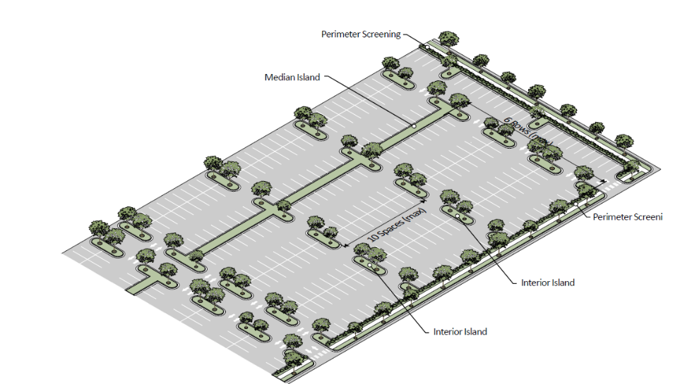
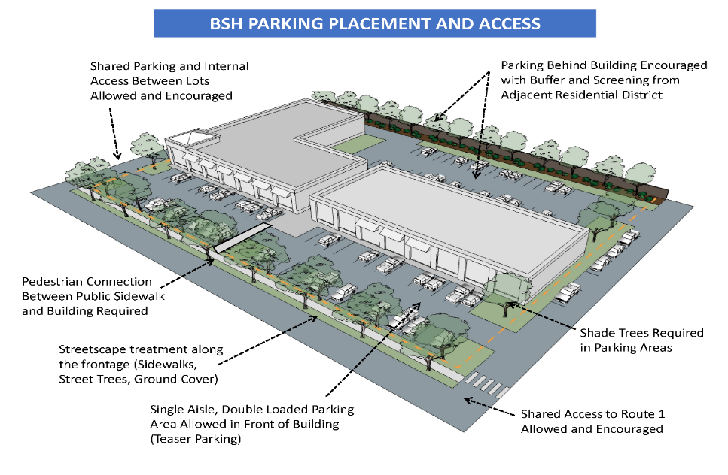

    - Coordination with Site Plan Approval. The Planning Board shall require a landscaping plan as part of an overall site plan for any premises subject to site plan review pursuant to Section 9.3.0 of this Bylaw. Such a landscaping plan shall be at a scale sufficient to determine compliance with the specifications set forth in this Section.

    - Maintenance of Landscaped Areas. The owner of the property used for nonresidential purposes shall be responsible for the maintenance, repair and replacement of all landscaping materials installed in accordance with this section and shall have a continuing obligation to comply with the provisions set forth herein. All plant materials required by this Section shall be maintained in a healthy condition, or replaced as necessary, in perpetuity.

SECTION 7.5.0. GENERAL PERFORMANCE REGULATIONS

    - Corner Clearance. To provide a clear view across a corner for a driver of a vehicle, no structure or planting shall be allowed between a plane two (2) feet above street level and a plane seven (7) feet above street level within that part of a corner lot which is within a triangle bounded by the street lot lines and a straight line drawn between points on each such lot line twenty-five (25) feet from the intersection of said lot lines or extension thereof.
    - Streets, Driveways, Parking and Service Areas. In all districts except "RO" One Family Dwelling Districts, all streets, driveways, parking areas, service areas, ramps, loading docks and exterior storage areas shall be paved or surfaced with impervious materials. In areas where contamination or other environmental factors do not preclude infiltration, porous pavement, porous concrete, and/or permeable pavers may be used in streets, driveways and parking areas. All systems shall be designed and constructed so that water falling on such areas will be directed into an approved system of pipes, or drainage structures, or Low Impact Development (LID) features.

