RIDEHAIL 101: HOW TO USE UBER & LYFT
Part 1: Tuesday September 8th 10:00am
Part 2: Thursday, September 10th 10:00am
This training is offered both virtually and at the senior center, but you must preregister if you wish to take it in person or you wil be turned away in order to ensure proper social distancing.
781-270-1953 or coa@burlington.org

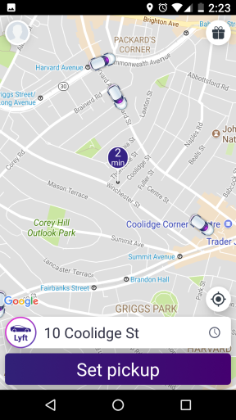
Description: Are you looking for ways to save on transportation costs but go further? Do you want to keep healthy & stay active in your community? Are you curious how rideshare services (like Uber & Lyft) might work for you?
We will introduce participants to ride-sharing, answer questions, and download the app (for those with a smartphone). If you plan on downloading the app, please bring your smartphone and your Apple ID or Google password. This program is supported by MCOA.
Presenter: Jane Gould, Phd is the author of "Aging in Suburbia," a book about transportation choices and future mobility. She is trained as a transportation planner and has more than fifteen years of experience developing campaigns for transit and public agencies. She keeps an interactive blog on technology, www.DearSmartphone.com, and has been an active trainer for Rideshare since 2016. Jane is a longtime volunteer for the TRIPPS Program at the Brookline COA.

