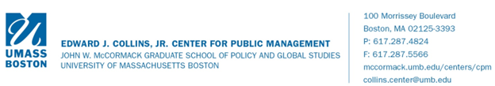

Example Towns for Study

The Collins Center Project Team has put together a core list of towns as examples for study and benchmarking. The team will be looking outside this list when appropriate, but these towns were chosen to illustrate a range of governing structures and charter language. These Towns were chosen based upon the following criteria and with input from the Committee Chair:

- Select Board/Representative Town Meeting form of government
- Population between approximately 22,000 and 30,000
- Generally suburban character in Eastern Massachusetts
- Operate under a Home Rule or Special Act town charter, with the exception of Milford, which operates under a combination of Special Acts and Bylaws

Town | Population* | Executive Officer | Charter, Special Acts or Bylaw Reference
Burlington | 26,527 | Town Administrator | https://www.burlington.org/DocumentCenter/View/882/Chapter-686-PDF
Dedham | 24,968 | Town Manager | https://ecode360.com/15734570
Milford | 30,257 | Town Administrator | https://www.milfordma.gov/DocumentCenter/View/297/Town-of-Milford-By-Laws-PDF
Milton | 28,374 | Town Administrator | https://ecode360.com/37837939
Reading | 25,428 | Town Manager | https://www.readingma.gov/DocumentCenter/View/2240/Reading-Home-Rule-Charter-PDF
Walpole | 25,964 | Town Administrator | https://ecode360.com/12698873
Winchester | 22,837 | Town Manager | https://www.winchester.us/DocumentCenter/View/226/Home-Rule-Charter-2001-PDF?bidId=
* 2003 Population from Mass DOR, Division of Local Services

